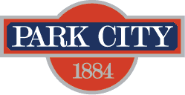

AGENDA
Park City Municipal Forestry Advisory Board
Thursday, August 3, 2023
10 am
Marsac East Conference Room

Board Member Attendance
Present:
Excused:
Absent:

Purpose & Product: To study, investigate, counsel, formulate, develop and/or update, and administer a Community Forestry Plan ("Forestry Plan") for the care, preservation, pruning, planting, replanting, removal or disposition of trees and shrubs in parks, along streets, and in other public places.

Working & Input

Old Business: 1202 Empire Ave – Trees in ROW
New Business: Parcel SSC-A-X
Ongoing:
- Forestry Plan RFP Discussion
- Municipal Code Update Discussion
  - Membership modification
  - Plant List
  - Next steps
Board Member Updates/Roundtable

Next Meeting: Thursday, September 7, 1000-1100, Marsac East Conference Room

