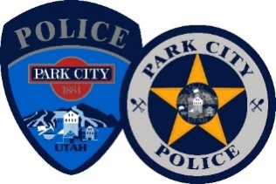

News Release – For Immediate Release
Lieutenant J. Randall, Park City Police Department
jrandall@parkcity.org
(435)615-5512
September 19, 2023

PARK CITY POLICE DEPARTMENT COMMAND STAFF UNDERGOES REORGANIZATION
Park City, Utah - The Park City Police Department underwent a reorganization of its Command Staff (Lieutenants) structure on September 15, 2023. The change was required to better structure responsibilities and define a clearer chain of command during critical incidents. All four of the Lieutenants competed in the rigorous and challenging testing process. The two successful candidates were Darwin Little and Robert McKinney.
Captain Little is currently Commander of the “Investigations Section” of the police department and will continue in this role, in addition to his new “Special Operations Section” duties. Captain Little will now oversee:
- Special Event/SWAT Lieutenant and assignments
- Detectives
- Victim Advocate program and employee
- Evidence Technician
- Taskforces – DEA, Wasatch Back Major Crimes Task Force, SECURE, Internet Crimes Against Children.
Captain McKinney is currently serving as the commander over “Patrol Operations” and will continue in this role, in addition to his “Administrative Captain” responsibilities. Captain McKinney will now oversee:
- Community Outreach Lieutenant
- Patrol Sergeants
- Patrol Officers
- Reserve Officers
- School Resource Officer (SRO)
- Records Department
- Community Outreach & Technical Specialists
The testing process included an in-basket exercise, written assignment, a presentation to a “mock” city council panel, an oral interview panel, and an interview with the Chief of Police, City Manager, and City Attorney. The two newly promoted Captains are directly under the Police Chief, Wade Carpenter. We would like to congratulate these two successful candidates and commend their years of dedicated service to our Park City Community.
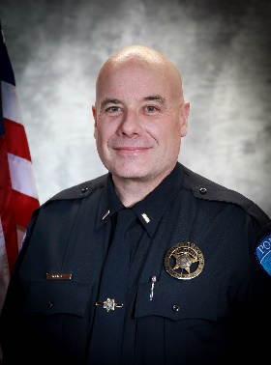
Captain Darwin Little
Captain Little has over 35 years of law enforcement experience with Park City, the last 25 years. He graduated from Weber State University with a Bachelor of Integrated Studies, emphasizing Criminal Justice, Design Engineering, and Manufacturing Engineering Technology. This degree has aided him in pre-operation planning, crash and crime scene diagramming, and 3D digital scanning. He also received two associate degrees, one in Arts and one in Applied Sciences, and is fluent in Portuguese. He was the 2002 Winter Olympics Deer Valley Venue Commander and was promoted to Patrol Sergeant in 2003. In 2014, Captain Little was promoted to Investigations Lieutenant and has also been a Commander for several years with the Wasatch Back Major Crimes Task Force. He is married with six children and four grandchildren.
Captain Robert McKinney
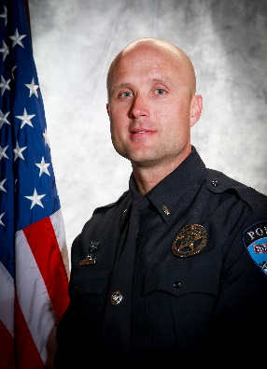
After obtaining his bachelor’s degree from Trinity International University in Deerfield, IL, Rob McKinney started his law enforcement career in 2009 as a Utah State Trooper. While working for the State of Utah, Rob held several assignments including being an operator on the DPS SERT Team and served an assignment to the DPS DUI taskforce in Salt Lake City. Hired by the Park City Police Department in 2014, Captain McKinney has held numerous positions including SWAT Operator, SWAT Team Leader, Motor Officer, Traffic Unit Supervisor, Department Training Coordinator, and department scheduling coordinator. In 2020, Captain McKinney was promoted to Lieutenant to oversee Patrol Operations, a role in which he will continue in addition to his role as Administrative Captain.
“I really appreciate the time and efforts from all four Lieutenants that have participated in this rigorous process. After interviewing the top two candidates at length, I feel confident that they will continue to lead the Park City Police Department through cutting edge practices under the direction of Chief Wade Carpenter.” – City Manager, Matt Dias

