Park City Municipal Corporation

REQUEST FOR PROPOSALS (NON-BID) FOR

Park City Dirt Jump Park Redesign and Build

NOTICE
REQUEST FOR PROPOSALS (NON-BID)
Park City Dirt Jump Park Redesign and Build

PROPOSALS DUE: Proposal submittals must be received by Tate Shaw, Assistant Recreation Director, by 5:00 p.m. on Monday, February 13, 2023 via email to tshaw@parkcity.org. Proposals must be less than 7 megs to be received by email.

PROJECT NAME: Park City Dirt Jump Park Redesign and Build

RFP AVAILABLE: January 23, 2023

PROJECT LOCATION: Creekside Park, 2392 Holiday Ranch Loop, Park City 84060

PROJECT DESCRIPTION (brief): Park City Municipal Corporation (‘PCMC’ or the “City” or “Park City”) is seeking a qualified trail and/or bike park design expert and construction contractor for the redesign and build of the Park City Dirt Jump Park located at Creekside Park.

PROJECT DEADLINE: October 31, 2023

OWNER: Park City Municipal Corporation
P.O. Box 1480
Park City, UT 84060

CONTACT: Tate Shaw, Assistant Recreation Director tshaw@parkcity.org All questions shall be submitted in writing to Tate Shaw via email by 4:00 p.m. on Wednesday, February 1, 2023

Park City reserves the right to reject any or all proposals received. Furthermore, the City shall have the right to waive any informality or technicality in proposals received when in the best interest of the City.

I. Introduction
Redesign and Build of the Park City Dirt Jump Park to become the Park City Dirt Jump and Skills Bike Park.

In July of 2005 PCMC, with help from the International Mountain Bike Association (“IMBA”), completed Park City’s first bike park as a temporary site to gauge interest. Once open, the Recreation Department took the lead to build awareness by offering a wide variety of programs and clinics. After a few years of running the park as a temporary facility, in 2011 the park received a permanent conditional use permit and underwent a complete remodel and design. Since 2011, the design has remained largely the same, featuring multiple, man-made dirt jumps ranging in levels from beginner to expert. The park was originally designed to allow for moderate progression.

PCMC has the desire to redesign a sustainable park that meets applicable industry and safety standards which, once built, requires less maintenance over time with more manageable surfaces, such as an asphalt or hard surfaced pump track, beginner through advanced jump lines, the addition of durable lips, and skills section. This should improve overall rider experience, better help with progression of skills, and make the park flow better, providing for a quality user experience.

Exhibit A: Creekside Park Conditional Use Permit

II. Purpose of Project

Redesign and Build the current infrastructure of the Park City Dirt Jump Park to that of a mountain bike skills park including jumps, pump tracks, and progressive skill features. The redesign is expected to enhance safety features and be less maintenance intensive. Some existing features of the park could remain if they tie into the proposed design. Any proposed topographic changes to the site must be approved by the City Engineer acting as the Floodplain Administrator prior to and after construction based on surveys conducted by the City.

III. Scope of Project

- Mandatory site visit and evaluation of project needs.
  - Bidder must have extensive knowledge, experience, and technical competence in dealing with design and construction of bike parks and have extensive knowledge of bike park design, build, maintenance, and management.
- Layout and design identification for:
  - Evaluate and recommend industry standards
  - Sustainable building of park
  - Seamless progressive features which provide safe options for riders of all skill levels
  - Greatest amount of space should be dedicated to the intermediate level skills
  - Designed features for common mountain bikes as primary use.
- Two design options with a ONE HUNDRED TEN THOUSAND DOLLAR ($110,000.00) limit.
  - Each design must include the following:
    - Jump Lines
      - A minimum of three jump lines from beginner to advanced riders
      - Each jump line must include
        - A minimum of four jumps Durable lip surfaces for intermediate and advanced jump lines
        - Berms and corners for creative design and topography flow
    - Hard or Asphalt Surface Pump Track
      - Design and build cost for a minimum of 300 linear feet
      - Design and build to ADA requirements for use with bikes, strider bikes, wheelchairs, skateboards, etc.
    - Skills Section
      - Including a minimum of:
        - one balance skill
        - one rock garden
        - three cornering or switchback turns
- Obtain necessary Building permits for the project
- Obtain all needed equipment, materials, and supplies
- Building cost and operation and maintenance plan
- Recommended safety and qualifications signage
- Quality of work and inspections will be done by City staff.

IV. Funding

PCMC will utilize funds allocated to capital improvement projects and approved grant funding. The City would like to see two options of design not to exceed ONE HUNDRED TEN THOUSAND DOLLARS ($110,000.00) for allocated funds.

V. Content of Proposal

Proposals will be valid through June 1, 2023, and will be evaluated on the criteria listed below.

- Scope of proposed work.
- Detailed site plans and maps of proposed designs.
- Cost of project including:
  - Fee proposal for work provided in the scope of proposed work. Proposals should include, at a minimum:
  - An overall project fee, and breakdown of overall fee per design elements, materials, etc.
  - An hourly rate sheet for personnel proposed to provide the task if additional work is requested.
  - A detailed estimate of all costs to accomplish the scope of proposed work.
- Timeline for project completion including the downtime required.
- Timeframe and availability of service provider to complete the project. Please include if your staff is available to work late evenings and weekends and if there are any additional costs associated for work during evenings and on weekends.
- If the bidder utilizes third parties for completing RFP requirements, list what portion of the RFP will be completed by third parties and the name, if known, of the third party.
- The nature and extent of requested changes to our standard contract, i.e., unwillingness to comply with our insurance/indemnity provision) counts against a bidder).

PCMC reserves the right to cancel or modify the terms of this RFP and/or the project at any time and for any reason preceding contract award and reserves the right to accept or reject any or all proposals submitted pursuant to this request for proposals. The City will provide respondents written notice of any cancellation and/or modification. Furthermore, the City shall have the right to waive any informality or technicality in proposals received when in the best interest of the City.

PCMC reserves the right to reject any and all proposals for any reason. Proposals lacking required information will not be considered. All submittals shall be public records in accordance with government records regulations (“GRAMA”) unless otherwise designated by the applicant pursuant to UCA §63G-2-309, as amended. The award of contract is subject to approval by City Council.

VI. Park City Municipal Standard Construction Contract

- The successful proposer is required to enter into, and comply with, Park City’s standard Construction Agreement in a form approved by the City Attorney, including all insurance provisions. A draft copy of that Agreement is attached to this Request for Proposal as Exhibit “B” and incorporated herein.

- ANY INQUIRIES RELATED TO INDEMNIFICATION OR INSURANCE PROVISIONS CONTAINED IN PARK CITY MUNICIPAL CORPORATION’S STANDARD AGREEMENT MUST BE SUBMITTED TO PARK CITY MUNICIPAL CORPORATION NO LATER THAN THE PROPOSAL/SUBMITTAL DEADLINE. PARK CITY MAY, IN ITS SOLE DISCRETION, CONSIDER SUCH INQUIRIES. ANY CHANGES TO PARK’S CITY’S STANDARD INSURANCE AND INDEMNIFICATION PROVISIONS SHALL BE APPROVED IN PARK CITY’S SOLE DISCRETION.

If there is a conflict between the written and numerical amount, the written amount shall supersede.

VII. Summary of Work

  - SUMMARY

The Work to be performed under this Contract consists of furnishing all tools, equipment, materials, supplies, and manufactured articles and furnishing all labor, transportation, and services, including fuel, power, water, and essential communications, and performing all Work, or other operations required for the fulfillment of the Contract in strict accordance with the Contract Documents. The Work shall be complete, and all Work, materials, and services not expressly indicated or called for in the Contract Documents, which may be necessary for the complete, safe and proper construction of the Work in good faith shall be provided by Contractor as though originally so indicated, at no increase in cost to the City.

  - WORK COVERED BY CONTRACT DOCUMENTS

The Project consists of the design and re-build the current infrastructure of the Park City Dirt Jump Park to that of a mountain bike skills park including jumps, pump tracks, and progressive skill features. Some existing features of the park could remain if they tie into the proposed design. It is anticipated and expected that new design and build will be less maintenance intensive (i.e., include wood jump lips, etc. Contractor shall provide all labor, equipment and materials necessary to complete the Work in accordance with the contract documents.

- The work is located in Park City, Utah as indicated on the above documents. Work will take place on property owned by Park City.

- Pre-Construction Services:
Upon selection and approval, the Contractor will be expected to provide the following pre-construction services and activities:
General:
- Participate with the City in design meetings, on-site meetings, constructability reviews, and conference calls.
Dirt Jump Park Construction Planning:
- The Contractor will prepare a final plan for construction timeline, parking and use mitigation, including any proposed means and methods, and showing detailed information and requirements such as overhead or buried installation, existing infrastructure, etc.; The Contractor shall suggest to the City alternatives and approaches based on the Contractor’s construction technical experience, resources and approach (means and method). For the purpose of the basis of proposal, a concept of design will be provided in the proposal documents. This information reflects concept design efforts and is subject to change as the project progresses.
- Identify proposed materials for highest and best use.
- Provide supplemental details for installations.
- Identify limits of Contractor work and identify work required by the City.
- Provide a list of materials and estimated quantities.
- Based on the Contractor’s technical experience, resources and approach (means and method), identify potential risks that can influence layout, cost, and schedule.
Constructability and Risk Assessment:
- Perform supplemental site investigations as necessary to better identify and define risks, safety improvements, and suggest mitigation approaches.
Cost Management:
    - Provide input on value engineering and constructing solutions to optimize project schedule, and not impact the quality.
Construction Scheduling:
- Work with the City to develop a work plan, including phasing and sequencing of the work, for permitting and construction activities.
- Provide a preliminary project schedule that accommodate all limiting factors.

- Construction Services
The successful proposer will be expected to provide the following construction services and activities:
- Contractor will design, furnish and install a complete and progressive skills bike park.
- Contractor will obtain applicable permits.
- Contractor will coordinate with the City’s Project Manager to obtain access to secure facilities prior to starting work.
- All construction shall be in accordance with PCMC Design Standards, Construction Specifications, and Standard Details.
- Temporary facilities, restoration of disturbed areas, and other project construction related activities.
- City Provided
- The City will provide construction quality control and testing related work.
- Survey of site prior to and post construction.

  - CONTRACT METHOD

A. The work hereunder will be designed and built under a Construction Agreement, a sample of which is as attached as Exhibit “B.”

  - STREAMLINED SPECIFICATIONS

- These specifications are written in streamlined or declarative style, often using incomplete sentences. This imperative language is directed to Contractor unless specifically noted otherwise.

- Omissions of such words and phrases as “Contractor shall,” “in conformity therewith,” “shall be,” “as shown on the Drawings,” “a,” “an,” “the,” and “all” are intentional in streamlined sections.
  - Omitted words shall be supplied by inference in the same manner as when a note appears on the Drawings.
  - Omission of such words shall not relieve Contractor from providing the items and work described herein or indicated on the Drawings.
  - Words “shall be” are included by inference where a colon (:) is used within sentences or phrases.

  - WORK SEQUENCE AND SCHEDULING CONSTRAINTS

- Schedule and perform the work in such a manner as to result in the least possible disruption to the public's use of roadways, driveways, and utilities. Utilities shall include but not be limited to water, sewerage, drainage structures, ditches and canals, gas, electric, cable television, and telephone. Contractor shall incorporate as-built locations on the reproducible record plans, in red ink, showing proper location on each sheet where these utilities are located.

  - CONTRACTOR USE OF PROJECT SITE

A. Use of the project site shall be limited to construction operations, including on-site storage of materials.

  - OWNER USE OF THE PROJECT SITE

A. Cooperate and coordinate with the City to facilitate the City's operations and projects and to minimize interference with Contractor's operations at the same time. In any event, the City shall be allowed safe access to the project site during the period of construction.

  - CONTRACTOR’S WORKING HOURS

A. Perform work within the City’s regular working hours from 7:00 AM to 7:00 PM Monday through Saturday unless otherwise approved. The Contractor shall comply with all working hour requirements of Park City when working in Park City right-of-way. If Contractor desires to work on a Sunday, or any legal holiday, obtain prior approval from the City and Project Manager.

  - STORAGE

A. Storage conditions shall be acceptable to the City for all materials and equipment not incorporated into the Work but included in Applications for Payment. Such storage arrangements and conditions shall be presented in writing for the City’s review and approval and shall afford adequate and satisfactory security and protection. Off-site storage facilities shall be accessible to Project Manager. The stored materials shall be insured for full value. Certificates of liability insurance coverage must be submitted to Project Manager with the request for payment by Contractor. All arrangements and costs for storage facilities shall be paid by Contractor, unless specifically designated in the Contract Documents to be furnished by the City.

  - NOTICES TO OWNERS OF ADJACENT PROPERTIES AND UTILITIES

- Notify owners of adjacent property and utilities when prosecution of the work may affect them.

- When it is necessary to temporarily deny access by owners or tenants to their property, or when any utility service connection must be interrupted, give notices sufficiently in advance to enable the affected person(s) to provide for their needs. Notices shall conform to any applicable local ordinance and, whether delivered orally or in writing, shall include appropriate information concerning the interruption and instructions on how to limit any resulting inconvenience.

  - LINES AND GRADES

- Perform all work to the lines, grades, and elevations shown on the drawings.

- Basic horizontal and vertical control points will be established or designated as provided in General Conditions paragraphs, if any. Use these points as datum for the work. Perform any additional survey, layout, or measurement work needed for proper construction of the work as a part of the work at no additional cost to the City.

- Employ experienced instrument personnel, competent assistants, and such instruments, tools, stakes, and other materials required to complete the survey, layout, and measurement work. In addition, furnish, without additional charge, competent
personnel and such tools, stakes, and other materials as Project Manager may require in establishing or designating control points or in checking survey, layout, and measurement of Work performed.

- Keep Project Manager informed, a reasonable time in advance, of the times and places at which work is to be done, so that horizontal and vertical control points may be established and any checking deemed necessary by Project Manager may be done with minimum delay to the Project.

  - PROJECT MEETINGS

- Preconstruction Conference
  - Prior to the commencement of work at the site, a preconstruction conference will be held at a mutually agreed time and place which shall be attended by Contractor's Project Manager, its Superintendent, its Safety Representative, and its Subcontractors as Contractor deems appropriate. Other attendees will be:
      - Project Manager
      - Representatives of the City
      - Governmental representatives as appropriate
      - Others as requested by Contractor, the City, or Project Manager
      - Project Manager’s Representative
  - The purpose of the conference is to designate responsible personnel, discuss contract requirements and establish a working relationship. Matters requiring coordination will be discussed and procedures for handling such matters established. The complete agenda will be furnished by Project Manager prior to the meeting date. However, be prepared to discuss all of the items listed below.
      - Contractor's assignments for safety and first aid, including Designated Competent person(s) and Contractor's safety Representative.
      - Status of Contractor's insurance and bonds.
      - Contractor's tentative schedules.
      - Transmittal, review, and distribution of Contractor's submittals.
      - Processing applications for payment.
      - Maintaining record documents.
      - Critical work sequencing.
      - Field decisions and change orders.

      - Use of project site, and storage areas, security, and Owner's needs.
      - Major equipment deliveries and priorities.
      - Permits required for construction.
      - Utilities required for construction.
      - Contract owner and channels of communication.
      - Coordination with others.
  - Project Manager will preside at the preconstruction conference and will arrange for keeping and distributing the minutes to all persons in attendance.
- Progress Meetings
  - Project Manager will schedule and hold regular on-site progress meetings at least weekly and at other times as deemed necessary by Project Manager or as required by progress of the work. Contractor, Project Manager and all Subcontractors active on the site must attend each meeting. Contractor may at its discretion request attendance by representatives of its suppliers, manufacturers, and other subcontractors.
  - Project Manager will preside at the meetings and will arrange for keeping and distributing the minutes. The purpose of the meetings will be to review the progress of the work, discuss safety, maintain coordination of efforts, discuss commercial issues, discuss changes in scheduling, and resolve other problems, which may develop. During each meeting, all parties are required to present any issues, which may impact its work, with a view toward resolving these issues expeditiously.

Submittal Requirements:

Proposal submittals must be received by Tate Shaw, Assistant Recreation Director, by 5:00 p.m. on Monday, February 13, 2023 via email to tshaw@parkcity.org. Proposals must be less than 7 megs to be received by email. Proposals must include costs, designs, resumes, and references.

Basic Information

Project Title Park City Dirt Jump Park Redesign and Build

Project Location 2392 Holiday Ranch Loop, Park City 84060

Send Bids to: Tate Shaw, Assistant Recreation Director, tshaw@parkcity.org

Questions: All questions shall be submitted in writing to Tate Shaw via email at tshaw@parkcity.org by 4:00 p.m. on Wednesday, February 1, 2023.

All questions are required to be made in writing to the above designated party. Any questions that are submitted and deemed applicable to all applicants will be posted on the Park City website with the answer. The questions and answers can be found at www.parkcity.org under the RFP section.

Timeline

Mandatory Pre-Submission Wednesday, February 1, 2023, at 10:00 a.m. at 2392 Holiday Ranch
and Site Visit: Loop, Park city, IT 84060 or online via zoom invite if requested. To
receive zoom invite email Tate Shaw tshaw@parkcity.org

Deadline to Submit By 5:00 p.m. on Monday, February 13, 2023.

Selection Committee will Tuesday, February 14, 2023, at 2:00 p.m.
Review Proposals: Selection Committee: Tate Shaw (Asst. Recreation Director), Cole Johnston (Recreation Division Manager), Logan Jones (Trails and Open Space) and Jarren Chamberlain (Parks Superintendent)

Bidders will be interviewed: Thursday, February 16, 2:00-4:00 p.m.

Anticipated Date of March 16, 2023
Council Approval:

PCMC reserves the right to change any dates or deadlines.

VIII. Preparation of Proposals

A. Failure to Read. Failure to Read the Request for Proposal and these instructions will be at the offeror's own risk.

B. Cost of Developing Proposals. All costs related to the preparation of the proposals and any related activities are the sole responsibility of the offeror. The City assumes no liability for any costs incurred by offerors throughout the entire selection process.

IX. Proposal Information

A. Equal Opportunity. The City will make every effort to ensure that all offerors are treated fairly and equally throughout the entire advertisement, review and selection process. The procedures established herein are designed to give all parties reasonable access to the same basic information.

B. Proposal Ownership. All proposals, including attachments, supplementary materials, addenda, etc., shall become the property of the City and will not be returned to the offeror.

C. Rejection of Proposals. The City reserves the right to reject any or all proposals received. Furthermore, the City shall have the right to waive any informality or technicality in proposals received when in the best interest of the City.

D. No proposal shall be accepted from, or contract awarded to, any person, firm or corporation that is in arrears to the City, upon debt or contract or that is a defaulter, as surety or otherwise, upon any obligation to the City, or that may be deemed irresponsible or unreliable by the City. Offerors may be required to submit satisfactory evidence that they have the necessary financial resources to perform and complete the work outlined in this RFP.

E. PCMC’s policy is, subject to Federal, State and local procurement laws, to make reasonable attempts to support Park City businesses by purchasing goods and services through local vendors and service providers. Pursuant to the procurement policy, local bidders who are within five percent (5%) of the lowest bid will be extended an opportunity to meet the low bid. If they do so within forty-eight (48) hours they will be awarded the contract, with possible additional negotiations.

F. Price may not be the sole deciding factor.

EXHIBIT “A”

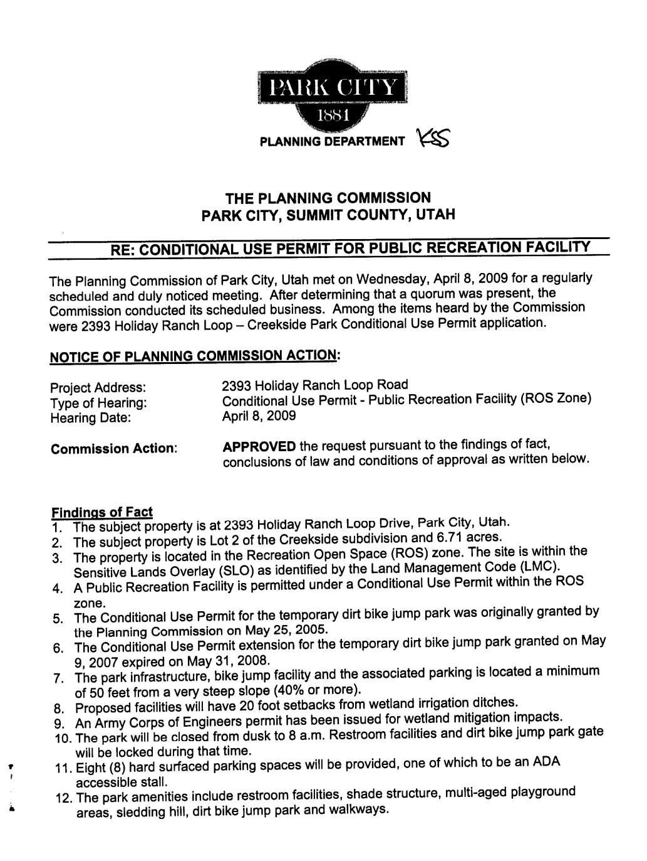

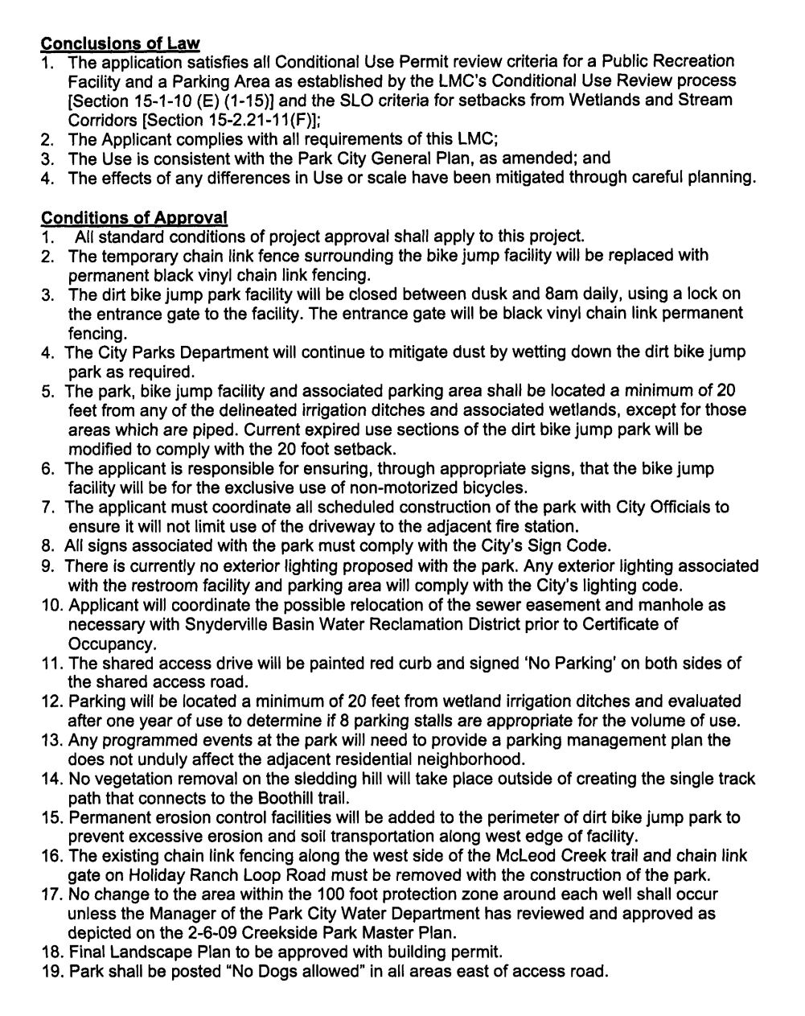

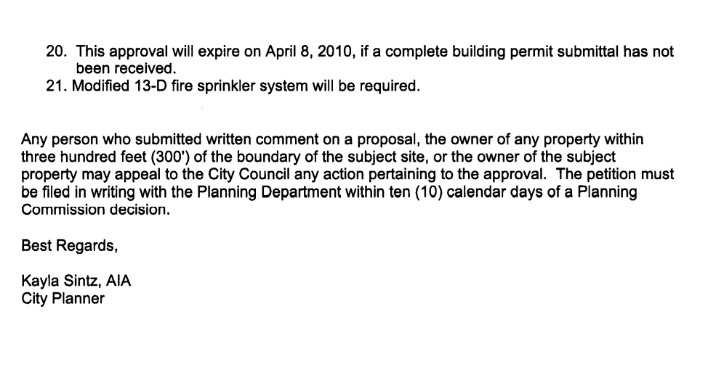

EXHIBIT “B”

CONSTRUCTION AGREEMENT

THIS AGREEMENT is made and entered into as of this ____ day of _____________, 20__, by and between PARK CITY MUNICIPAL CORPORATION, a Utah municipal corporation, P.O. Box 1480, Park City, UT 84060, , (hereinafter “City”), and _______________________________________________, a ________________ (Insert state of incorporation) ______________________ (insert either “corporation” or “limited liability company”), whose post office address is ______________________________________________, (hereinafter “Contractor”).

PURPOSE: For the project known as the (project name) (hereinafter “Project”), which consists of (brief description of work and address).

NOW, THEREFORE, in consideration of the mutual promises contained herein, the parties hereby agree as follows:

SECTION 1. SCOPE OF WORK. Contractor shall furnish all labor, materials and equipment to complete the Project, consisting of the work described in the Information for Bidders as the Basic Bid, and the following additive alternates: _____________ ______________, as specifically set out in the contract specifications, which is made a part hereof by reference, herein called the “Project.”

The Project will be bound by the specifications referenced herein, according to the Advertisement for Bid, the Information for Bidders, the General Project Requirements and Specifications provided by City, the Bid of the Contractor, Bid Bond, Drawings, Notice of Award and Notice to Proceed, (collectively referred to as the “Contract Documents”), all of which are incorporated herein by reference and on file in the ___________ Department. To the extent that this Construction Agreement (hereinafter “Contract” or “Agreement”) conflicts in any way with a proposed form agreement which may have been submitted as part of the bid specifications, this Agreement shall control.

If any of the work performed by Contractor in any phase of the Project does not meet City standards as outlined in the bid documents and specifications, then Contractor shall immediately repair or correct the work at no additional cost to City.

A. SUBCONTRACTORS. No part of this Contract shall be subcontracted by the Contractor without prior written approval by City through the Project Manager/Engineer. The Contractor shall be fully responsible to the City for the acts and omissions of its subcontractors and of persons either directly or indirectly employed by them as it is for the acts and omissions of persons directly employed by it.

If written approval is granted to subcontract a part of this Contract, the Contractor shall require each subcontractor that physically performs services within Utah to submit an affidavit to the Contractor stating that the subcontractor has used E-Verify, or an equivalent program, to verify the employment status of each new employee.

The Contractor shall, within ten (10) days of submittal of request for final payment, include an affidavit showing satisfactory evidence that all claims of subcontractors, laborers and material men who supplied services or materials to the Project have been fully paid, discharged, or waived. The Contractor shall submit lien waivers for each pay release.

If the City reasonably believes that Contractor has failed to pay Subcontractors, materialmen, or laborers for work on the Project within a reasonable time of when payment is due, then City may, after having notified the Contractor, either pay unpaid bills or withhold from the release of Contractor's payment bond for this Project, a sum of money deemed reasonably sufficient to pay any and all such lawful claims until satisfactory evidence is furnished that all liabilities have been fully discharged and a ten percent (10%) fee for administering such claims.

B. STANDARDS OF WORKMANSHIP. Contractor shall demonstrate workmanship equal to or better than current industry standards for this Project. Where Park City specifications exist, (for example, asphalt, concrete, irrigation, sprinkling system and landscaping), they shall provide the benchmark for determination of acceptability.

C. INSPECTION AND TESTING. All materials and equipment used in the construction shall be subject to inspection by the Project Manager/Engineer. If laws, ordinances, rules or regulations of any public authority having jurisdiction require any work to specifically be inspected, tested, or approved by someone other than Project Manager/Engineer, the Contractor shall give the Project Manager/Engineer timely notice of readiness. Inspections, tests or approvals by the City or appropriate authorities will not relieve the Contractor from obligations to perform the work in accordance with the requirements of the Contract Documents and/or provisions. The Project Manager/Engineer and other designated persons will at all times have access to the work. All work shall ultimately be inspected for final acceptance by the Project Manager/Engineer within a reasonable time upon receipt of notice from the Contractor that work is complete and ready for final inspection.

During construction, the work will be inspected and observed by the Project Manager/Engineer or his designated representative. All work that is deficient or does not meet specifications shall be removed and replaced with proper material at Contractor's expense.

D. WARRANTY. Contractor warrants that all materials and supplies used in the construction of the Project shall be new, except as otherwise agreed to in writing by the City's Representative. All materials, equipment, parts and labor and any necessary corrections to the Project shall be guaranteed for a period of at least one (1) year following the date of substantial completion of the Project under the terms of the performance bond or as provided in the project specifications and construction documents, whichever is longer.

E. ADOPTED CODES. All work shall be completed at a minimum in accordance with all building, electric and energy codes adopted by Park City.

SECTION 2. PERFORMANCE AND PAYMENT BONDS. Contractor shall furnish to the City payment and performance bonds satisfactory to the City guaranteeing Contractor's payment and performance, in the amount, for each separately, of one hundred percent (100%) of the Contract amount.

SECTION 3. INSURANCE. Unless otherwise specified in the bid documents, the Contractor shall procure and maintain for the duration of the Agreement, insurance against claims for injuries to persons or damage to property which may arise from or in connection with the performance of the work hereunder by the Contractor, their agents, representatives, employees, or subcontractors.

The Contractor shall provide Park City Municipal Corporation a Certificate of Insurance evidencing:

A. General Liability insurance written on an occurrence basis with limits no less than Two Million Dollars ($2,000,000) combined single limit per occurrence and Three Million Dollars ($3,000,000) aggregate for personal injury, bodily injury and property damage. Coverage shall include but not be limited to blanket contractual; products/completed operations; explosion, collapse and underground (XCU) if specifically requested; and employer's practices.

The Contractor shall increase the limits of such insurance to at least the amount of the Limitation of Judgments described in Section 63G-7-604 of the Governmental Immunity Act of Utah, as calculated by the state risk manager every two years and stated in Utah Admin. Code R37-4-3.

B. Automobile Liability insurance with a combined single limit of not less than Two Million Dollars ($2,000,000) each accident for bodily injury, death of any person, and property damage arising out of the ownership, maintenance, and use of owned, hired, and non-owned motor vehicles. This policy must not contain any exclusion or limitation with respect to loading or unloading of a covered vehicle.

C. Workers Compensation and Employers Liability coverage with Workers Compensation limits complying with statutory requirements, and Employer’s Liability Insurance limits of at least One Million Dollars ($1,000,000) each accident, One Million Dollars ($1,000,000) for bodily injury by accident, and One Million Dollars ($1,000,000) each employee for injury by disease.

The Workers’ Compensation policy shall be endorsed with a waiver of subrogation in favor of Park City Municipal Corporation for all work performed by the Contractor, its employees, agents and subcontractors.

D. Builder’s Risk Insurance (Course of Construction) (at City’s discretion)

Before starting the Work, Contractor shall obtain and maintain in force, at its own expense, Builder’s Risk (Course of Construction) insurance utilizing an “All Risk” (Special Perils) coverage form, with limits equal to the completed value of the project and no coinsurance penalty provisions. Such coverage shall name Park City Municipal Corporation as an additional insured.

- Professional Liability (Errors and Omissions) insurance with annual limits no less than One Million Dollars ($1,000,000) per occurrence. Service Provider agrees to continue to procure and maintain professional liability insurance coverage meeting these requirements for the applicable period of statutory limitation of claims (or statute of repose, if applicable) after the project completion or termination of this Agreement.

If written on a claims-made basis, the Service Provider warrants that the retroactive date applicable to coverage precedes the effective date of this agreement; and that continuous coverage will be maintained for an extended reporting period endorsement (tail coverage) will be purchased for a period of at least three (3) years beginning from the time that work under this agreement is complete.

F. The general liability and auto liability insurance policies are to contain, or be endorsed to contain, the following provisions:

Park City Municipal Corporation, its officers, officials, employees, and volunteers are to be covered as additional insureds on the commercial general liability policy with respect to liability arising out of work or operations and completed operations performed by or on behalf of the Contractor including materials, parts, or equipment furnished in connection with such work or operations and automobiles owned, leased, hired, or borrowed by or on behalf of the Contractor.

G. Should any of the above described policies be cancelled before the
expiration date thereof, notice will be delivered in accordance with the policy provisions. The City reserves the right to request certified copies of any required policies.

H. The Contractor's insurance shall contain a clause stating that coverage shall apply separately to each insured against whom claim is made or suit is brought, except with respect to the limits of the insurer's liability.

I. For any claims related to this Construction Agreement, the Contractor’s insurance coverage shall be primary insurance coverage with respect to Park City Municipal Corporation, its officers, officials, employees, and volunteers. Any insurance or self-insurance maintained by Park City Municipal Corporation, its officers, officials, employees, or volunteers shall be excess of the Contractor’s insurance and shall not contribute with it.

SECTION 4. CONTRACT AMOUNT, ACCEPTANCE OF WHOLE, ADDITIONS. City shall pay Contractor a total sum not to exceed (insert amount, in words) ($ numerically) (“Contract Amount”) for all work and materials expended to complete this Project, which shall include the cost of all bonds, insurance, and all charges, fees, permits (including water and sewer fees, unless waived), expenses or assessments of whatever kind or character that are or may be necessary to complete this Project, including any additive alternates listed within the scope of work described in Section 1.

SECTION 5. PERMITS AND FEES. As set out in Section 4 above, the Contract Amount includes the price of all normally applicable fees and permits. The City may, at its discretion, arrange for the waiver of certain fees, permits and expenses.

SECTION 6. TERMS OF PAYMENT. The City shall pay for services provided hereunder according to and in an aggregate amount not to exceed the Contract Amount or as detailed in an attached payment schedule (if attached, will be Attachment A) and only upon Contractor's request on forms approved by and submitted to the Project Manager. The City shall make payment within thirty (30) days thereafter. Requests for a more rapid payment may be considered if a discount is offered for early payment. At no time shall the aggregate amount of money paid to the Contractor in proportion to the Contract Amount be greater than the proportion of the work performed at that point to the total Project work. No payment shall be made for any service rendered by the Contractor except for services set forth and identified in this Agreement. The City reserves the right to withhold payment in whole or part from the Contractor for non-compliance with the provisions of the Contract Documents.

A. RETAINAGE. The City may, in its sole discretion (1) retain five percent (5%) of the value of all work done and materials or equipment supplied as part security for the fulfillment of the Agreement by the Contractor; or (2) retain the final payment of up to five percent (5%) of the total Project amount. As work nears completion and solely at the City's discretion, the City may reduce the retainage to an amount more in line with the work remaining. The City reserves the right to retain all amounts previously withheld or due, including any liquidated damages, until all services specified herein are complete. Any money withheld pursuant to this section shall be placed in an interest bearing account and the interest shall also be payable to the Contractor upon final payment.

Before final payment is made, the Contractor must submit evidence satisfactory to the City that all payrolls, material bills, subcontracts and all outstanding indebtedness in connection with the Project have been paid for.

The City may withhold a reasonable amount of the payment bond sufficient to cover any outstanding indebtedness or monies owed or claimed by any person who supplied work or materials to the Project plus ten percent (10%) of such indebtedness as the City's cost of administering such claims until Contractor supplies a release satisfactory to the City, signed by all persons who have supplied labor or materials to the Project or, at the City's option if no claim is made, until one hundred five (105) days after the date on which any person performed the last of the labor or supplied the last of the material for the Project and upon written request from the Contractor.

The Contractor shall supply to the Project Manager/Engineer within a reasonable time after his/her request a signed statement verifying all the suppliers, subcontractors, and other persons who have supplied labor or materials to the Project.

B. FINAL PAYMENT. Acceptance by the Contractor of the final payment from the City shall release the City of all claims, demands and liability of the Contractor, its officers, agents, employees and subcontractors, whether communicated or not by the Contractor, except with respect to those matters referred to in writing delivered to the Contractor and approved in a signed writing by the Project Manager.

SECTION 7. COMPLETION TIME. The work on this Project shall commence within ten (10) days of receipt of the Notice to Proceed and shall be completed by <<insert date>>. Work stoppage due to inclement weather conditions and other factors must be approved in writing by the Project Manager. Inclement weather shall not otherwise constitute cause for delay. Unless otherwise agreed by the City by change order, no damages shall become due to Contractor for City caused delay. A change order for delay will generally be accepted for delay so excessive and unreasonable that it is beyond the scope of the Contract or delay attributed to direct, active or willful interference by the City. The change order must be based upon actual damages sustained by the Contractor which are directly attributed to the delay.

In the event that Contractor fails to complete all of the work required herein within the time limit set out above, then for each partial or complete day during which the work remains uncompleted thereafter, the Contractor agrees to pay the City One Hundred Dollars ($100.00), ______ (Contractor Initials) which the parties believe, due to the difficulty of actually assessing the damages the City will suffer in the event of such a delay, is a fair estimate of the loss the City will suffer. The parties agree that the daily liquidated damages provided for herein is reasonable and fair, and is not a penalty. TIME IS OF THE ESSENCE IN THIS AGREEMENT.

SECTION 8. ADDITIONAL WORK/CHANGE ORDERS. The City may enlarge or reduce the work to be performed by Contractor hereunder by written notification to Contractor, including changes to the plans and specifications. The City shall pay Contractor for any additional work so requested, and shall reduce the payment to the Contractor for any reduction in labor, materials, overhead and profit margin resulting from the reduction in the work. Except as the City shall so notify the Contractor in writing, it is understood and agreed by the parties hereto that no money will be paid to the Contractor for any new or additional labor or materials furnished unless a written modification is agreed to in a document signed by both parties.

The value of any work covered by a change order or of any claim for increase or decrease in the Contract price shall be determined by one (1) or more of the following methods in order of precedence listed below:

A. An agreed lump sum; or in the event the parties cannot agree; then

B. The unit rate for the work bid by the Contractor, if applicable, or in the event there was no such rate bid; then

C. The actual cost for: (1) labor; (2) materials; (3) supplies; (4) equipment; (5) direct overhead (not to exceed 5% of the sum total of items 1-4, unless approved by the City); and (6) other services necessary and approved by the City to complete the work. In the event of a net increase in the Contract Amount for a change order as a whole, the City shall allow a payment to the Contractor of an additional ten percent (10%) of the actual cost of the work, not including direct overhead or bond costs, to cover the cost of general overhead and profit. The Contractor may also charge the City for actual cost of the net increase in bond costs as a result of the overall change to the Contract Amount. The City specifically reserves the right to request documentation, including, but not limited to, payroll stubs, bond bills, and invoices, to validate the Contractor’s calculations.

SECTION 9. DISPUTES. Except as otherwise provided in this Agreement, any disputes concerning a question of fact arising under this Agreement which are not disposed of by agreement shall be decided by the City. The decision of the City shall be final and conclusive unless, within thirty (30) days from the date of receipt of such decision, the Contractor shall mail or otherwise furnish the City a written signed appeal addressed to the
Project Manager/Engineer. In connection with any appeal proceeding under this clause, the Contractor will be afforded an opportunity to be heard and to offer evidence in support of its appeal. Pending final decision of a dispute hereunder, the Contractor will proceed diligently with the performance of the Contract and in accordance with the City's decision. The decision of the City shall be final and conclusive, but shall not be arbitrary or unreasonable. Although this Contract has been drafted by the City, the Contractor expressly agrees that any ambiguity herein shall be resolved in favor of the City.

SECTION 10. DEFAULT, REMEDY AND TERMINATION. The City may terminate this Agreement upon the occurrence of one or more of the following events:

A. If Contractor or any subcontractor should substantially violate any of the provisions of this Agreement;

B. If Contractor substantially fails to perform any part of this Agreement;

C. If Contractor repeatedly fails or becomes unable to perform the services under this Agreement as required herein, or substantially fails to provide services under this Agreement for a period of seventy two (72) hours;

D. If Contractor (1) shall become insolvent in a bankruptcy case; (2) shall be generally not paying its debts as they become due, or within a reasonable time thereafter; (3) shall suffer, voluntarily or involuntarily, the entry of an order by any court or governmental authority authorizing the appointment of or appointing of a custodian (as that term is defined in 11 U.S.C. §101(11)), receiver, trustee, or other officer with similar powers with respect to it or any portion of its property which remains undismissed for a period of ninety (90) days; (4) shall suffer, voluntarily or involuntarily, with or without judicial or governmental authorization, any such custodian, receiver, trustee, or other officer with similar powers to take possession of any part of its property which third party remains in possession for an excess of ninety (90) days; (5) shall suffer, voluntarily or involuntarily, the filing of a petition respecting an assignment for the benefit of creditors which is not dismissed for a period of ninety (90) days; (6) shall be dissolved; (7) shall become the subject of any proceeding, suit, or action at law or in equity under or relating to any bankruptcy, reorganization or arrangement of debt, insolvency, readjustment of debt, receivership, liquidation, or dissolution law or statute or amendments thereto to be commenced by or against it or against any of its property which remains undismissed for a period of ninety (90) days; (8) shall voluntarily suspend substantially all of its business operations; (9) shall be merged with, acquired by, or otherwise absorbed by any individual, corporation, or other business entity or organization of any kind except for any individual corporation or other business entity or organization which is controlled by, controlling, or under common control with the Contractor; or (10) shall take action for the purpose of any of the foregoing.

After serving ten (10) days written notice on the Contractor and its surety of its intention to terminate the services of Contractor, and if within ten (10) days after serving such notice, the violation is not corrected to City's reasonable satisfaction, the City then may take over the work and prosecute it to completion by contract or by any other method it may deem advisable at the expense of the Contractor. The Contractor and the bonding company shall be liable to the City for any reasonable cost occasioned by the City in excess of the amount agreed to for the service herein.

The Contractor shall be entitled to a hearing before a City hearing officer upon the issue of termination if it submits a written request therefore within seven (7) days of the service of the notice of the City's intent to terminate. The Contractor shall be entitled to be heard at such hearing on the issue of termination. The Contractor shall not bring an action against the City, its officers, agents or employees arising out of or relating to the termination of this Agreement before the decision is issued by the City's hearing officer(s).

Waiver of any default shall not be deemed to be a waiver of any subsequent default. Waiver of any provision of this Agreement shall not be construed to be modification of the terms of this Agreement, unless stated to be such in writing, signed by the City's authorized representative.

The Contractor shall continue the performance of this Agreement to the extent not terminated under the provisions of this section.

The rights and remedies of the City provided in this clause shall not be exclusive and are in addition to any other rights and remedies provided by law or under this Agreement

SECTION 11. HOLD HARMLESS INDEMNIFICATION. The Contractor clearly and unequivocally agrees to indemnify and to hold the City and its agents, employees, and officers, harmless from and shall process and defend at its own expense any and all claims, demands, suits, at law or equity, actions, penalties, losses, damages, or costs, of whatsoever kind or nature, brought against the City arising out of, in connection with, or incident to the execution of this Agreement and/or the Contractor's performance or failure to perform any aspect of this Agreement; provided, however, that if such claims are caused by or result from the concurrent negligence of the City, its agents, employees, and officers, this indemnity provision shall be valid and enforceable only to the extent of the negligence of the Contractor or others; and provided further, that nothing herein shall require the Contractor to hold harmless or defend the City, its agents, employees and/or officers from any claims arising from the sole negligence of the City, its agents, employees, and/or officers. The Contractor expressly agrees that the indemnification provided herein constitutes the contractor's waiver of immunity under Utah Code Section 34A-2-105 for the purposes of this Agreement. This waiver has been mutually negotiated by the parties. The provisions of this section shall survive the expiration or termination of this Agreement. No liability shall attach to the City by reason of entering into this Agreement except as expressly provided herein.

SECTION 12. CONTROLLING LAW AND ATTORNEY FEES AND COSTS. These general conditions shall be construed in accordance with and enforced under the laws of the State of Utah. Any action of law, suit in equity, or judicial proceeding for the enforcement of the Agreement, or any provisions thereof, shall be instituted and maintained only in any of the courts of competent jurisdiction in Summit County, Utah. If any legal proceeding is brought for the enforcement of this Agreement, or because of a dispute, breach, default, or misrepresentation in connection with any of the provisions of this Agreement, the prevailing party shall be entitled to recover from the other party, in addition to any other relief to which such party may be entitled, reasonable attorney’s fees and other costs incurred in connection with that action or proceeding.

SECTION 13. ASSIGNMENT. The Contractor shall not assign nor transfer any interest in this Agreement without the prior written consent of the City, provided however, that claims for compensation due or to become due the Contractor from the City under this Agreement may be assigned to a bank, trust company, or other financial institution without such approval. Written notice of any such assignment shall be promptly furnished to City.

SECTION 14. SAFETY AND TRAFFIC CONTROL. Contractor shall take all reasonable precautions to protect the safety of pedestrians, school children, motorists, and others who may use or come near to the Project site, including, but not limited to, compliance with the Manual of Uniform Traffic Control Devices.

SECTION 15. SAFETY AND PROTECTION OF THE WORK. Contractor shall be responsible for initiating, maintaining and supervising all safety precautions and programs in connection with the Project work. Contractor shall provide reasonable protection to prevent damage, injury or loss to employees on the Project work and all other persons who may be affected thereby, materials and equipment, whether on or off the site, and other property at the work site or adjacent thereto, including trees, shrubs, lawns, walks, pavements, roadways, structures and utilities not designated for removal, relocation or replacement in the course of construction. In addition, the Contractor shall give all notices and comply with all applicable laws, ordinances, rules, regulations and lawful orders of any public authority bearing on the safety of persons or property or their protection from damage, injury or loss.

The Contractor shall erect and maintain, as required by the existing conditions and progress of the work, all reasonable safeguards for safety and protection, including posting danger signs and other warnings against hazards, setting safety regulations, and notifying owners and user of adjacent utilities.

The Contractor shall promptly remedy all damage or loss to any property referred to in this section caused in whole or in party by the Contractor, any subcontractor, or anyone directly or indirectly employed by any of them, or by anyone for whose acts any of them may be liable and for which the Contractor is responsible, except for acts or omissions by the City or anyone directly or indirectly employed by it, or by anyone for whose acts it may be liable, and not attributable to the fault or negligence of the Contractor. Contractor shall remove from the site all cuttings, debris, equipment and unused material.

SECTION 16. UNENFORCEABLE CONTRACT, WAIVERS. In the event that any provision of this Agreement shall be ruled invalid and unenforceable, the remaining provisions shall be valid and binding upon the parties. One or more waivers by either party of any provision, term, or covenant shall not be construed by the other party as a waiver of a subsequent breach of the same provision by the other party.

SECTION 17. ENTIRE AGREEMENT. This Agreement represents the entire integrated agreement between City and Contractor and supersedes all prior negotiations, representations or agreements, either written or oral. This Agreement may be amended only by written modification signed by both parties.

SECTION 18. COMMENCEMENT OF WORK. Contractor will commence work as required by the specifications within ten (10) calendar days after receiving the Notice To Proceed.

SECTION 19. UTILITIES. The right is reserved to the owners of public utilities and franchises to enter upon the street or work site for the purpose of making repairs or changes of their property that may become necessary by the work. The City shall also have the privilege of entering upon the street or work site for the purpose of repairing culverts, storm drains, water system repairs or adjustments, and any and all other necessary City work.

The Contractor takes the whole risk, responsibility and expense with respect to the location of utilities, and in working with utility owners about locating, moving, repairing, and modifying utilities. All utility locations shown on the plans and specifications are approximate and are marked on the plans, if at all, only for convenience. The City makes no representation about the location of any such utilities, and Contractor is encouraged to contact utility companies and owners about the location of all utilities that may be impacted by or impact the Project work.

SECTION 20. HOURS AND DAYS OF WORK. All work performed by the Contractor, its subcontractors, materialmen, agents and employees shall be performed during work hours of 7:00 a.m. to 9:00 p.m. Monday through Saturday unless otherwise specified in a Conditional Use Permit or Construction Mitigation Plan. In individual Construction Mitigation Plans, the Building Official may further reduce the hours or days of work for special events or as other circumstances may reasonably warrant. When work is prohibited, no exterior construction, excavation or delivery of supplies and concrete are allowed. Interior work, however, may be allowed Monday through Sunday, with no limitation on hours for the following types of construction:

A. Interior work on individual single-family home construction or addition projects not involving materials or supply deliveries.

B. Construction of decks, patios, landscape walls less than four feet (4’) in height, and fences on individual single-family lots.

C. Non-mechanized exterior painting on individual single-family residences.

D. Non-mechanized landscaping on individual single-family residences.

E. Survey work not involving grading or use of power equipment to cut vegetation.

Extended Hours Special Permit. The Building Official may authorize extended hours for construction operations or procedures which, by their nature, require continuous operation, or modify or waive the hours of work on projects in generally isolated areas where the extended hours do not impact upon adjoining property occupants. In such cases, the Building Official shall issue a special permit identifying the extended hours. Contractor shall display the special permit on site.

Special Event Regulations. The Building Official and/or Police Chief may, at their discretion, restrict construction activity, including governmental or special improvement agencies, in order to assure the public safety during special events within the City. Special events shall include, but not be limited to, the Art Festival, Film Festival, ski events, and holiday events.

SECTION 21. CONSTRUCTION ̻ PLANS. Contractor shall submit a Construction Mitigation Plan to be approved by the City Engineer or his/her designee, for all building permits. The Community Development Department may waive this requirement for minor
remodels, additions and interior construction where the impact on adjacent property is minimal. This plan shall be written and shall address, to the satisfaction of the City Engineer or his/her designee:
A. Hours and Days of Operation. The Construction Mitigation Plan shall specify the daily construction start and finish times. Construction activity occurring outside of the times specified in Section 11-14-6 of the Park City Municipal Code may only be allowed by special permit issued by the Building Official or the City Engineer.

B. Parking. The Construction Mitigation Plan shall include a parking plan. Construction vehicle parking may be restricted at construction sites so as to not block reasonable public and safety vehicle access along streets and sidewalks. Construction parking in paid or permit only parking areas require the Public Works Department to review and approve a parking plan. The plan shall also include anticipated temporary parking, e.g., delivery vehicles, and large equipment parking.

C. Deliveries. The Construction Mitigation Plan shall identify proposed delivery locations and routes. Deliveries of construction materials and supplies including concrete may be regulated as to time and routing if such deliveries will cause unreasonable noise, parking, or access issues. In order to reduce the number of delivery trips to construction sites, the stockpiling of materials on or near the site may be required. In the case of multiple construction sites in close proximity, a common materials storage and staging site may be required.

D. Construction Phasing. Due to the narrow streets, small lot configuration, topography, traffic circulation, weather, construction parking and material staging problems, projects in the Historic District and other areas of the City may be required to be phased if more than one project is under construction in close enough proximity to create public safety or nuisance problems. In cases where phasing is deemed necessary by the City Engineer or his/her designee, the first project to receive a building permit shall have priority, however, the Building Official shall have the authority to phase projects as necessary to assure efficient, timely and safe construction.

E. Trash Management and Recycling. Construction sites shall provide adequate storage and a program for trash removal.

F. Control of Dust and Mud on Streets. A program for the control of dust or other airborne debris shall be required. Provision must be made to eliminate the tracking of mud on streets and a program shall be required to remove any such mud daily.

G. Noise. Construction activity shall not exceed the noise standards as specified in Section 6-3-9 of the Park City Municipal Code.

H. Grading and Excavation. Because of the truck hauling involved in grading and excavation, restrictions on trucking routes as well as the hours of operation may be necessary to mitigate the adverse impacts from such operations. Destination and total cubic yards of excavated material shall be noted.

I. Construction Sign Requirements. A sign indicating the name of the party responsible for the Project shall be posted in a location where such sign is readable from the street or driveway to the construction site. The sign shall not exceed twelve (12) square feet in size, six (6’) feet in height and shall not exceed a letter type of four inches (4"). Information on the sign shall include, at a minimum:

1. Name, address and phone number of Contractor;
2. Name, address, and phone number of person responsible for the project; and
3. Phone number of party to call in case of emergency.

No additional fee is required for this sign.

SECTION 22. TOILET FACILITIES AND CONTAINERIZED TRASH SERVICE REQUIRED.

A. The Contractor shall obtain and maintain on the site a container of suitable size and design to hold and confine trash, scraps, and other construction related refuse created or accumulated on the site. All such construction refuse shall be maintained in a closed container at all times, until transferred to the landfill. Containers may be placed in setback areas, provided that the placement of the container does not obstruct the view of motorists on adjoining streets and thereby create traffic hazards. Contractor shall not permit accumulated debris, litter, or trash on the construction site to blow or scatter onto adjoining properties, including the public street, or to accumulate on the site outside of the container, or in transit to the landfill or dump. The owner or Contractor shall service the container as frequently as needed to prevent trash from over-flowing.

- The Project site shall have permanent toilets, or an approved temporary toilet facility positioned in a location approved by the Building Department, at the rate of one toilet per fifteen on-site employees (1-15 employees = one toilet, 16-30 employees= two toilets and so on).

SECTION 23. OBEY LAWS.

A. The Contractor shall obey all laws, ordinances and regulations of the United States, the State of Utah, and Park City in performing this Agreement.

B. The Contractor shall register and participate in E-Verify, or an equivalent program. The Contractor agrees to verify employment eligibility through E- Verify, or an equivalent program, for each new employee that is employed within Utah, unless exempted by Utah Code § 63G-12-302.

SECTION 24. NONDISCRIMINATION.

Any Contractor that enters into an agreement for goods or services with Park City Municipal Corporation or any of its boards, agencies, or departments shall:

- Implement an employment nondiscrimination policy prohibiting discrimination in hiring, discharging, promoting or demoting, matters of compensation, or any other employment related decision or benefit against a person otherwise qualified, because of actual or perceived race; color; sex; pregnancy, childbirth, or pregnancy- related conditions; age, if the individual is 40 years of age or older; religion; national origin; disability; sexual orientation; gender identity; genetic information; or military status.

- In the performance of this Agreement, Contractor shall not discriminate on account of actual or perceived race; color; sex; pregnancy, childbirth, or pregnancy-related conditions; age, if the individual is 40 years of age or older; religion; national origin; disability; sexual orientation; gender identity; genetic information; or military status.

- Incorporate the foregoing provisions in all subcontracts or assignments hereunder and take such actions as may be required to ensure full compliance with the provisions of this policy.

SECTION 25. THIRD PARTY RIGHTS. Nothing herein is intended to confer rights of any kind in any third party. No member, officer, or employee of the City shall have any interest, direct or indirect, in this Agreement or the proceeds thereof.

SECTION 26. PROJECT MANAGER/ENGINEER. The Project Manager/Engineer for this Project is ______________________________, or such other person designated by the City Engineer or Public Works Director to the Contractor orally or in writing.

SECTION 27. PARTIES' REPRESENTATIVES. For purposes of notice required or desired by the parties or communication involving the services under this Agreement, such notice or communication shall be deemed to have been given when personally delivered or mailed certified mail, postage pre-paid, or sent by facsimile transmission, to the parties at the following addresses:

Contractor: _________________________, or such other person designated in writing by the Contractor's chief administrative officer, at the Contractor's address set out first above.
Park City: Project Manager/Engineer, at the address set out first above for the City, or when given to such other person as either of the above representatives shall designate in writing. The designation of any address may be changed by notice given in the same manner as provided in this section.

SECTION 28. SEVERABILITY. Should any part of this Agreement for any reason be declared invalid, such decision shall not affect the validity of any remaining provisions, which remaining provisions shall remain in force and effect as if this Agreement had been executed with the invalid portion thereof eliminated, and it is hereby declared the intention of the parties that they would have executed the remaining portion of this Agreement without including any such part, parts, or portions which may, for any reason, be hereafter declared invalid. If any provision of this Agreement is held invalid or unenforceable with respect to particular circumstances, such provision shall nevertheless remain in full force and effect in all other circumstances.

SECTION 29. COUNTERPARTS. This Agreement may be executed in counterparts, each of which will be deemed an original and all of which together will constitute one and the same instrument.

SECTION 30. ELECTRONIC SIGNATURES. Each party agrees that the signatures of the parties included in this Agreement, whether affixed on an original document manually and later electronically transmitted or whether affixed by an electronic signature through an electronic signature system such as DocuSign, are intended to authenticate this writing and to create a legal and enforceable agreement between the parties hereto.

IN WITNESS WHEREOF, the parties have entered into this Agreement on the day and year set out at the top of this Agreement.

PARK CITY MUNICIPAL
CORPORATION, a Utah municipal corporation

________________________________
Matt Dias, City Manager
ATTEST:

_____________________________
City Recorder’s Office

APPROVED AS TO FORM:

_____________________________
City Attorney’s Office

INSERT CONTRACTOR NAME
Address:
Address:
City, State, Zip:

_____________________________
Utah Contractor License No.

Tax ID#:
_________________________

________________________________
Signature

________________________________
Printed name

________________________________

Title

THE CITY REQUIRES THE CONTRACTOR TO COMPLETE EITHER THE NOTARY BLOCK OR THE UNSWORN DECLARATION, WHICH ARE BELOW.

STATE OF UTAH )
) ss.
COUNTY OF SUMMIT )
On this ____ day of ________________, 20__, personally appeared before me _____________________________, whose identity is personally known to me/or proved to me on the basis of satisfactory evidence and who by me duly sworn/affirmed, did say that he/she is the _________________________ (title or office) of __________________________________, a ___________________________ corporation (or limited liability company), by authority of its Bylaws/Resolution of the Board of Directors (if as to a corporation) or Operating Agreement/Member Resolution (if as to a limited liability company), and acknowledged that he/she signed it voluntarily for its stated purpose as _______________________ (title) for _______________________________, a _______________ corporation (or limited liability company).

__________________________________
Notary Public

I declare under criminal penalty under the law of Utah that the foregoing is true and correct. Signed on the ___ day of __________________________, 20___, at _____________________________________ (insert State and County here).

Printed name _________________________________________

Signature: ____________________________________________

