State of Utah

Community Wildfire
Preparedness Plan
For the Wildland – Urban Interface

Park City
Utah

2021

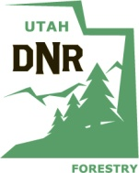
Department of Natural Resources
Division of Forestry, Fire and State Lands
1594 W North Temple, PO Box 145703, Salt Lake City, UT 84114-5703

Page Intentionally Left Blank

Table of Contents
Declaration and Concurrence 5
INTRODUCTION 8
RESOURCES 9
STATEMENT OF LIABILITY 9
PLANNING OVERVIEW 10
PLAN OVERVIEW MAP – Summit County 12
PLAN OVERVIEW MAP – Park City 13
PART I: COMMUNITY DESCRIPTION – Park City 14
Legal Structure 14
Community Partnerships & Collaboration 15
Population Summary 16
Population – Park City 16
Access 17
Roads 18
Driveways 18
Structures 18
Bridges Gates, Culverts 19
Utilities 19
Propane Tanks 20
Primary Water Sources 20
PART II: RISK ASSESSMENT 21
Natural Resources 22
Communities at Risk (CARs) List 23
Fuel Hazard 24
Values Protected 25
Insurance Rating 25
Utah Wildfire Risk Assessment Portal (UWRAP) 26
Total Acres Areas of Interest (AOI) - Summit County 26
Park City Areas of Interest (AOI) 26
PART III: RISK REDUCTION GOALS/ ACTIONS - Park City 28
GOAL A: PREVENTION 28
GOAL B: PREPAREDNESS 29
GOAL C: MITIGATION 32
GOAL D: MAINTENANCE 33
PART IV: CONTACTS 33
Part V: APPENDICES 39
Appendix A: Summit County Pre-Disaster Mitigation Plan Excerpt 39
Appendix B: URWAP Report - Summit County - ALL 39
Appendix C: UWRAP Reports 39
Appendix D: Agency CWPP 39
Appendix E: Community CWPP 39
Appendix G: Park City HOA Contacts 39
Appendix F: UFFSL Communities at Risk List (CARS) - 2016 39

Declaration and Concurrence

Andy Beerman |  | Park City Mayor
Name |  | Affiliation
Signature |  | Date

Matt Dias |  | Park City Manager
Name |  | Affiliation
Signature |  | Date

 |  | Park City Forestry Manager
Name |  | Affiliation
Signature |  | Date

Dave Thacker |  | Park City Chief Fire Code Official
Name |  | Affiliation
Signature |  | Date

Declaration and Concurrence Page, continued

J. M. McComb |  | Park City Emergency Manager
Name |  | Affiliation
Signature |  | Date

Wade Carpenter |  | Park City Police Chief
Name |  | Affiliation
Signature |  | Date

Bryce Boyer |  | Summit County Fire Warden
Name |  | Affiliation
Signature |  | Date

Brant Lucas |  | Park City Fire District
Name |  | Affiliation
Signature |  | Date

Travis Wright |  | Forestry Fire and State Lands WUI Coordinator
Name |  | Affiliation
Signature |  | Date

Bob Kollar |  | Park City Chamber of Commerce/Visitors Bureau
Name |  | Affiliation
Signature |  | Date

Steve Graff |  | Deer Valley Resort
Name |  | Affiliation
Signature |  | Date

Mike Lewis |  | Vail / Park City Mountain Resort
Name |  | Affiliation
Signature |  | Date

Clint McAffee |  | Park City Utilities Director
Name |  | Affiliation
Signature |  | Date

Gretchen Milliken |  | Park City Planning Director
Name |  | Affiliation

INTRODUCTION
Over 600 of Utah’s communities have been classified as “at risk” of wildfire. The safety of the citizens of any community and the protection of private property and community infrastructure is a shared responsibility between the citizens; the owner, developer or association; and the local, County, State and Federal governments. The primary responsibility, however, remains with the local government and the citizen/owner.
The purpose of wildfire preparedness planning is to…
- Motivate and empower local government, communities, and property owners to organize, plan, and take-action on issues impacting the safety and resilience of values at risk
- Enhance levels of fire resilience and protection to the communities and infrastructure
- Identify the threat of wildland fires in the area
- Identify strategies to reduce the risks to structures, infrastructure and commerce in the community during a wildfire
- Identify wildfire hazards, education, and mitigation actions needed to reduce risk
- Transfer practical knowledge through collaboration between stakeholders toward common goals and objectives

Outcomes of wildfire preparedness planning are to…
- Facilitate organization of sustainable efforts to guide planning and implementation of actions:
  - Fire Adapted Communities
  - Resilient Landscapes
  - Safe and Effective Fire Response
- Improve community safety through:
- Coordination and collaboration | - Improved fire response capabilities
- Public awareness and education | - Fire prevention
- Firefighter training | - Development of long-term strategies
- Fuel modification and reduction

RESOURCES
- Local / Primary fire protection provider  - Local Resource, Conservation and Development Districts  - Utah Division of Forestry, Fire and State Lands  - Utah State Fire Marshal (Dept. of Public Safety)  - Utah Division of Emergency Management  - Utah Living With Fire | - Local emergency management services  - USDA Forest Service  - U.S. Department of Interior Agencies  - Utah Resource Conservation Districts  - Utah Soil Conservation Districts  - Local fire agencies

STATEMENT OF LIABILITY
The activities suggested by this template, associated checklists and guidance documents, the assessments and recommendations of fire officials, and the plans and projects outlined by the community wildfire council, are made in good faith according to information available at this time. The Utah Division of Forestry, Fire and State Lands and Park City Municipal Corporation assume no liability and make no guarantees regarding the level of success users of this plan will experience. Wildfire still occurs, despite efforts to prevent it or contain it; the intention of all decisions and actions made under this plan is to reduce the potential for, and the consequences of, wildfire.

PLANNING OVERVIEW
Park City is a municipality located within Summit County, Utah, and is entirely contained within the wildland urban interface (WUI). Every residential and commercial area within Park City limits lies inside the WUI. Most of Park City's jurisdiction is mountainous, especially the south, southwestern, and western boundaries of the City. The wildland ranges from sagebrush foothills to mountain peaks. Decades of drought, fire suppression, and climate change have resulted in a buildup of fuels in these lands, creating a dangerous environment set for catastrophic fire that if it occurred, could destroy thousands of homes, critical infrastructure, and the local economy.
Summit County, in which Park City is mostly housed, is home to the headwaters of four of the five major rivers in Utah (Duchesne, Provo, Weber and Bear), which provide critical drinking and irrigation water to Summit County and communities downstream, such as major population centers in the Salt Lake Valley. Catastrophic wildfire poses a huge risk to the security of these water systems due to contamination from mudslides and debris flows that inevitably occur after a megafire has destroyed the landscape and tree systems in the area.
In an effort to build a fire resilient community and continue participating in the State of Utah’s fire suppression program, Park City has engaged in a planning effort to update its 2013 Community Wildfire Preparedness Plan (CWPP) with the intent of identifying and committing to additional actions in the areas of wildfire mitigation, prevention, and preparedness.
Planning for the City's CWPP update began in early 2020 and involved representatives from the City Council, City Administration, County Fire Warden, City and County Emergency Management, Chief Fire Official and Deputy Chief Fire Official, Forestry Manager and Planning Director, Emergency Management, Park City Fire District , Deer Valley and Vail Resorts, Park City Chamber of Commerce/Visitors Bureau, Historic Park City Alliance, Snyderville Basin Parks and Recreation, Forestry Fire and State Lands, U.S. Forest Service, Mountainlands Regional Water District, Rocky Mountain Power, Dominion Energy, and others. Members of this group met monthly over the course of seven months to discuss goals and actions the City would take in fire mitigation, prevention, and preparedness.
During these meetings, the group examined maps, analyzed fire risk data, studied effective strategies and best practices in mitigation, prevention, and preparedness, and discussed actions that both the City and property owners could take to help make the community more resistant to wildfire.
The intended outcome of this planning effort was to update the City's community wildfire preparedness plan for the City Council to adopt and which would inform City efforts in the areas of wildfire mitigation, prevention and preparedness. Following is the plan resulting from this effort.
The City Council adopted this CWPP on xxxxx 2021 and authorized staff to submit it to the State via the County Fire Warden.
This is a dynamic, working document that will be updated as information changes, progress is made towards the goals outlined in the plan, and the community evolves. Because fires are likely to spread beyond political boundaries, data from Summit County is included in this report.

PLAN OVERVIEW MAP – Summit County
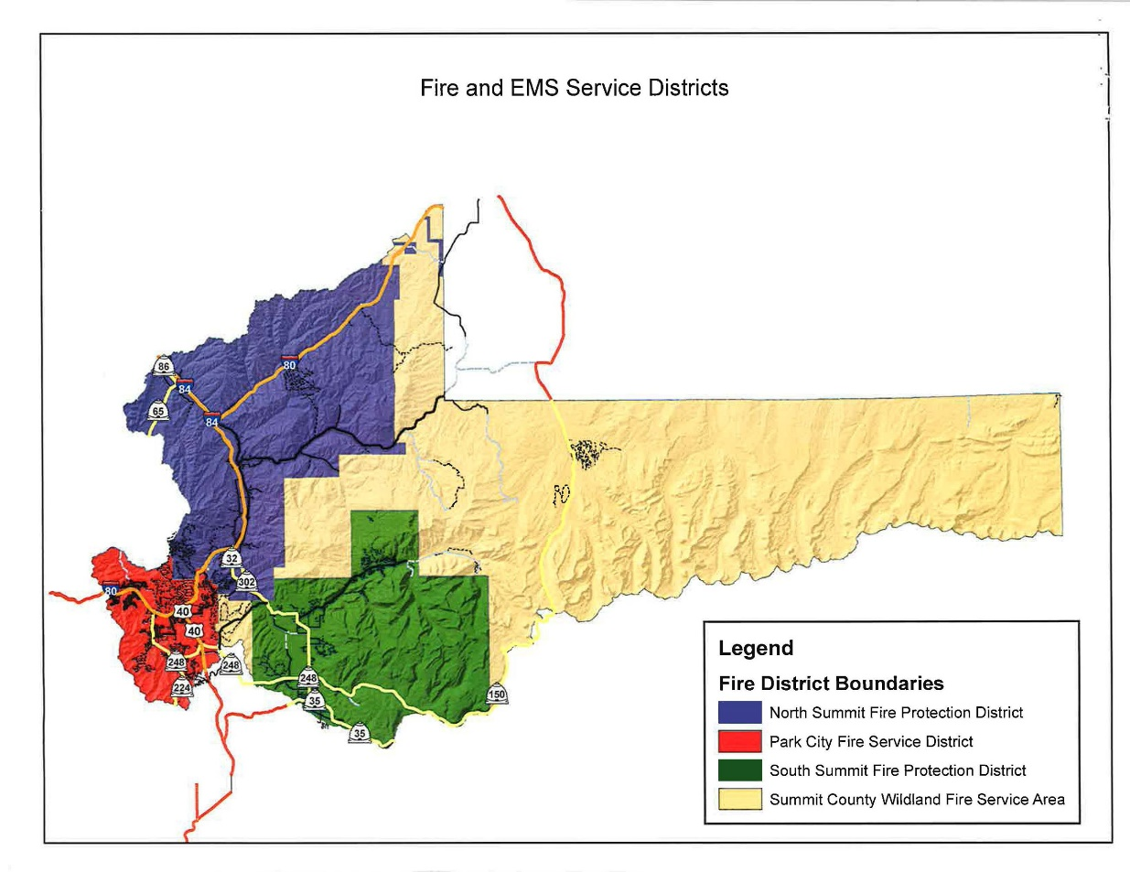

PLAN OVERVIEW MAP – Park City
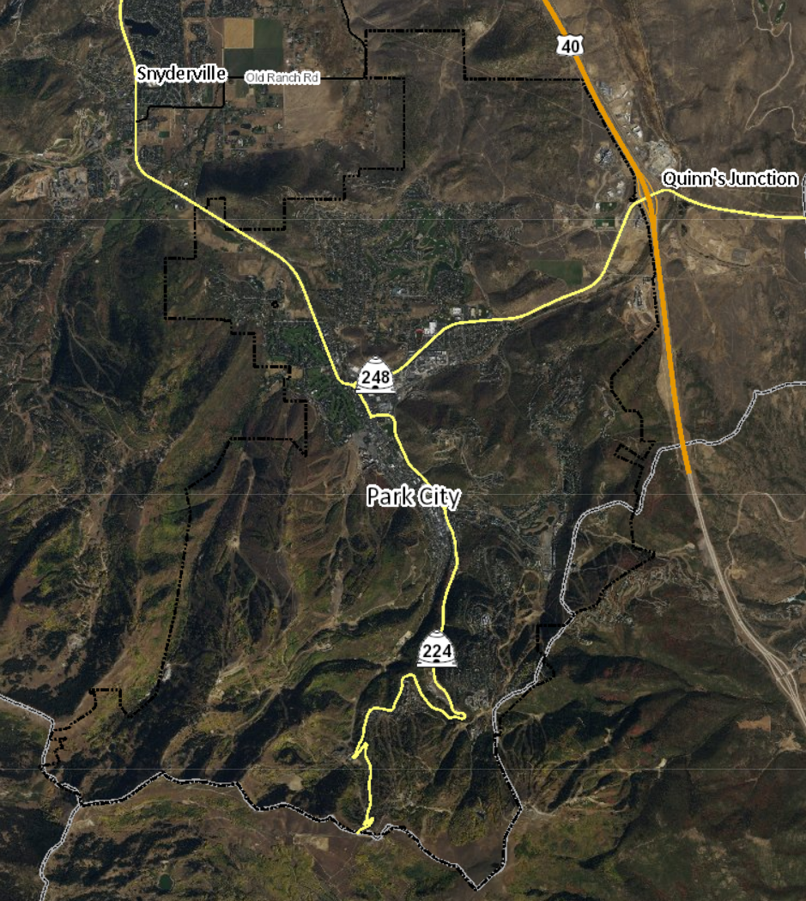

PART I: COMMUNITY DESCRIPTION – Park City

Legal Structure

Organization | Contact Person | E-mail
Park City Council | Andy Beerman  Mayor | andy@parkcity.org
Park City Municipal Corporation | Matt Dias  City Manager | matt.dias@parkcity.org
Park City Police Department | Wade Carpenter  Police Chief | wade.carpenter@parkcity.org
Park City Fire District | Brant Lucas | blucas@pcfd.org
Summit County Fire Warden | Bryce Boyer | bruceboyer@utah.gov
Park City Public Works | Troy Dayley  Director | troy@parkcity.org
Park City Public Utilities | Clint McAffee  Director | clint.mcaffee@parkcity.org
Park City Municipal Athletic and Recreation Center (MARC) | Tate Shaw  Assistant Director | tshaw@parkcity.org
Park City Chief Fire Code Official/Chief Building Official | Dave Thacker | dave.thacker@parkcity.org
Park City School District | Mike Tanner  Chief Operating Officer | mtanner@pcschools.us
Park City Municipal Forestry Manager
Park City Trails, Open Space, & Real Estate | Heinrich Deters | hdeters@parkcity.org
Park City Attorney | Mark Harrington | mark@parkcity.org
Park City Public Information Officer | Linda Jager | linda.jager@parkcity.org
Park City Planning Director | Gretchen Milliken | gretchen.milliken@parkcity.org
Park City Emergency Manager | Mike McComb | mike.mccomb@parkcity.org

Community Partnerships & Collaboration
Community Partnerships & Collaboration
List the government entities associated with the community – city, town, unincorporated community, special service district, homeowner association(s), other.
Organization | Contact Person | E-mail
Park City HOA List
Summit County | Tom Fisher  County Manager | tfisher@summitcounty.org
Summit County Emergency Manager | Kathryn McMullin | kmcmullin@summitcounty.org
Dominion Energy (Questar) | Seth Plaizier | seth.plazier@dominionenergy.com
Rocky Mountain Power | Lisa Romney | Lisa.romney@rockymountainpower.com
Mountain Regional Water Special Service District | Scott Morrison  General Manager | scottm@mtregional.org
Snyderville Basin Special Recreation District, Open Space Management Supervisor | Jessica Kirby | jessica@basinrecreation.org
Department of Natural Resources, Forestry Fire and State Lands WUI Coordinator | Travis Wright | tdwright@utah.gov
Central Utah Water Conservancy District | Gene Shawcraft | www.cuwcd.com
Utah Division of Water Resources | Rachel Shilton | rachelshilton@utah.gov
Snyderville Basin Water Reclamation District | Mike Luers  General Manager | mluers@sbwrd.org
Deer Valley Resort | Steve Graff  Operations Manager | sgraff@deervalley.com
Vail (Park City Mountain Resort) | Mike Lewis  Operations Manager | mlewis@vailresorts.com
Park City Chamber of Commerce/Visitors Bureau | Bob Kollar | bob@visitparkcity.com
Historic Park City Alliance
U.S. Forest Service, Heber and Kamas | Daniel Jauregui | daniel.jauregui@usda.gov

Restricting Covenants, Ordinances

Population Summary

Population – Park City
Approximate number of homes | 3,214 (estimated)
Approximate number of commercial entities | 3,377 (estimated)
Approximate number of full-time residents | 8,526
Approximated number of part-time residents | Fluctuates with season
Notes/comments:
Data in this table identifies dwellings. Of note, by one estimate, more than 67% of Park City dwellings are vacant much of the year. Summit County’s approximated resident population is 42,145 people, making Park City residents approximately 20% of the County's population.

Restricting Covenants, Ordinances, etc.-
For example, home association bylaws may have requirements regarding building construction materials or vegetation removal, or regarding access in a gated community.
Source | Details | Focus area
Municipal Ordinance 2020-35 | Adopts 2006 Utah Wildland Urban Interface Code, updates Municipal Code and Land Management Code. | Park City WUI
Summit County Zoning Map | ArcGIS zoning map | Summit County - All
Summit County Parcel Viewer - GIS | Interactive map of information, data and records. | Summit County - All

Access
Access – Summit County and Park City
Directions to community
Summit County lies on the upper east side of Utah. Its northeast borders follow the south and west borders of the state of Wyoming. Its central and eastern portion consists largely of the east-west oriented Uinta Mountains, while its western portion runs to the east slopes of the north-south oriented Wasatch Mountains. The City's highest point is Jupiter Peak, located on the border with Salt Lake and Wasatch Counties, at 9900' ASL. The City has a total area of 19.99 square miles, almost all of which consists of land. Water sources present within City limits consist of small ponds and streams.

Major public surface roads providing access to Park City:
- US Interstate I-80 | - UT Route SR-248
- US Route US-40/US-189 | - UT Route SR-224/SR-190 Guardsman Pass (seasonal, mountain summit closed in winter)
Summit County ArcGIS Roads Map

All-weather access
Major roads and access routes are generally paved and plowed with exceptions as noted. Non-paved surfaces may not be accessible during winter months or severe storms.
Seasonal access
- SR-224/190 Guardsman Pass MP 17.7 (SR- 190)-0.84 (SR- 224) between Wasatch County, Brighton, and Park City

- UDOT Seasonal Road Closures

Roads
Roads – Park City
 | None | Some | All | Adequate | Inadequate | % Pavement | % gravel | %  dirt
Road signs present |  | X |  | X |  | % | % | %
Will support normal flow of traffic |  |  | X | X |  | % | % | %
Are loop roads |  | X |  | X |  | % | % | %
Are dead-end roads |  | X |  | X |  | % | % | %
Turnaround space available at end of road for emergency equipment |  | X |  | X | X | % | % | %
Notes/comments:
96% of roads are pavement; 2% are gravel; 2% are dirt. Most will support two lanes of traffic (based upon neighborhood and snowfall).

Driveways
Driveways – Park City
 | Adequate | Inadequate | None | Few | Most | All
Most driveways width and height clearance, road grades and vegetation appearance are… | X |  |  |  | X
Individual homeowners have posted their address | X |  |  |  | X
Notes/comments:
Specific concerns regarding grade and slope considerations for driveways in particular.

Structures
Structures – Park City
 | None | Few | Some | Many | Most | All
Wood frame construction |  |  |  |  | X
Have wood decks or porches |  |  |  | X
Have wood, shake or shingle roofs |  |  | X
Are visible from the main subdivision road |  |  |  | X
Notes/comments:
Specific concerns expressed for Deer Valley areas.

Bridges Gates, Culverts

Bridges, Gate, Culverts, other – Park City
 | None | Some | All
Bridges support emergency equipment |  |  | X
Gate provides easy access to emergency equipment |  |  | X
Culverts are easily crossed by emergency equipment |  |  | X
Notes/comments:

Utilities
Utilities – Park City
 | Below ground | Above ground | Provided by | Phone number | % marked with a flag or other highly visible means | % utilized
Water | X |  | Park City Water | 435-649-7324 | % | %
Telephone Service | X | X | All West | 866-255-9378 | % | %
Telephone Service | X | X | Century Link | 855-284-1591 | % | %
Telephone Service | X | X | Xfinity | 800-934-6489 | % | %
Electrical Service | X | X | Rocky Mountain Power | 888-221-7070 | % | %
Are there homes utilizing propane? |  |  | Utah LP Gas  Suburban Propane | 435-336-2147  800-776-7263 | % | %
Are there homes utilizing natural gas? | X |  | Dominion Energy | 800-767-1689 | % | %
Solid Waste & Recycling | NA | NA | Republic Services | 801-924-8500 | % | %
Recycling | NA | NA | Recycle Utah | 435-649-9698 | % | %
Landfill | NA | NA | Summit County | 435-336-5297 | % | %
Notes/comments:

Propane Tanks
List locations of propane tanks above ground – Park City
Owner | Address, lat/long, etc. | Size
Notes/comments:
Not applicable

Primary Water Sources
Primary Water Sources – Park City
Approximate % homes using central water system |  | 100%
Approximate % homes using individual wells |  | 0%
Approximate % homes having additional private water source |  | 00%
Water provided by | Park City Municipal Corporation |  | Phone | 435-615-5335
Notes/comments:

List locations of water sources – Park City
Owner | Address, lat/long, etc. | Accessible
Park City Municipal | Quinn's Junction Water Treatment Plant (Surface water from Weber River / Rockport Reservoir) | N
Park City Municipal | Middle School Well | N
Park City Municipal | Divide Well | N
Park City Municipal | Park Meadows Well | N
Park City Municipal | Thiriot Spring | N
Park City Municipal | Spiro Tunnel | N
Park City Municipal | Municipal Golf Course holding ponds  40.65942584726672, -111.51275616372773 | Y
Vail Resorts | Shadow Lake  40.61655425005351, -111.548042411611 | Y
Vail Resorts | Mid-Mountain Pond (Canyons)  40.646194269414664, -111.54984707728825 | Y
Deer Valley | Basin ponds  40.64313666683746, -111.48022544646922 | Y
Deer Valley | Deer Valley snowmaking reservoir  8803' ASL  40.60883 N 111.48916 W | Y
Park Meadows Country Club | Golf course ponds  40.674954858961144, -111.50391617098366 | Y
Jordanelle Special Service District | Jordanelle Reservoir  40.609963479702046, -111.41637852614078 | Y
Silver Springs | Silver Springs ponds  40.691917544049026, -111.52656582020717 | Y
Notes/comments: Jordanelle Reservoir is located outside City limits, but is the closest large body of water adjacent to City limits. Mid-Mountain Pond at Canyons and Silver Springs ponds are also outside City limits, but are potential water sources. Note that firefighting helicopters may be restricted from crossing active public highways while carrying water, so resources may be needed to close those roads.

PART II: RISK ASSESSMENT
Estimated Values at Risk
Estimated / assessed current market values of residential and commercial property in the area - Park City
Estimated market values at risk of commercial and residential property. Source: Summit County Tax Assessor | $ 11,637,579,052
Year | 2020

Natural Resources
Natural Resources at Risk
Describe the natural resources at risk in the area, such as watershed, forest products, wildlife, recreation tourism, etc.
Park City lies in the southwest corner of Summit County, Utah, with City limits bordering Salt Lake County to the west and Wasatch County to the south. Some 1,300 acres of City property, designated as open space, are located within Wasatch County.

Forests/Parks/Ski Resorts/Protected Areas
- Deer Valley Resort  - Park City Mountain Resort  - Round Valley  - McPolin Farm and surrounding area | - Wasatch National Forest  - Bonanza Flats  - Treasure Hill
Rivers/Creeks/Streams
- City Creek | - McLeod Creek
- Poison Creek

Ponds/Lakes/Reservoirs within City limits
- Deer Valley basin ponds
- Park City Municipal Golf Course pond
- Park Meadows Country Club golf course ponds
- Aspen Springs Drive pond
- Shadow Lake

Communities at Risk (CARs) List
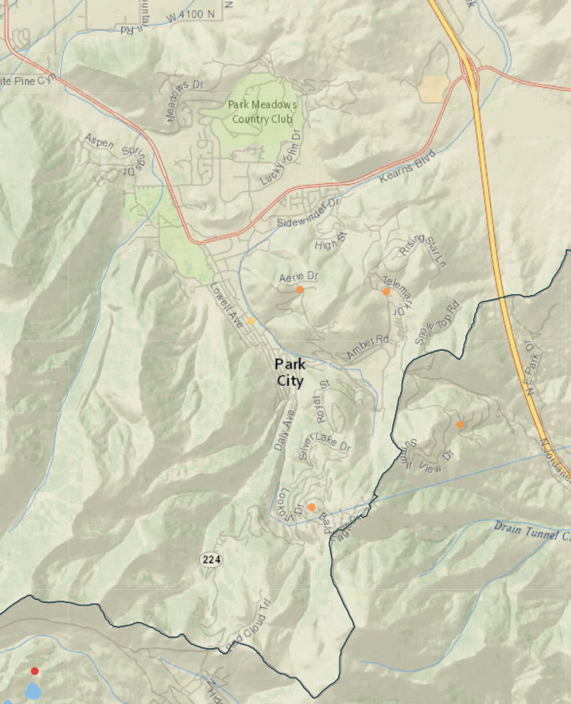
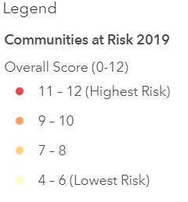
The following information is based on the Communities at Risk (CARs) list (Appendix F) that was developed cooperatively at the local and state level to assist land management agencies and other stakeholders in determining the scope of the WUI challenge and to monitor progress in mitigating the hazards in these areas. This information is updated annually through the interagency fuel groups.

2019 Communities at Risk Excerpt for Park City/adjacent communities
Community Name | Fire Occurrence | Fuels Hazards | Values Protected | Fire Protection Capability | Overall Score | Notes
Aerie | 2 | 3 | 3 | 2 | 10 | Within City limits
Deer Valley | 2 | 3 | 3 | 2 | 10 | Within City limits
Park City | 1 | 3 | 3 | 1 | 8
Solamere | 2 | 3 | 3 | 2 | 10 | Within City limits
Cloud Rim | 2 | 3 | 3 | 3 | 11 | Adjacent to Bonanza Flats
Deer Crest | 2 | 3 | 3 | 2 | 10 | Adjacent to Park City limits

Fire Occurrence: Number of fires in the area for the last 10 years __2010____ to __2020____
 | 0 | No Risk
 | 1 | Moderate | 0 to 1 fire/township
X | 2 | High | 2 to 14 fires/township (does not include small fires)
 | 3 | Extreme | Greater than 14 fires/township
Area Fire History
Year | Area | Ignition source | Acres burned
2010 | Aerie | Human
2012 | Fox Bay | Human | 600
2013 | Rockport | Lightning | 5,000+
2017 | Dollar Ridge | Lightning | 100,000+
2019 | Mirror Lake | Human
2019 | Deer Creek | Human
2020 | Saddle | Human-Intentional | 600
2020 | Wallsburg | Human
2020 | Canyon | Human
2020 | Fire Canyon | Human

Fuel Hazard
Fuel Hazard: Assess the fuel conditions of the landscape and surrounding the community
 | 0 | No Risk
 | 1 | Moderate | Moderate to low to control, fire intensities would generally cause moderate damage to resources based on slope, wind speed and fuel. Vegetation Types: Ponderosa pine/mountain shrub, grassland, alpine, dry meadow, desert grassland, Ponderosa pine, Aspen and mountain riparian.
 | 2 | High | High resistance to control, high to moderate intensity resulting in high to moderate damage to resources depending on slope, rate of spread, wind speed and fuel loading. Vegetation Type: Maple, mountain shrubs, sagebrush, sagebrush/perennial grass, salt desert scrub, Black Brush, Creosote and Greasewood.
X | 3 | Extreme | High resistance to control, extreme intensity level resulting in almost complete combustion of vegetation and possible damage to soils and seed sources depending on slopes, wind speed, rate of spread and fuel loading.

Values Protected
Values Protected: Evaluate the human and economic values associated with the community or landscape, such as homes, businesses and community infrastructure.
 | 0 | No Risk
 | 1 | Moderate | Secondary Development: This would be seasonal or secondary housing and recreational facilities.
 | 2 | High | Primary Development: This would include primary residential housing, commercial and business areas.
X | 3 | Extreme | Community infrastructure and community support: This would be water systems, utilities, transportation systems, critical care facilities, schools, manufacturing and industrial sites. It may also include valuable commercial timber stands, municipal watersheds and areas of high historical, cultural and/or spiritual significance which support and/or are critical to the well-being of the community.

Insurance Rating

Insurance Rating
Provide the current insurance rating for the community
ISO Fire Insurance Rating: | 3

Protection Capabilities: Insurance Services Organization (ISO) rating for the community will serve as an overall indicator of the protection capabilities.
X | 1 | Moderate | ISO Rating of 6 or lower
 | 2 | High | ISO Rating 7 to 9
 | 3 | Extreme | ISO Rating 10
Fire  Occurrence | Fuel  Hazard | Values  Protected | Fire Protection  Capabilities | Overall  Rating
2 | 3 | 3 | 1 | 9
Total: 4-7 Moderate, 8-11 High, 12 Extreme |  |  |  | High

Utah Wildfire Risk Assessment Portal (UWRAP)

The following information is based on the Utah Wildfire Risk Assessment Portal (UWRAP) and Area of Interest (AOI) Summary Reporting Tool. Reports are generated using a set of predefined map products developed by the West Wide Wildfire Risk Assessment (2012) project. The UWRAP provides a consistent, comparable set of scientific results to be used as a foundation for wildfire mitigation and prevention planning in Utah.
Wildland Development Area (WUI) Impacts: Data set is derived using a Response Function modeling approach. To calculate the Wildland Development Area Impact Response Function Score, the Wildland Development Area housing density data was combined with flame length data and Response Functions assignments to represent potential impacts.
Wildfire Threat: A number that is closely related to the likelihood of an acre burning.
Wildfire Risk: Combines the likelihood of a fire occurring (Threat), with those of areas of most concern that are adversely impacted by fire (Fire Effects). Wildfire Threat Index is derived from historical fire occurrence, landscape characteristics including surface fuels and canopy fuels, percentile weather derived from historical weather observations and terrain conditions. Fire Effects are comprised of Value Impacts and Suppression Difficulty.

Total Acres Areas of Interest (AOI) - Summit County

 | Total Acres AOI for each Category with the percentage added
 | Wildfire Risk |  | WUI Impacts |  | Wildfire Threat
Low (1-4) | 970,868 | 80.60% | 31,788 | 70.80% | 1,023,899 | 85.00%
Moderate (5-7) | 208,944 | 17.40% | 9,931 | 22.20% | 168,745 | 14.00%
High (8-10) | 24,030 | 1.90% | 3187 | 7% | 11,198 | 0.90%
Total Acres | 1,203,842 |  | 44,906 |  | 1,203,842

Park City Areas of Interest (AOI)
Eight AOIs within Park City limits were developed using the UWRAP summary risk tool. These areas, with approximate acreage, include:

- Prospector - Quinn's (1,483 acres)
- Deer Valley - Empire (2,309 acres)
- Solamere (1,125 acres)
- Park Meadows (1,632 acres)
- Old Town - PCMR (3,558 acres)
- Round Valley (2,200 acres)
- Thaynes (827 acres)

The associated risk summaries for these areas are included in Appendix C.

Past Accomplishments
Prevention | - Park City Fire District Fire Prevention Open Houses, Emergency Preparedness Fairs  - Annual fire prevention/preparedness mailer  - 2019 Wildfire Panel Discussion - 'Era of Megafires' video  - Public event attendance – flyer distribution at markets, HOA meetings  - Coordinated with Leadership Park City Class 25 on public outreach and education, resulting in a 3-minute PSA video and community resource guide informing property owners about the wildfire risk and importance of hardening their homes and creating defensible space to create a fire resilient community.
Preparedness | - Park City Fire District wildfire training/certifications - including Local IMT/Response Team - Type III Incident  - Emergency Manager wildland firefighting training  - Evacuation plan development
Mitigation | - PCFD chipping program  - Defensible space/fuel break programs
Response | - Implemented integrated public alert and warning system/emergency alert system throughout City and County  - Addition of dedicated wildfire station in Summit Park  - Addition of wildland apparatus
Maintenance | - Fuel break maintenance/Trail work

PART III: RISK REDUCTION GOALS/ ACTIONS - Park City

Goals of Plan: This plan is intended to increase the number and area of resilient landscapes, promote fire-adapted communities, and improve wildfire response, supporting Prevention, Preparedness, Mitigation and Maintenance goals. These align with the pillars of the National Cohesive Strategy and the Utah Catastrophic Wildfire Reduction Strategy (1.Resilient Landscapes 2. Fire Adapted Communities 3. Wildfire Response).

Identification of Actions:

GOAL A: PREVENTION – Activities directed at reducing the occurrence of fires, including public education, law enforcement, and personal contact.

Goal A.1 – Public Outreach
Action(s): | Timeline: | Community Lead: | Priority: | Focus Area
- Encourage community wildfire prevention programs and planning committees | 2021-2023 | City, Agency | 1 | All
- Public presentations & workshops | 2019- | City, County, Agency | 1 | Preparedness
- Wildfire information & updates @ Summit County website | 2019- | Summit County | 1 | All
- Wildfire/WUI information @ BeReadyParkCity.org website | Ongoing | City | 1 | All
- Lot assessment (Survey 123) | 2019-2022 | Summit County | 3 | Planning
- Adopt WUI ordinances and building codes (see note) | 2019-2020 | City | 1 | Planning
- Expand chipper program | 2019-2022 | Park City Fire District | 1 | Mitigation
- Community/HOA rules & covenants review | 2021-2025 | Community | 2 | Preparedness
- Emergency mass notification system campaign | Ongoing | City | 1 | Response
- Summer wildfire preparedness mailer | Annual | City | 2 | Preparedness
Notes, updates ,and monitoring
In 2020, the Planning Department proposed revisions to the Municipal Code including the adoption of the 2006 Utah Wildland Urban Interface Code, as amended; implementing Wildland Urban Interface standards; and adding Firewise designations to the Title 14-1-5 plant list; revisions to the Land Management Code defining Defensible Space and Firewise Landscapes/Landscaping; and implementing Wildland Urban Interface standards for the Sensitive Lands Overlay, Annexations, and Master Planned Developments. Council unanimously passed Ordinance 2020-35 on July 9, 2020.

GOAL B: PREPAREDNESS – Activities that lead to a state of response readiness to contain the effects of wildfire to minimize loss of life, injury, and damage to property. Including access to home/community, combustibility of homes/structures and creating survivable space.
Goal B.1 – Evaluate, upgrade and maintain community wildfire preparation
Action(s): | Timeline: | Community Lead: | Priority: | Focus Area
- CWPP development | 2020-2021 | City | 1 | Planning
- Response agency & personnel requirements & training | Ongoing | City, Agency | 1 | Planning
- Increase response agency depth | Ongoing | Park City Fire Department, City, County | 1 | Preparedness
- PPE, communications & response equipment | Ongoing | Agency, City, County | 1 | Response
- Evacuation routes & plans | 2020-2021 | City | 1 | Planning
- Home hardening & defensible space | Ongoing | Community | 1 | Planning
- Lot assessment (Survey 123) | Ongoing | Agency | 3 | Planning
- Lot assessments – PSA to help homeowners do their own (Survey 123) | Ongoing | Park City Fire District, Fire Warden | 3 | Planning
Notes, updates ,and monitoring

Goal B.2 – Educate community members to prepare for and respond to wildfire.
Action(s): | Timeline: | Community Lead: | Priority: | Focus Area
- Wildfire education campaign/website | Ongoing | City, County | 1 | Preparedness
- Public outreach displays/marketing/ mailers | Ongoing - annual | City | 1 | Preparedness
- Preparedness fairs & public meetings | 2019-2025 | City, Fire Warden, Park City Fire District, EM | 2 | Preparedness
- Firewise USA certification | 2020-2022 | City | 2 | Planning, Preparedness
- Home hardening & defensible space | Ongoing | City, Community | 1 | Mitigation
- Ready, Set, Go Program | 2019-2022 | Fire Warden, City, Agency | 2 | Planning
- CERT | 2021-2022 | Summit County | 2 | Preparedness
Notes, updates ,and monitoring

Goal B.3 – Address identified regulative issues impacting community wildfire prevention and response needs.
Action(s): | Timeline: | Community Lead: | Priority: | Focus Area
- Adopt WUI ordinances and building codes (see note) | 2019-2020 | City | 1 | Planning
- Community/HOA rules & covenants review | 2019-2022 | Community | 2 | Preparedness
- Evaluate landscaping plans/requirements (see note) | Ongoing | City | 2 | Planning
- Fire resilient revegetation (see note) | 2019-2022 | City, County | 2 | Mitigation
- Burning programs, notifications & regulations | Ongoing | Summit County | 1 | Mitigation
- Bio-char pilot program | 2021- | City | 3 | Mitigation
Notes, updates ,and monitoring

In 2020, the Planning Department proposed revisions to the Municipal Code including the adoption of the 2006 Utah Wildland Urban Interface Code, as amended; implementing Wildland Urban Interface standards; and adding Firewise designations to the Title 14-1-5 plant list; revisions to the Land Management Code defining Defensible Space and Firewise Landscapes/Landscaping; and implementing Wildland Urban Interface standards for the Sensitive Lands Overlay, Annexations, and Master Planned Developments. Council unanimously passed Ordinance 2020-35 on July 9, 2020.

Goal B.4 – Evaluate response personnel, facilities and equipment.
Action(s): | Timeline: | Community Lead: | Priority: | Focus Area
- Personnel, training & qualifications | Ongoing | Park City Fire District | 1 | Response
- Equipment requirements & maintenance | Ongoing | Park City Fire District | 1 | Response
- Facilities evaluations & improvements | Ongoing | Park City Fire District | 1 | Response
- Finance & funding | Ongoing | City | 1 | Planning
- Local IMT/Response Team - Type III incident | Ongoing | Park City Fire District | 2 | Response

GOAL C: MITIGATION – Actions that are implemented to reduce or eliminate risks to persons, property or natural resources including fuel treatments and reduction.
Goal C.1 – Decrease fuels within the community to reduce wildfire impact in and around the community.
Action(s): | Timeline: | Community Lead: | Priority: | Focus Area
- Fuels Reduction Committee | 2021- | City | 1 | Mitigation
- Evaluate City-owned lands, fuel breaks, reductions | Ongoing | City | 2 | Planning
- Chipper program (FEMA grant) | 2020-2022 | Park City Fire District, Summit County | 1 | Mitigation
- Recreation/trails – open space – fuel breaks | Ongoing | City | 1 | Mitigation
- CatFire grant | 2019-2022 | Summit County | 1 | Mitigation
- Pre-Disaster Mitigation grants | 2019-2022 | Summit County | 1 | Mitigation
- WRI Utah grant – revegetation, reductions | 2019-2022 | Summit County | 1 | Mitigation
- Pre-wildfire/fuel reduction treatments to reduce debris flow impacting Weber River | Ongoing | Community (Mountain Regional, Park City Municipal Water, USU, other stakeholders) | 1 | Mitigation
Notes, updates ,and monitoring

Goal C.2 – Work with local, state and federal fire officials to decrease fuels on private and adjacent public lands to reduce wildfire intensity and impact in and around the community.
Action(s): | Timeline: | Community Lead: | Priority: | Focus Area
- Public outreach programs | 2019-2022 | City | 1 | Preparedness
- Fuels reduction programs | 2019-2022 | City, County | 1 | Mitigation
Notes, updates ,and monitoring

GOAL D: MAINTENANCE – the process of preserving actions that have occurred including fuel treatments and reduction.
Goal D.1 - Regularly evaluate, update and maintain project commitments.
Action(s): | Timeline: | Community Lead: | Priority: | Focus Area
- CWPP | 2020-2021 | City | 1 | Mitigation
- Trails & open space work | Ongoing | City | 1 | Mitigation
- Funding & match requirements | Ongoing | City | 1 | Mitigation
Notes and updates

PART IV: CONTACTS

Planning Committee Member List
Name | Affiliation |  |  |  | E-mail
Bob Kollar | Chamber of Commerce/Visitors Bureau |  |  |  | bob@visitparkcity.com
Steve Graff | Deer Valley Resort |  |  |  | sgraff@deervalley.com
Seth Plaizier | Dominion Energy |  |  |  | seth.plaizier@dominionenergy.com
Travis Wright | Forestry Fire & State Lands WUI Coordinator |  |  |  | tdwright@utah.gov
Alison Kuhlow | Historic Park City Alliance |  |  |  | alison@historicparkcity.com
Scott Morrison | Mountain Regional Water |  |  |  | scottm@mtregional.org
Steve Joyce | Park City Council |  |  |  | steve.joyce@parkcity.org
Brant Lucas | Park City Fire District |  |  |  | blucas@pcfd.org
Lisa Romney | Rocky Mountain Power |  |  |  | lisa.romney@rockymountainpower-pacificpower.net
Jessica Kirby | Snyderville Basin Special Recreation District |  |  |  | jessica@basinrecreation.org
Kathryn McMullin | Summit County Emergency Manager |  |  |  | kmcmullin@summitcounty.org
Daniel Jaregui | U.S. Forest Service |  |  |  | daniel.jauregui@usda.gov
Mike Lewis | Vail Resorts |  |  |  | mlewis@vailresorts.com
Nicole Caito | Vail Resorts |  |  |  | nlcaito@vailresorts.com
Planning Committee Member List (Cont.)
Name | Affiliation |  |  |  | E-mail
Dave Thacker | Park City Municipal Corporation Chief Fire Code Official |  |  |  | dave.thacker@parkcity.org
Mark Harrington | Park City Municipal Corporation City Attorney |  |  |  | mark@parkcity,org
Tricia Lake | Park City Municipal Corporation City Attorney's Office |  |  |  | tricia.lake@parkcity.org
Margaret Plane | Park City Municipal Corporation City Attorney's Office / Special Counsel |  |  |  | margaret.plane@parkcity.org
Lynn Ware Peek | Park City Municipal Corporation Community Engagement |  |  |  | lynn.ware-peek@parkcity.org
Linda Jager | Park City Municipal Corporation Community Engagement Director |  |  |  | linda.jager@parkcity.org
Matt Dias | Park City Municipal Corporation City Manager |  |  |  | matt.dias@parkcity.org
David Everitt | Park City Municipal Corporation Deputy City Manager |  |  |  | david.everitt@parkcity.org
Sarah Pearce | Park City Municipal Corporation Deputy City Manager |  |  |  | sarah.pearce@parkcity.org
Cherie Wellmon | Park City Municipal Corporation Building Department/Fire Inspector |  |  |  | cherie.wellmon@parkcity.org
Brittney Buchanan | Park City Municipal Corporation Planning Department |  |  |  | brittney.buchanan@parkcity.org
Elizabeth Jackson | Park City Municipal Corporation Planning Department |  |  |  | Lizjackson073@gmail.com
Gretchen Milliken | Park City Municipal Corporation Planning Department Director |  |  |  | gretchen.milliken@parkcity.org
Rebecca Ward | Park City Municipal Corporation Planning Department |  |  |  | rebecca.ward@parkcity.org
Bruce Erickson | Park City Municipal Corporation Planning Director / Forestry Manager
Clint McAffee | Park City Municipal Corporation Public Utilities Director |  |  |  | clint.mcaffee@parkcity.org
Tate Shaw | Park City Municipal Corporation Recreation Department Assistant Director |  |  |  | tate.shaw@parkcity.org
Logan Jones | Park City Municipal Corporation Trails, Open Space, and Real Estate |  |  |  | logan.jones@parkcity.org
Heinrich Deters | Park City Municipal Corporation Trails, Open Space, and Real Estate Director |  |  |  | heinrich.deters@parkcity.org
Chief Wade Carpenter | Park City Police Department |  |  |  | wade.carpenter@parkcity.org
Lt. Vai Lealaitafea | Park City Police Department |  |  |  | vaifoa.lealaitafea@parkcity.org
Madison Sinisley | Park City Police Department |  |  |  | madison.sinisley@parkcity.org
Mike McComb | Park City Municipal Corporation Emergency Manager |  |  |  | mike.mccomb@parkcity.org
Formal Associations
Organization |  | Contact Person | Phone Number | E-mail or Website
Park City Chamber of Commerce/Convention & Visitors Bureau |  | Jennifer Wesselhoff | 435-658-9617 | jennifer@visitparkcity.com
Historic Park City Alliance |  | HPCA | 435-658-9612 | info@historicparkcityutah.com
Park City Board of Realtors |  | Jamie Johnson Hoppe | 435-649-4112 | jamie@parkcityrealtors.com
LDS Stakes (Jeremy, Park City) |  | Park City Stake | 435-649-0725 | https://parkcityutahstake.org/
St. Mary’s Catholic Church |  |  | 435-649-9676 | info@stmarysparkcity.com  http://www.stmarysparkcity.com/
Mountain Life Church |  | Pastor Steve | 435-647-5855 | https://mountainlife.org/
St. Lukes Episcopal Church |  | Pastor Charles Robinson | 435-649-4900 | pastor@stlukespc.org https://www.stlukesparkcity.org/
Temple Har Shalom |  | Deb Sheldon  Executive Director | 435-649-2276 | https://www.harshalomparkcity.org/
Christian Center of Park City |  | Max Ventura  Rob Harter | 435-649-2260 | max@ccofpc.org  rob@ccofpc.org  https://www.ccofpc.org/
Capital Church Park City |  | Leif Oines leif@capitalchurch.com | 435-631-9877 | https://www.capitalchurch.com/
Park City Area Lodging Association |  |  | 435-647-0055 | info@pcala.org
Lodging Association and Park City Area Restaurant Association |  | Ginger Wick | 435-640-1168 | pcrestaurants@gmail.com  gingerwicks@icloud.com
Nuzzles & Co.  (Previously Friends of Animals) Lindsay Ortega |  | Lindsay Ortega | 801-598-9895 | Lindsay@nuzzlesandco.org
Recycle Utah |  | Carolyn Wawra, Director  Troy Holding, Operations Manager  troy@recycleutah.org  801-599-2466 | 435-649-9698 | director@recycleutah.org
Park City Rotary |  | Corrie Forsling (2021) |  | www.parkcityrotary.org
Sunrise Rotary |  | Scott Peppler (2021) | 801-864-2643 | scottpeppler@gmail.com  president@parkcitysunriserotary.org
Community Emergency Response Team (CERT) |  | Kathryn McMullin, SCEM | 435-640-0510 | kmcmullin@summitcounty.org
Snyderville Basin Special Recreation District, Open Space Management Supervisor |  | Jessica Kirby | 435-649-1564 | jessica@basinrecreation.org
Local Emergency Planning Committee (LEPC) |  | Kathryn McMullin, SCEM | 435-940-2508 | kmcmullin@summitcounty.org

Commercial Entities
Organization | Contact | Phone Number | E-mail
Deer Valley Resort | Steve Graff  Director of Mountain Operations |  |  | 435-645-6904 |  | sgraff@deervalley.com
Park City Mountain Resort | Mike Lewis, Director of Operations |  |  | 801-301-1500 |  | mlewis@vailresorts.com
Woodward Park City |  |  |  | 435-658-2648 |  | info@woodwardparkcity.com
Utah Olympic Park | Colin Hilton |  |  | 435-658-4227 |  | colin@utaholympiclegacy.com
Historic Park City Alliance | Allison Kuhlow  435-640-3188 |  |  | 435-658-9612
Swaner Nature Preserve | Nell Larson Executive Director  Nell.Larson@usu.edu 435-797-8941 |  |  | 435-252-3575
Park City Outlets | Heather Nash  General Manager  Heather.nash@outletsparkcity.com  801-232-8560  Tom Daughetee  Operations Manager  Tom.daughetee@outletsparkcity.com  307-679-1609 |  |  | 435-645-7078 |  | Outlets Park City | Park City, UT
Quarry Village | David Nadler  Owner  631-418-5437  Paul Piper  Property Manager  435-659-8289 |  |  | 435-200-0023
National Ability Center | Katie Hobert  Vice President of Operations  katieh@discovernac.org  435-649-3991 Ex. 622 |  |  | 435-649-3991 |  | info@discoverNAC.org
Canyons Village Management Association (CVMA) | John Simmons, Planning & Operations Manager |  |  | 435-655-2581  Main Office: 435-655-2580 |  | jsimmons@cvma.com
Media Support
Organization |  | Contact Person | Phone Number |  | E-mail
KPCW Radio |  | Rick Brough | 435-649-9004 |  | Kpcw.org
Park Record |  | Scott Iwasaki | 435-649-9014 |  | Parkrecord.com
Park City TV |  | Danielle Turner | 435-649-0045 |  | danielle@parkcity.tv
Summit County Health Department Public Information Officer |  | Derek Siddoway | 435-333-1503 |  | dsiddoway@summitcounty.org
Summit County Sheriff’s Office  Public Information Officer |  | Andrew Wright | 435-615-3600 |  | awright@summitcounty.org
Park City Municipal Community Engagement / Public Information Officer |  | Linda Jager | 435-615-5191 |  | linda.jager@parkcity.org
Park City Fire District Public Information Officer |  | Tricia Hazelrigg | 435-565-1744 |  | thazelrigg@pcfd.org

Schools
School | Contact Person | Phone Number | E-mail | Address
Park City School District | Jill Gildea, Superintendent | 435-645-5600 | Pcschools.ut | 2700 Kearns Blvd  Park City, UT 84060
Park City HS | Roger Arabi, Principal | 435-645-5600 x2005 |  | 1750 Kearns Blvd  Park City, UT 84060
Treasure Mountain Junior High | Caleb Fine, Principal | 435-645-5600 x3205 |  | 2530 Kearns Blvd  Park City, UT 84060
McPolin ES | Bob Edmiston, Principal | 435-645-5600 x4205 |  | 2270 Kearns Blvd  Park City, UT 84060
Jeremy Ranch ES | Shawn Kuennen, Principal | 435-645-5600 x4005 |  | 3050 Rasmussen Rd, Park City, UT 84098
Trailside ES | Caroly Synan, Principal | 435-645-5600 x4605 |  | 5700 Trailside Dr  Park City, UT 84098
Ecker Hill MS | Amy Jenkins, Principal | 435-645-5600 x3005 |  | 2465 West Kilby Rd, Park City, UT 84098
Parleys Park ES | Bob Edmiston, Principal | 435-645-5600 x4405 |  | 4600 Silver Springs Drive  Park City, UT 84098
Weilenmann Discovery | Jo Jones  Front Office Manager  435-757-5411 | 435-575-5411 | jojones@wsdpc.org  info@wsdpc.org | 4199 Kilby Road  Park City, UT 84098
Park City Day School | Jennifer Kanzler  Officer Manager  435-640-2149 | 435-649-2791 | jkanzler@parkcitydayschool.org | 3120 Pinebrook Road, Park City, UT 84098
Winter Sports School | Megan Altman  Director of Operations | 435-649-8760 Ex.1001 | www.wintersportsschool.org  maltman@wintersportsschool.org | 4251 Shadow Mountain Dr, Park City, UT 84098
Montessori School | Bruce King  Owner/Manager | 435-649-3626 | bruce@soaringwings.org | 1580 Old Ranch Road  Park City, UT 84098
PC Tots |  | 435-731-8860 | pctots.org | 1850 Sidewinder Dr Suite 410, Park City, UT 84060

Transportation
Organization | Contact Person | Phone Number | E-mail
Summit County Transportation | Caroline Rodriguez | 435-336-3113 | crodriguez@summitcounty.org
Park City Municipal Corporation Transit | Kim Fjelsted | (435) 615-5360 | kim.fjelsted@parkcity.org

MOU/Private Equipment Capabilities
Type of Equipment | Contact Person | Phone Number | E-mail | Address
Earth-moving equipment, generators, saws, trailers, etc. | Diamond Rental & Tools | (435) 645-7840 | store13@diamondrental.com | 6450 Silver Creek Drive, Park City
Earth-moving equipment, dump trucks | Geneva Rock Prod. Inc. | (435) 649-3033 | N/A | 4219 E Atkinson Rd., Heber City
Bulldozers, loaders, snow removal equipment, snowcats | Deer Valley Resort | (435) 513-2787 | admin@deervalley.com | 2250 Deer Valley Dr. South, Park City
Bulldozers, loaders, snow removal equipment, snowcats | Park City Mtn. Resort | (801) 301-1500 | PCMRinfo@pcmr.com | 1345 Lowell Avenue, Park City

Part V: APPENDICES

Appendix A: Summit County Pre-Disaster Mitigation Plan Excerpt

Appendix B: UWRAP Report - Summit County - ALL

Appendix C: UWRAP Reports

Appendix D: Agency CWPP
- CWPP - Park City Fire District

Appendix E: Community CWPP

Appendix F: Park City HOA Contacts
- Park City HOA List

Appendix G: UFFSL Communities at Risk List (CARS) - 2019

