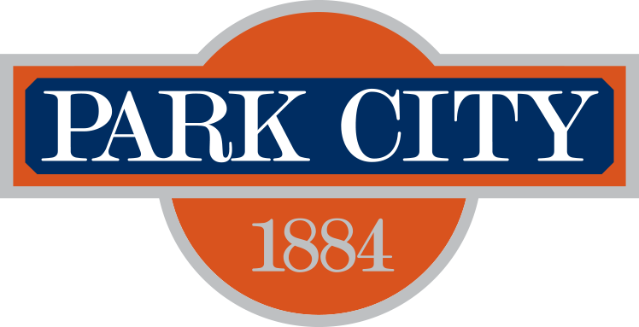 Park City Municipal Seeks a consultant to
Prepare Scope for a Downtown Trash RFP. 6.21.19

The City entered into a contract with Allied Waste in 2013 to address trash in the commercial district around Main Street aka Business Improvement District (BID) (exhibit A). That contract expires in November 30, 2019.

The consultant is expected to coordinate meetings with Park City Staff, the staff and members of the Historic Park City Alliance, and ultimately to City Council to finalize scope for an RFP to secure waste provider for solid waste, recycling and food waste for the downtown BID. The scope and outcome of the RFP should result in a five year contract with options to renew between the service provider(s) and Park City Municipal

The following scope should be completed by September 1, 2019. Please provide a price (not to exceed) for:

- Determine current capacity, project 10-year waste growth for the Main Street BID.
- Determine PCMC and HPCA’s Goals for Trash and Recycling
- Solicit input from merchants regarding permanent bins for recycling, food waste collection and ultimate sustainability goals for the district. Coordinate with HPCA Trash and Recycling Committee.
- Review trash capacity during significant events and analyze cost recovery process.
- Review Allied Waste cost recovery spreadsheet.
- Suggest strategies to implement and approaches to fund diversion programs including recycling and food waste. Estimate additional cost savings if solid waste is decreased. Consider footprint, space limitations, and other logistical issues for additional containers for diverting waste.
- Facilitate conversations with Summit County with assistance from PCMC and merchants.
- Draft Trash and Recycling Plan, including strategies
- Draft Main Street BID Trash and Recycling RFP, for consideration and approval by City Staff and Council.

PROPOSALS DUE:
4:00 p.m., June 27th, 2019
Via email to: Jonathan Weidenhamer, Economic Development Manager:
jweidenhamer@parkcity.org. Any questions should be submitted via email to the same address
no later than June 25, 2019 at 5:00 pm. The subject line of any question should be labeled, “TRASH!”.

Exhibit 1 Current Trash Contract
Exhibit 2 City Contract

Park City reserves the right to reject any or all proposals received. Furthermore, the City shall have the right to waive any informality or technicality in proposals received when in the best interest of the City.

The following criteria are mandatory will be the basis for consideration:

- 5 years minimum experience working with or for local government, or explanation of experience substitute.
- 2 years minimum experience working with or for a non profit in a leadership staff or board position.
- Experience in solid waste.

