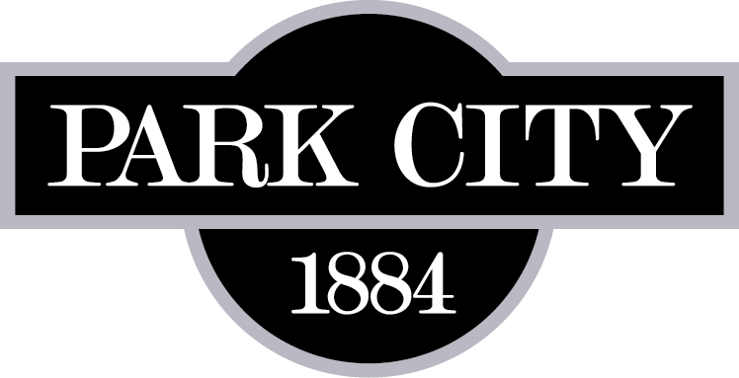

PROJECT NAME: SLURRY SEAL TYPE II,
HIGH DENSITY MINERAL BOND FOR BIKE PATHS,
ROTOMILLING, OVERLAYS, UTILITY ADJUSTMENTS,
AND CRACK SEALS
2019
Park City, Utah

ADDENDUM NUMBER ONE
April 9, 2019

ITEM #1: SCHEDULE B: HIGH DENSITY MINERAL BOND FOR BIKE PATHS 2019

Page 6 of the bid document references the use of HIGH DENSITY MINERAL BOND FOR BIKE PATHS 2019. In compliance with APWA SPEC 32 01 13.68 1. Mineral aggregate and asphalt binder slurry spread as a high density mineral bond seal coat over a bike path surface.

Park City requests that all bidders use Tuffcoat as the product to be applied in SCHEDULE B: TUFFCOAT for the Seal Coating of Bike Paths.

Authorized Signature Date

Print Name ________________________________

Title ________________________________

Company ________________________________

Please fax a confirmation to Park City Municipal Corporation at 435-615-9055.

