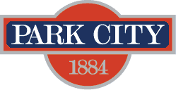

Public Art Advisory Board (PAAB) Vacancy
Notice Date: Friday, September 27, 2018

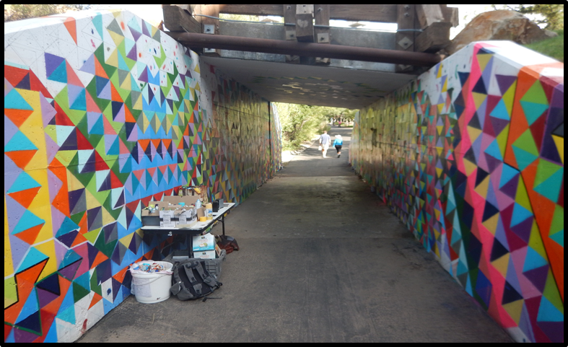
Poison Creek Tunnel Mural, 2015

The Mayor and City Council are looking for one community member to serve on the Park City Public Art Advisory Board (PAAB) to fulfill a vacant term ending in June of 2019.

Those interested in applying must reside within the city limits of Park City. Board members serve three-year terms, and may serve no more than two consecutive terms. The Board meets on the second Monday of every month at 5:00 p.m. at City Hall in the Marsac Executive Conference Room. Board members are not compensated and serve as representatives of the citizens of Park City.

PAAB makes recommendations to City Council regarding Public Art planning, expenditures and maintains the City’s public art inventory. The seven-member board focuses on project identification, requests for proposals, selection process (including reviewing artists’ proposals for each project), and making recommendations to City Council.

The Public Art Advisory Board page on the city’s website includes links to the Strategic Plan, Public Art Master Plan, and Policies documents.

An interview schedule will be sent out after the application deadline. Interviews are anticipated to be scheduled at the City Council meeting on Thursday, October 5. The selected candidate will begin their term at the November 13th meeting.

The application is available on the City’s website. Application deadline is 5:00 p.m. on Sunday, August 12, 2018. Applications may be submitted by email to minda.stockdale@parkcity.org or in person to Minda Stockdale, Executive Office, Park City Municipal Corporation/City Hall, 445 Marsac Avenue – 3rd Floor, PO Box 1480, Park City UT 84060.For questions, please contact Minda Stockdale at minda.stockdale@parkcity.org / 435.615.5186.

