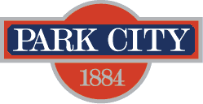

AGENDA
Park City Municipal Forestry Advisory Board
Thursday, January 4, 2024
10 am
Marsac East Conference Room

Board Member Attendance
Present:
Excused:
Absent:

Purpose & Product: To study, investigate, counsel, formulate, develop and/or update, and administer a Community Forestry Plan ("Forestry Plan") for the care, preservation, pruning, planting, replanting, removal or disposition of trees and shrubs in parks, along streets, and in other public places.

Working & Input

New Business:
- 4807 Legacy Ct
City property defensible space assessments
Ongoing:
- Forestry Plan RFP Discussion
- Municipal Code Update
- Board Member Updates/Roundtable

Next Meeting: Thursday, February 1, 2024, 1000-1100, Marsac East Conference Room

