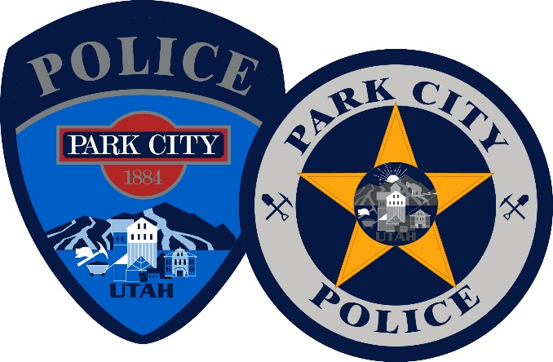
To: The Trust Building Campaign Team February 13, 2023
Re: IACP Trust Initiative Pledge

The Park City Police Department is proud of its extensive efforts and initiatives to maintain a safe and welcoming community consistent with Park City’s core values.
Public safety officers are tasked with protecting the public and their position is held to high standards of integrity. Officers who engage in lawful policing practices are essential to protect our residents, businesses, and visitors. The Park City Police Department remains committed to providing a safe and welcoming community while also supporting equality, justice, transparency, and officer accountability.
The Park City Police Department regularly reviews its policies and procedures to ensure they are up to date with best practices. From being the first department in Utah to equip all officers with body cameras to our forward-thinking community outreach programs, the Park City Police Department strives to achieve the highest standards of integrity and accountability.
The Park City Police Department wants to share its efforts regarding ongoing Policing initiatives aimed at accountability, high officer skillsets, and community engagement. The information is presented in the following main areas: Training, Policy, Transparency, Recruitment and Retention, Victim Services, Community Outreach and Leadership.

Training
Each year officers are required by the State to receive a minimum of 40 training hours. These training hours include 16 hours of required training set forth by the Utah State Legislature which include: mental health, crisis intervention responses, arrest control, de-escalation training an autism awareness. Our department also requires officers to train on defensive tactics, Taser, firearms, emergency vehicle operations and First Aid/CPR. In addition to the annual training requirement, Park City Police Department arranges for additional department-wide trainings each year to continue building officer skills and provide ongoing development, including: Domestic Violence Response, Active Shooter Response, Implicit Bias, Street Smart De-escalation, and Crisis Intervention Training. Park City Police Department aims to give officers skills to de-escalate incidents where possible and appropriately respond in dangerous situations to most effectively save lives. Additionally, we are proud of our work in conjunction with the One Mind Campaign , which seeks to ensure successful interactions between law enforcement and individuals with mental health conditions.

Policy
To ensure department policies are in accordance with best practices, since 2010 Park City Police Department has contracted with Lexipol, the industry standard for providing constitutionally sound online policies and training to over 8,000 public safety agencies. Lexipol’s attorneys continuously review their policy recommendations to ensure they meet state and federal statutory requirements. Park City Legal team also reviews all Park City Police Department policies.

Transparency
The Police Department has posted our policy manual online. In support of transparency and accountability, Park City Police Department established an internal Use of Force Board several years ago where officers discuss specific incidents and provide recommendations for training and potential disciplinary actions for their peers. Park City Police Department has also had a Police Complaint Review Committee in place since 2003. This is a citizen advisory committee that reviews and responds to complaints regarding police personnel.
Additionally, for the last two years Park City Police Department has undergone a review by the Utah Law Enforcement Professional Standards Accreditation Program. The accreditation process allowed for the department to further develop and implement policies and procedures that are conceptually sound, operationally effective, and in line with Utah law and local ordinances. Park City Police Department also achieved accreditation under the direction of the Utah Chiefs of Police Association in February 2021.

Recruitment and Retention
The Park City Police Department is strongly supported by our City Council which has publicly and consistently prioritized our officer’s compensation. This greatly assists our department in not only attracting the best officers in the state of Utah, but also retaining quality people. Each candidate is thoroughly tested to verify they are capable of fulfilling the duties of the job, but also to ensure they are a cultural fit with the rest of the department.

Victim Services
Our department is staffed with a full-time Victim Advocate coordinator who has extensive experience in assisting victims. The Victim Advocate helps coordinate programs and volunteers to assist with support and outreach to people who desperately need these critical resources. The Victim Advocate also works in an on-call capacity and can be readily available on short notice for crucial or time-sensitive situations.

Community Outreach
The Park City Police Department is constantly creating and actively engaging in community outreach efforts with an emphasis on obtaining diverse perspectives including: Cada Domingo/KPCW Interviews, Victim Advocacy Program, Shop with a Cop, Neighborhood Watch Program, Citizen’s Academy, Latino Citizen’s Academy, Camp Safety, Spanish Driver’s License Course, Explorer Program, School Watch Dog Program and HOA Outreach.

Leadership
Park City Police Department makes every effort to be an exemplary role model and leader in good policing practices through actively participating in the Utah Chiefs of Police Association and the International Association of Chiefs of Police. Inter-local coordination is prioritized with surrounding jurisdictions and recently demonstrated when Park City provided support to Salt Lake City during protests. In May 2020, the Department was featured in a Body-Worn Camera Site Spotlight by the Body-Worn Camera Training and Technical Assistance Program. We have had a Body Worn Camera program continuously since 2013.

The Police Department is honored to have these achievements recognized by Federal Government body camera grant funding, the Utah Chiefs of Police Association Award (2017), the Patrick J Flemming Award for Excellence in Public Service (2017), and the Covid-19 Response Appreciation Award from the University of Utah (2020).
While the department is confident in this community policing model, we also continue to seek new policing policies and remain willing to listen, learn and grow to maintain alignment with Park City’s core values and maintain the best interests of the community.
We are also currently meeting with communities of color, in coordination with the IACP Trust Initiative, to better understand issues and perspectives pertinent to those communities. Our goal is to best protect and serve all distinctive populations within the Park City community, and we are working to better accomplish this objective through additional collaborative efforts with the community.

Sincerely,
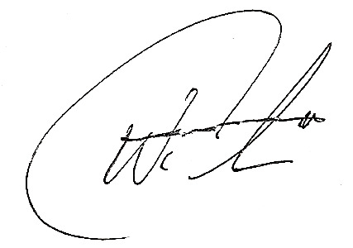
Chief Wade Carpenter
Park City Police Department

