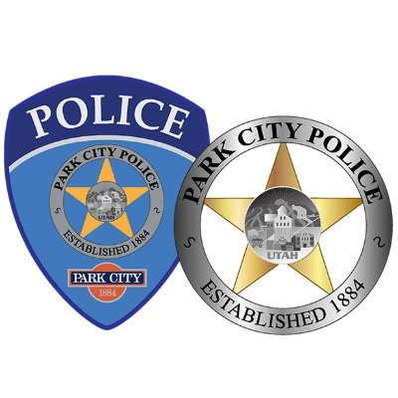

Email us anytime at pcparking@parkcity.org

For after hours parking concerns between 10pm and 8am call Park City Police Summit County Dispatch (non-emergency)

**435-615-3607**

For general parking questions and requests between 8am and 5pm call our Office

**435-615-5301**

For general parking questions and patrol requests between 5pm and 10pm call

***or text!*** an on-duty Parking Officer

**435-640-6906**

Know Who to Call and When!