ADDENDUMS WILL BE POSTED ON THE WEBSITE.
IT IS THE RESPONSIBILITY OF THE CONTRACTOR TO REGULARLY CHECK THE WEBSITE FOR ANY NEW ADDITIONS.

REQUEST FOR PROPOSALS
2021 JANITORIAL CLEANING SERVICES

OWNER
PARK CITY MUNICIPAL CORPORATION
PUBLIC WORKS
PO BOX 1480
PARK CITY, UTAH 84060

PARK CITY MUNICIPAL CORPORATION
REQUEST FOR PROPOSALS

JANITORIAL CLEANING SERVICES

PROPOSALS DUE: By 1:00 p.m., Friday, November 19, 2021
Public Works Department (East Building)
1053 Iron Horse Drive, Park City, UT 84060
Attn: Mike Lennon

PROJECT NAME: Janitorial Cleaning Services

RFP AVAILABLE: 2:00 p.m., Friday, November 5, 2021, at www.parkcity.org

MANDATORY PRE- 8:00 a.m., Tuesday, November 16, 2021
SUBMISSION Public Works Department (East Building)
MEETING AND 1053 Iron Horse Drive, Park City, UT 84060
WALK-THROUGH This meeting is mandatory for all contractors.

PROJECT LOCATION: Twenty-three (23) municipal spaces located
throughout Park City, Utah.

PROJECT Qualified contractors will submit a proposal to provide
DESCRIPTION: janitorial services for twenty-three (23) Park City municipal spaces.

PROJECT TERM: The term of the agreement shall be for three (3)
years, with the City’s sole option to renew for an additional two (2) years.

OWNER: Park City Municipal Corporation
P.O. Box 1480
Park City, UT 84060

PROJECT MANAGER All questions must be submitted in writing
/CONTACT: by 12:00 p.m., Thursday, November 18, 2021, to the attention of:
Michael Lennon
Building Maintenance Supervisor
1053 Iron Horse Drive
Park City, Utah 84060
(435) 615-4909 fax
mlennon@parkcity.org

PCMC reserves the right to reject any or all proposals received for any reason. Furthermore, the City shall have the right to waive any informality or technicality in proposals received when in the best interest of the City.

In the absence of the project manager, proposals should be dropped off to the City Recorder, located at 445 Marsac Avenue, Third Floor – Executive Department, Park City, UT 84060.

GENERAL INFORMATION

Introduction

Park City Municipal Corporation (“PCMC or the “City”) is soliciting proposals for janitorial cleaning services at twenty-three (23) PCMC municipal spaces.

Purpose of Project

Park City is a resort community, serving both residents and visitors, and host of numerous annual special events. PCMC is seeking qualified janitorial service providers to provide daily cleaning services at the twenty-three (23) City municipal spaces, as well as supplementary janitorial services during special events, when City facilities see higher than normal usage. We consider our facilities to be the “Jewels of the City” and take great pride in the appearance of our buildings. First impressions are important, and we expect our facilities to shine. Attention to detail, quality control, dependability, and a commitment to upholding City standards are paramount.

Scope of Project

A detailed Scope of Services is provided in Exhibits A, B, C, D, and E, attached hereto and made a part hereof. The term of this agreement shall be for three (3) years, with the City’s sole option to renew for an additional two (2) years.

PCMC will agree to:

  - Provide a project manager to oversee the contract and to act as a City contact.
  - Provide information to the selected contractor, as needed, for contractor to meet the obligations set forth in the RFP in a timely and satisfactory manner.
  - Cover the cost of finger printing and criminal background checks for all contracted personnel. (Minor misdemeanors are acceptable [i.e., traffic violation, etc.]).
  - Provide notification to the contractor of the results of personnel background checks.
  - Supply contractor with approved cleaning chemicals, mop handles, mop buckets, brooms, dustpans, duster handles, paper products, soap, trash can liners, floor machine, and debris blower as needed.
  - Supply the contractor with building alarm codes, keys, and room access key cards, where applicable.
  - Supply Photo ID badges for all janitorial cleaning personnel.
  - Provide advance notice to the contractor if the terms of the agreement have/will change (i.e., period of cleaning services, special events, etc.).
  - Provide contractor with an email address for submitting daily reports and reporting building damage and other non-emergencies.

Contractor will be required to:

- Attend a mandatory walk-through presentation of each city facility with the Building
Maintenance Supervisor to be held at 8:00 AM on Tuesday, November 16, 2021, starting at the Public Works Department (East Building), 1053 Iron Horse Drive, Park City, UT 84060.
- Enter into PCMC’s Standard Service Provider Agreement in a form approved by the City Attorney (a copy of which is attached hereto as Exhibit “F” and incorporated herein).
- Participate in current criminal and sex offender background checks and fingerprints for all contracted personnel.
- Wear standardized company uniform and city issued ID badges at all times when cleaning any PCMC building.
- Check-in at the front desk prior to cleaning the Police Building.
- Provide all cleaning services during business hours, except where designated differently in the attached Scope of Services.
- Provide an on-call 24 hour/7 days-per-week phone number that Building Maintenance can call for emergencies, as well as for additional cleaning needs.
- Provide daily and weekly reports to the Project Manager of all janitorial services completed via Building Maintenance’s designated email. The location and start/stop times of cleaning shall be included on the report. Daily reports should include updates on chemical and paper supply status at each location (example: Paper towels are low). For weekly reports, the period starts on Monday and ends on Sunday, and reports are due Mondays by 10:00 AM.
- Be responsible for reporting any broken fixtures, building damages, leaks, excessive graffiti, or other items needing attention or repair to the Building Maintenance Department. Water leaks and emergencies shall be communicated by calling the Building Maintenance On-Call phone line. All other non-urgent items should be communicated via email.

Proposal Content/Selection Criteria

Proposals will be evaluated on the criteria listed below. Proposals shall be limited to two hundred (200) pages.

  - The variety of services to be offered and the cost to be charged to the City.
  - The ability of the contractor to provide all cleaning services during business hours, except when designated differently in the Scope of Service.
  - The demonstrated professional experience of the contractor, including any prior experience with the City.
  - The demonstrated financial responsibility and business viability of the contractor.
  - The general attitude, ability, and apparent willingness of the contractor to cooperate and fulfill the City’s requirements.
  - Overall content of proposal.
  - Past customer service history.
  - Acceptance of the terms contained in PCMC’s Service Provider Agreement, including insurance requirements.
  - Estimated budget of cleaning equipment.
  - Estimated emergency response time(s) and costs thereof.
  - Ability to meet cleaning needs of facilities during Special Events.
  - Ability of staff to pass current criminal and sex offender background checks. (Minor misdemeanors are acceptable [i.e., traffic violation, etc.]).

Proposals must include, but are not limited to the following:

- A detailed statement of the number of staff, cleaning hours and the services and programs the contractor intends to provide for each building. Statements should include the type of cleaning to be provided, as well as deep cleaning services to be provided weekly, monthly, quarterly, and annually. Statement should include the ability of contractor to supply staff for special events and for any additional cleaning services outside the agreed upon hours/duties for a specific location.
- The cost to be charged for said services and programs, submitted on Payment Schedules via Exhibits A, B, C, D, and E. Costs should include hourly rates for: Normal hours, After hours, Holidays, Special Events, Emergency Calls, and Additional Cleaning Services outside the agreed upon hours/duties for a specific location.
- A detailed list of all labor, equipment, and any overhead costs involved, such as 24-hour emergency response, communication devices, facility management software, insurance, secretarial and vehicle costs.
- A detailed description on how your company would improve our Scope of Services.
- List of guaranteed emergency response time(s) for all of the twenty-three (23) spaces.
- A detailed “Statement of Business Experience” to include the following:
  - The contractor’s prior experience in the operation of a business that provides janitorial cleaning services.
  - Total years of professional cleaning experience.
  - A detailed Financial Statement for the past two (2) years.
  - List of at least three (3) references from clients who have received similar services, as listed in the Scope of Services, from the contractor.
- Copy of the Certificate of Worker’s Compensation Insurance, Park City Business License, certificate of liability insurance naming PCMC as additional insured and with limits required in Park City’s Provider Service Agreement, and any other license that may be required.
- Any other elements that the submitter would recommend, and the costs to be charged for each.

PCMC reserves the right to reject any and all proposals for any reason. Proposals lacking required information will not be considered. All submittals shall be public records in accordance with government records regulations (“GRAMA”) unless otherwise designated by the applicant pursuant to UCA §63G-2-309, as amended. The award of contract is subject to approval by City Council.

Price may not be the sole deciding factor.

Selection Process

Proposals will be evaluated on the factors listed in Section IV., Proposal Content/Selection Criteria, listed above.

The following schedule is anticipated for awarding of this project. PCMC reserves the right to change any dates or deadlines related to the submittal process. If a change occurs, information will be posted at parkcity.org and all recipients of this downloadable RFP document will be notified.

- RFP will be advertised for two (2) weeks in The Deseret News (November 5 and November 12) and The Park Record (November 6 and November 13).
- A mandatory pre-submission meeting and facility walk-through will be held at 8:00 AM on Tuesday, November 16, 2021, at the Public Works Department (East Building), 1053 Iron Horse Drive, Park City, UT 84060.
- Proposals will be received by Park City by 1:00 PM on Friday, November 19, 2021, at the front desk of the Public Works Department (East Building), 1053 Iron Horse Drive, Park City, Utah 84060.
- A selection committee comprised of Mike Lennon, Sara Rush-Mabry, Troy Dayley, Malena Stevens, and Tate Shaw will review all submissions and conduct interviews between November 22-26, 2021.
- It is anticipated that City Council will vote to approve the contract for the chosen proposal on Thursday, December 16, 2021.

Park City Municipal Standard Service Provider/Professional Services Agreement
  - The successful proposal will be required to enter into PCMC’s standard Service Provider/Professional Services Agreement, in its current form, with the City. A draft of the agreement is attached to this RFP as Exhibit “F” and incorporated herein.

  - ANY INQUIRIES RELATED TO INDEMNIFICATION OR INSURANCE PROVISIONS CONTAINED IN PARK CITY MUNICIPAL CORPORATION’S STANDARD AGREEMENT MUST BE SUBMITTED TO PARK CITY MUNICIPAL CORPORATION NO LATER THAN THE PROPOSAL/SUBMITTAL DEADLINE. PARK CITY MAY, IN ITS SOLE DISCRETION, CONSIDER SUCH INQUIRIES. ANY CHANGES TO PARK CITY’S STANDARD INSURANCE AND INDEMNIFICATION PROVISIONS SHALL BE APPROVED IN PARK CITY’S SOLE DISCRETION.

  - Any service provider who contracts with PCMC is required to have a valid Park City business license.

Information to be Submitted:

- To be considered, submit five (5) copies of your proposal, no more than two hundred 200 pages, including completed Payment Schedules for Exhibits A, B, C, D, and E in a sealed envelope clearly marked:

“PROPOSAL FOR 2021 JANITORIAL CLEANING SERVICES”
To: Park City Municipal Corporation
ATTENTION: Mike Lennon, Building Maintenance Supervisor
- Proposals must be received at the Public Works Department (East Building), 1053 Iron Horse Drive, Park City, UT 84060 by 1:00 PM on Friday, November 19, 2021.
- Email and facsimile submittals will not be accepted.
- PCMC assumes no responsibility for delayed or undelivered mail or express packages.
Additionally, the use of an FTP site to download the proposal will not be considered
responsive. Proposals which are not hand delivered to the Public Works Department by the above specified time and date will not be considered.

Preparation of Proposals

- Failure to Read. Failure to Read the Request for Proposal and these instructions will be at the offeror's own risk.

- Cost of Developing Proposals. All costs related to the preparation of the proposals and any related activities are the sole responsibility of the offeror. The City assumes no liability for any costs incurred by offerors throughout the entire selection process.

Proposal Information

- Discussions with Offerors. The City reserves the right to enter into discussions with the
offeror(s) determined to be reasonably susceptible of being selected for award, or to enter into exclusive discussions with the offeror whose proposal is deemed most advantageous, whichever is in the City’s best interest, for the purpose of negotiation. In the event that exclusive negotiations are conducted and an agreement is not reached, the City reserves the right to enter into negotiations with the next highest ranked offeror without the need to repeat the formal solicitation process.

- Equal Opportunity. The City will make every effort to ensure that all offerors are treated fairly
and equally throughout the entire advertisement, review and selection process. The procedures established herein are designed to give all parties reasonable access to the same basic information.

- Local Support. PCMC’s policy is, subject to Federal, State and local procurement laws, to make reasonable attempts to support Park City businesses by purchasing goods and services through local vendors and service providers.

- Proposal Ownership. All proposals, including attachments, supplementary materials, addenda, etc., shall become the property of the City and will not be returned to the offeror.

- Rejection of Proposals. PCMC reserves the right to cancel or modify the terms of this RFP and/or the project at any time and for any reason preceding contract award and reserves the right to accept or reject any or all proposals submitted pursuant to the request for proposals. PCMC will provide respondents written notice of any cancellation and/or modification. Furthermore, the City shall have the right to waive any informality or technicality in proposals received when in the best interest of the City. Proposals lacking required information will not be considered.

- No proposal shall be accepted from, or contract awarded to, any person, firm or corporation that is in arrears to the City, upon debt or contract or that is a defaulter, as surety or otherwise, upon any obligation to the City, or that may be deemed irresponsible or unreliable by the City. Offerors may be required to submit satisfactory evidence that they have the necessary financial resources to perform and complete the work outlined in this RFP.

- Scope of Services. The City reserves the right to change the nature or scope of the project generally described in the RFP without the need to repeat the formal solicitation process.

- GRAMA. All submittals shall be public records in accordance with government records
regulations ("GRAMA") unless otherwise designated by the applicant pursuant to UCA § 63G-2-309, as amended.

- Proposal Term. Proposals shall be good for six (6) months from submittal deadline.

PCMC reserves the right to reject any and all proposals for any reason.
Proposals lacking required information will not be considered. All submittals shall be public records in accordance with government records regulations (“GRAMA”) unless otherwise designated by the
applicant pursuant to UCA §63G-2-309, as am ended. The award of contract is subject to approval by City Council.

Third Parties

If submittal utilizes third parties for completing RFP requirements, list what portion of the RFP will be completed by third parties and the name, if known, of the third party.

Confidentiality

All responses, inquiries, and correspondence relating to this RFP and all reports, charts, displays,
schedules, exhibits, and other documentation produced by the offeror that is submitted to the City, as part of the proposal or otherwise, shall become the property of the City when received by the City and may be considered public information under applicable law. The City is subject to the disclosure
requirements of the Government Records Access and Management Act, Title 63, Chapter 2, Utah Code Annotated. The City generally considers proposals and all accompanying material to be public and
subject to disclosure.

Any material considered by the offeror to be proprietary must be accompanied by a written claim of
confidentiality and a concise written statement of reasons supporting the claim. Blanket claims that the entire RFP is confidential will be denied. The City cannot guarantee that any information will be held confidential. Under Section 63-2-309 of the Governments Records Access and Management Act, if the offeror makes a claim of confidentiality, the City, upon receipt of a request for disclosure, will determine whether the material should be classified as public or protected, and will notify the offeror of such determination. The offeror is entitled under the Governments Records Access and Management Act to appeal an adverse determination. The City is not obligated to notify the offeror of a request and will not consider a claim of confidentiality unless the offeror’s claim of confidentiality is made in a timely basis and in accordance with the Governments Records Access and Management Act.

Scope of Services – Exhibit A
Locations
(Renderings not perfectly to scale)
Location 1.
Police Facility on SR 224– 2060 Park Avenue
All cleaning to be completed five (5) days per week, Monday through Friday from 9:00AM until 1:00PM.

Daily Cleaning Projects:

RESTROOMS (5):
- Empty all trash cans and dispose of in dumpster; replace liners and spot clean trash cans
- Restock all paper products and soap
- Clean and disinfect all restroom fixtures, dispensers, faucets, rails, sinks, toilets, and urinals
- Clean and disinfect all flush sensors and underside of all toilets
- Clean and disinfect all countertops
- Clean and disinfect all handrails and doorknobs
- Clean mirrors
- Wipe down partitions and walls
- Vacuum all carpeting, including mats, if applicable
- Sweep, mop, and disinfect hard surfaced floors, if applicable

LOCKER ROOMS (2):
- Empty all trash cans and dispose of in dumpster; replace liners and spot clean trash cans
- Restock all paper products and soap
- Clean and disinfect all restroom fixtures, dispensers, faucets, rails, sinks, toilets, and urinals
- Clean and disinfect all flush sensors and underside of all toilets
- Clean and disinfect all countertops and benches
- Clean and disinfect all handrails and doorknobs
- Clean mirrors
- Clean and disinfect showers
- Wipe down lockers, partitions, and walls
- Vacuum all carpeting, including mats, if applicable
- Sweep, mop, and disinfect hard surfaced floors, if applicable

INTERIOR COMMON AREAS – CORRIDORS AND STAIRS:
- Empty all trash cans and dispose of in dumpster; replace liners and spot clean trash cans
- Clean and disinfect doorknobs and water fountains
- Clean all interior glass doors, windows, and window ledges, as needed
- Vacuum or sweep and mop all stairways
- Clean and disinfect all handrails and doorknobs
- Vacuum all carpeting, including mats, if applicable
- Sweep, mop, and disinfect hard surfaced floors, if applicable

ENTRANCE, LOBBY, ENTRY DESK AREA AND TRAINING ROOM:
- Empty all trash cans and dispose of in dumpster; replace liners and spot clean trash cans
- Clean and disinfect all handrails and doorknobs
- Clean and disinfect water fountains
- Clean all interior/exterior glass doors, windows, and window ledges, as needed.
- Vacuum all carpeting, including mats, if applicable
- Sweep, mop, and disinfect hard surfaced floors, if applicable

DISPATCH AREA (TOC AND SIDE OFFICE):
- Empty all trash cans and dispose of in dumpster; replace liners and spot clean trash cans
- Clean and disinfect large tables
- Clean and disinfect all doorknobs
- Clean all interior glass doors, windows, and window ledges, as needed
- Vacuum all carpeting, including mats, if applicable
- Sweep, mop, and disinfect hard surfaced floors, if applicable

DISPATCH KITCHEN AREA (NORTHEAST CORNER):
- Empty all trash cans and dispose of in dumpster; replace liners and spot clean trash cans
- Restock all paper products and soap
- Clean and disinfect tables, counter tops and sink
- Clean and disinfect all doorknobs
- Wipe down lockers and walls
- Clean all interior glass doors, windows, and window ledges, as needed
- Vacuum all carpeting, including mats, if applicable
- Sweep, mop, and disinfect hard surfaced floors, if applicable

OFFICER KITCHEN AREA (SOUTHWEST CORNER):
- Empty all trash cans and dispose of in dumpster; replace liners and spot clean trash cans
- Restock all paper products and soap
- Clean and disinfect tables, counter tops and sink
- Clean and disinfect all doorknobs
- Clean all interior glass doors, windows, and window ledges, as needed
- Vacuum all carpeting, including mats, if applicable
- Sweep, mop, and disinfect hard surfaced floors, if applicable

INTERVIEW ROOMS:
- Empty all trash cans and dispose of in dumpster; replace liners and spot clean trash cans
- Clean and disinfect tabletops and hard surfaced chairs, if applicable
- Spot clean fabric chairs or couches as needed
- Clean and disinfect all handrails and doorknobs
- Vacuum all carpeting, including mats, if applicable
- Sweep, mop, and disinfect hard surfaced floors, if applicable

ELEVATOR:
- Pick up all trash and dispose of in dumpster
- Polish stainless steel, wipe down walls and doors, and disinfect buttons
- Clean and disinfect all handrails and doorknobs
- Sweep, mop, and disinfect hard surfaced floors, if applicable

BASEMENT LEVEL:
- Empty all trash cans and dispose of in dumpster; replace liners and spot clean trash cans
- Clean and disinfect tabletops and hard surfaced chairs, if applicable
- Clean and disinfect all handrails and doorknobs
- Clean and disinfect doorknobs and water fountains
- Vacuum all carpeting, including mats, if applicable
- Sweep, mop, and disinfect hard surfaced floors, if applicable

ADDITIONAL ITEMS:
- Spot cleaning
- Check and report on any maintenance issues (i.e., low on paper products, soap, etc.)
- All janitorial closets are to be kept clean, sanitary, and have proper MSDS Book

POLICE RENDERINGS
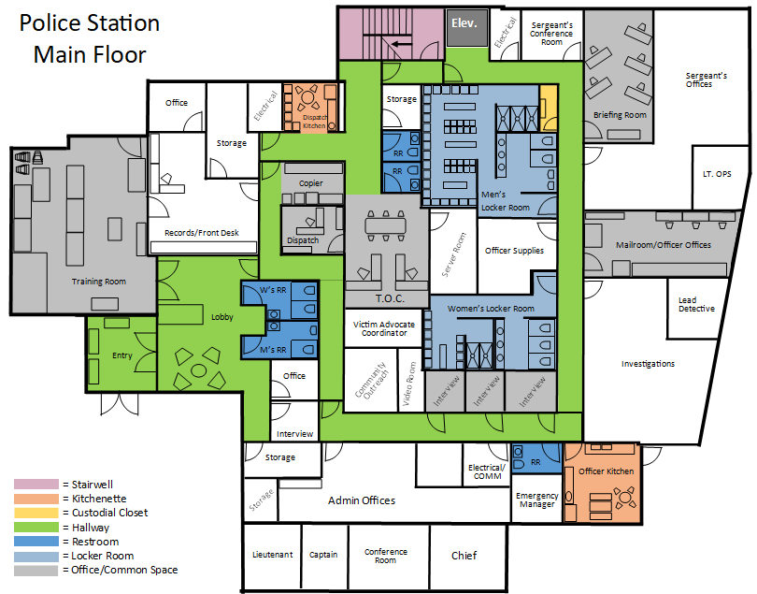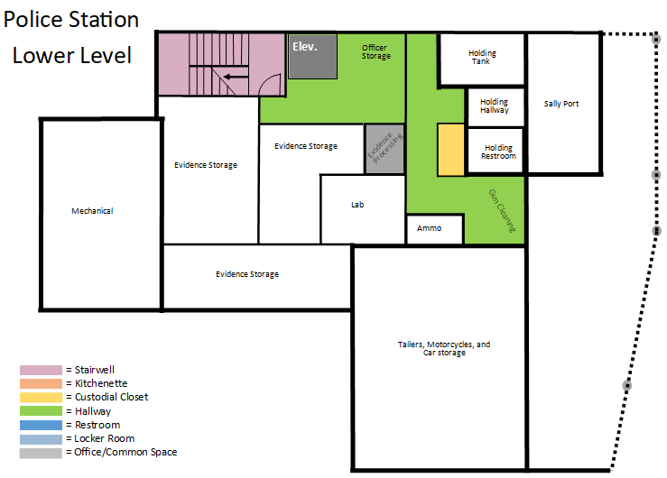
Location 2.
Marsac Building – 445 Marsac Avenue
All cleaning to be completed five (5) days per week, Monday through Friday from 6:00 AM until 8:00 AM.

Daily Cleaning Projects:

RESTROOMS (4):
- Empty all trash cans and dispose of in dumpster; replace liners and spot clean trash cans
- Restock all paper products and soap
- Clean and disinfect all restroom fixtures, dispensers, faucets, rails, sinks, toilets, and urinals
- Clean and disinfect all flush sensors and underside of all toilets
- Clean and disinfect all countertops
- Clean and disinfect all handrails and doorknobs
- Clean mirrors
- Wipe down partitions and walls
- Clean all interior glass doors, windows, and window ledges, as needed
- Vacuum all carpeting, including mats, if applicable
- Sweep, mop, and disinfect hard surfaced floors, if applicable

INTERIOR COMMON AREAS – CORRIDORS, HALLWAYS, STAIRS AND RAMPS
- Empty all trash cans and dispose of in dumpster; replace liners and spot clean trash cans
- Clean and disinfect all handrails and doorknobs
- Clean and disinfect tabletops and hard surfaced chairs, if applicable
- Clean and disinfect water fountains
- Clean all interior glass doors, windows, and window ledges, as needed
- Vacuum or sweep and mop all stairways
- Vacuum all carpeting, including mats, if applicable
- Sweep, mop, and disinfect hard surfaced floors, if applicable

ENTRANCES
- Empty all trash cans and dispose of in dumpster; replace liners and spot clean trash cans
- Clean and disinfect all handrails and doorknobs
- Clean all interior glass doors, windows, and window ledges, as needed
- Vacuum all carpeting, including mats, if applicable
- Sweep, mop, and disinfect hard surfaced floors, if applicable

CONFERENCE ROOM
- Empty all trash cans and dispose of in dumpster; replace liners and spot clean trash cans
- Clean and disinfect all handrails and doorknobs
- Clean and disinfect tabletops and hard surfaced chairs, if applicable
- Clean all interior glass doors, windows, and window ledges, as needed
- Vacuum all carpeting, including mats, if applicable
- Sweep, mop, and disinfect hard surfaced floors, if applicable

COUNCIL CHAMBERS
- Empty all trash cans and dispose of in dumpster; replace liners and spot clean trash cans
- Clean and disinfect all handrails and doorknobs
- Clean and disinfect tabletops and hard surfaced chairs, if applicable
- Clean all interior glass doors, windows, and window ledges, as needed
- Vacuum all carpeting, in and around furniture, if applicable
- Sweep, mop, and disinfect hard surfaced floors, if applicable

KITCHEN AREA:
- Empty all trash cans and dispose of in dumpster; replace liners and spot clean trash cans
- Restock all paper products and soap
- Clean and disinfect all handrails and doorknobs
- Clean tables, counter tops, and sink(s)
- Clean all interior glass doors, windows, and window ledges, as needed
- Sweep, mop, and disinfect hard surfaced floors, if applicable

ELEVATOR:
- Polish stainless steel, wipe down walls and doors, and disinfect buttons
- Clean and disinfect all handrails and doorknobs
- Vacuum all carpeting, including mats, if applicable
- Sweep, mop, and disinfect hard surfaced floors, if applicable

ADDITIONAL ITEMS:
- Spot cleaning
- Check and report on any maintenance issues (i.e., low on paper products, soap, etc.)
- All janitorial closets are to be kept clean, sanitary, and have a proper MSDS Book
MARSAC RENDERINGS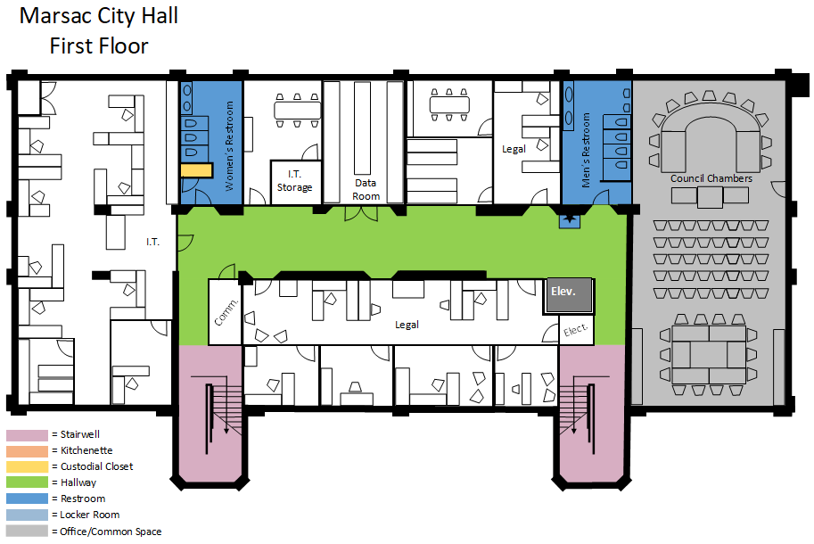
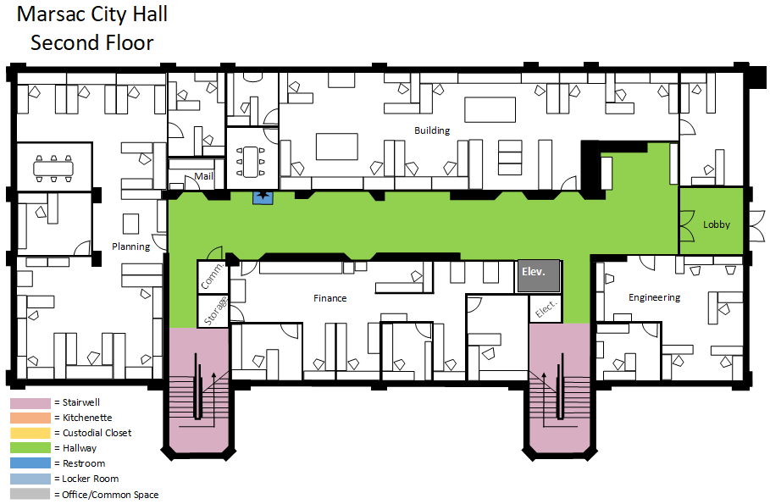
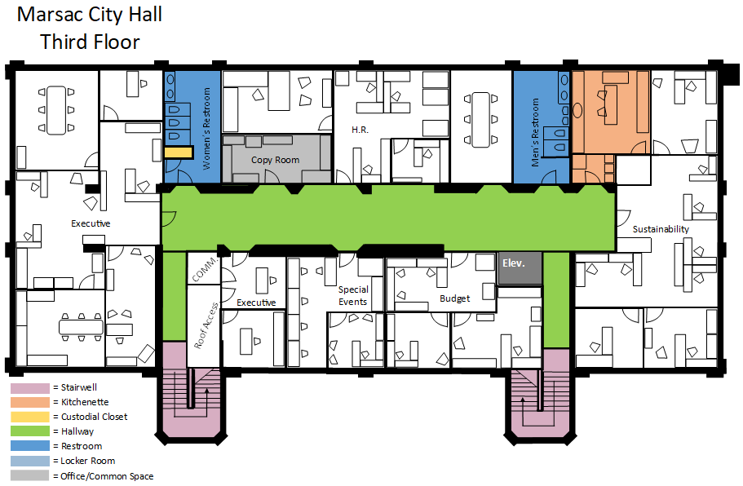
Location 3.
Library Center – 1255 Park Avenue
All cleaning to be completed seven (7) days per week from 2:00 AM until 6:00 AM.

Daily Cleaning Projects:

RESTROOMS (9):
- Empty all trash cans and dispose of in dumpster; replace liners and spot clean trash cans
- Restock all paper products and soap
- Clean and disinfect all restroom fixtures, dispensers, faucets, rails, sinks, toilets and urinals
- Clean and disinfect all flush sensors and underside of all toilets
- Clean and disinfect all countertops
- Clean and disinfect all handrails and doorknobs
- Clean and disinfect water fountains as neededoutside restrooms [(3) – one on each floor]
- Clean mirrors
- Wipe down partitions and walls
- Clean all interior glass doors, windows and window ledges, as needed.
- Vacuum all carpeting, including mats, if applicable
- Sweep, mop, and disinfect hard surfaced floors, if applicable

INTERIOR COMMON AREAS – CORRIDORS, ENTRANCE AND STAIRS:
- Empty all trash cans and dispose of in dumpster; replace liners and spot clean trash cans
- Clean and disinfect tabletops and hard surfaced chairs, if applicable
- Clean and disinfect all handrails and doorknobs
- Clean all interior glass doors, windows and window ledges, as needed.
- Vacuum or sweep and mop all stairways
- Vacuum all carpeting, including mats, if applicable
- Sweep, mop, and disinfect hard surfaced floors, if applicable

ELEVATOR:
- Polish stainless steel, wipe down walls and doors, and disinfect buttons
- Clean and disinfect all handrails and doorknobs
- Vacuum all carpeting, including mats, if applicable
- Sweep, mop, and disinfect hard surfaced floors, if applicable

FREE STANDING BOOKSHELVES – ALL LEVELS:
- Empty all trash cans and dispose of in dumpster; replace liners and spot clean trash cans
- Dust tops of all bookshelves**
- Vacuum all carpeting, including mats, if applicable
- Sweep, mop, and disinfect hard surfaced floors, if applicable
** Note: Please do not dust individual shelves. This is done by library staff.

PUBLIC SEATING (5) – ALL LEVELS:
- Empty all trash cans and dispose of in dumpster; replace liners and spot clean trash cans
- Clean and disinfect tabletops and hard surfaced chairs, if applicable
- Spot clean fabric chairs or couches as needed
- Vacuum all carpeting under tables and chairs, including mats, if applicable
- Sweep, mop and disinfect hard surfaced floors

PUBLIC COMPUTER STATIONS (2) – ALL LEVELS:
- Empty all trash cans and dispose of in dumpster; replace liners and spot clean trash cans
- Clean and disinfect tabletops and hard surfaced chairs, if applicable
- Vacuum all carpeting, including mats, if applicable
- Sweep, mop, and disinfect hard surfaced floors, if applicable

MEETING ROOMS 101, 201, AND 301:
- Empty all trash cans and dispose of in dumpster; replace liners and spot clean trash cans
- Restock all paper products and soap
- Clean and disinfect all handrails and doorknobs
- Clean and disinfect tabletops and hard surfaced chairs, if applicable
- Clean all interior glass doors, windows, and window ledges, as needed
- Clean and disinfect countertops and sink
- Vacuum all carpeting, including mats, if applicable
- Sweep, mop, and disinfect hard surfaced floors, if applicable

CHILDREN’S STORYTIME ROOM – LEVEL 1
- Empty all trash cans and dispose of in dumpster; replace liners and spot clean trash cans
- Clean and disinfect all handrails and doorknobs
- Clean all interior glass doors, windows and window ledges, as needed.
- Vacuum all carpeting, including mats, if applicable
- Sweep, mop and disinfect hard surfaced floors

KID’S MOUNTAIN READING AREA – LEVEL 1
- Spot clean fabric chairs, couches, and vinyl seating as needed
- Empty all trash cans and dispose of in dumpster; replace liners and spot clean trash cans
- Vacuum all carpeting, including mats, if applicable
- Sweep, mop, and disinfect hard surfaced floors, if applicable

YOUCREATE MEDIA LABS (2) – LEVEL 1
- Empty all trash cans and dispose of in dumpster; replace liners and spot clean trash cans
- Clean and disinfect all handrails and doorknobs
- Clean and disinfect tabletops and hard surfaced chairs, if applicable
- Clean all interior glass doors, windows and window ledges, as needed.
- Vacuum all carpeting, including mats, if applicable
- Sweep, mop, and disinfect hard surfaced floors, if applicable

LUCKY ONE’S COFFEE LOUNGE – LEVEL 1
- Empty all trash cans and dispose of in dumpster; replace liners and spot clean trash cans
- Clean and disinfect all handrails and doorknobs
- Clean and disinfect tabletops and hard surfaced chairs, if applicable
- Clean all interior glass doors, windows and window ledges, as needed.
- Vacuum all carpeting, including mats, if applicable
- Sweep, mop and disinfect hard surfaced floors

READING ROOM – LEVEL 2
- Empty all trash cans and dispose of in dumpster; replace liners and spot clean trash cans
- Clean and disinfect all handrails and doorknobs
- Clean all interior glass doors, windows and window ledges, as needed.
- Clean and disinfect tabletops and hard surfaced chairs, if applicable
- Spot clean fabric chairs, couches, and vinyl seating as needed
- Dust tops of all bookshelves.**
- Vacuum all carpeting, including mats, if applicable
- Sweep, mop, and disinfect hard surfaced floors, if applicable

NORTH & SOUTH CONFERENCE ROOMS – LEVEL 2:
- Empty all trash cans and dispose of in dumpster; replace liners and spot clean trash cans
- Clean and disinfect all handrails and doorknobs
- Clean all interior glass doors, windows and window ledges, as needed.
- Vacuum all carpeting, including mats, if applicable
- Sweep, mop, and disinfect hard surfaced floors, if applicable

STUDY ROOMS (8) – LEVEL 2
- Empty all trash cans and dispose of in dumpster; replace liners and spot clean trash cans
- Clean and disinfect all handrails and doorknobs
- Clean all interior glass doors, windows, and window ledges, as needed
- Clean and disinfect tabletops and hard surfaced chairs, if applicable
- Spot clean fabric chairs, couches, and vinyl seating as needed
- Vacuum all carpeting, including mats, if applicable
- Sweep, mop, and disinfect hard surfaced floors, if applicable

STAFF OFFICES – LEVEL 2 (ONE time per week: Fridays):
- Empty all trash cans and dispose of in dumpster; replace liners and spot clean trash cans
- Clean and disinfect all handrails and doorknobs
- Clean all interior glass windows and doors as needed
- Spot clean fabric chairs, couches, and vinyl seating as needed
- Vacuum all carpeting, including mats, if applicable
- Sweep, mop, and disinfect hard surfaced floors, if applicable

STAFF KITCHEN – LEVEL 2 (ONE time per week: Fridays):
- Empty all trash cans and dispose of in dumpster; replace liners and spot clean trash cans
- Clean and disinfect all handrails and doorknobs
- Restock all paper products and soap
- Clean all interior glass doors, windows and window ledges, as needed.
- Vacuum all carpeting, including mats, if applicable
- Sweep, mop, and disinfect hard surfaced floors, if applicable

SANTY AUDITORIUM – LEVEL 3:
- Empty all trash cans and dispose of in dumpster; replace liners and spot clean trash cans
- Clean and disinfect all handrails and doorknobs
- Use blower to remove trash and debris from under/in-between seats
- Vacuum all carpeting, including mats, if applicable
- Sweep, mop and disinfect stage (once a month)

SANTY AUDITORIUM COMMUNITY SPACE – LEVEL 3:
- Empty all trash cans and dispose of in dumpster; replace liners and spot clean trash cans
- Clean and disinfect all handrails and doorknobs
- Clean all interior glass doors, windows and window ledges, as needed.
- Vacuum all carpeting, including mats, if applicable
- Sweep, mop, and disinfect hard surfaced floors, if applicable

KITCHEN – LEVEL 3:
- Empty all trash cans and dispose of in dumpster; replace liners and spot clean trash cans
- Restock all paper products and soap
- Clean all interior glass doors, windows and window ledges, as needed.
- Clean and disinfect countertops
- Clean and disinfect sink with stainless steel cleaner
- Vacuum all carpeting, including mats, if applicable
- Sweep, mop, and disinfect hard surfaced floors, if applicable

ADDITIONAL ITEMS:
- Spot cleaning
- Check and report on any maintenance issues (i.e., low on paper products, soap, etc.)
- All janitorial closets are to be kept clean, sanitary, and have a proper MSDS Book

LIBRARY RENDERINGS
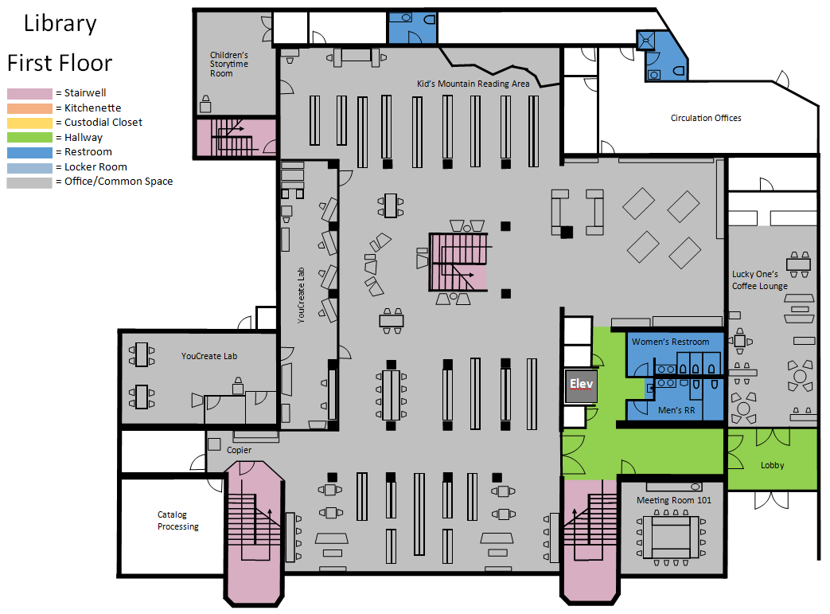
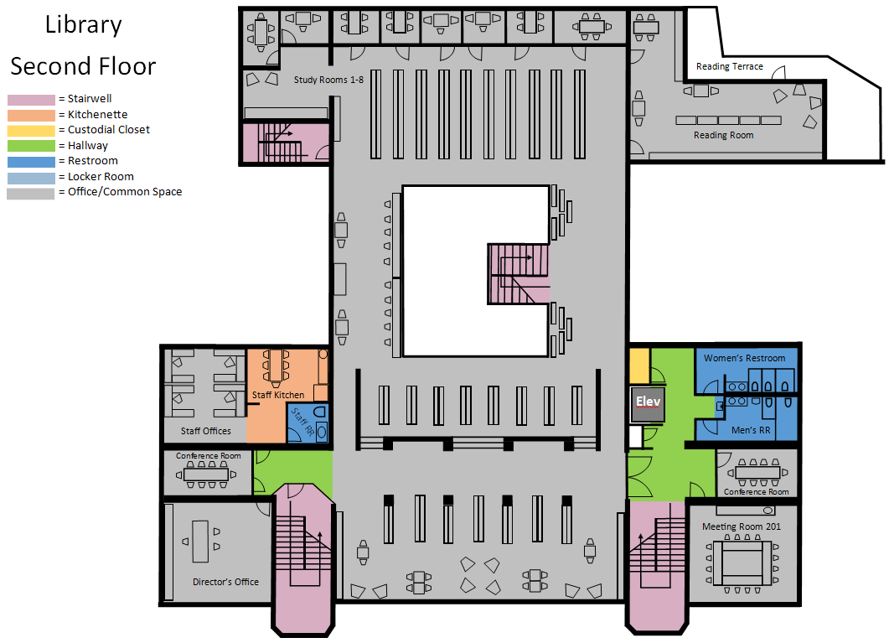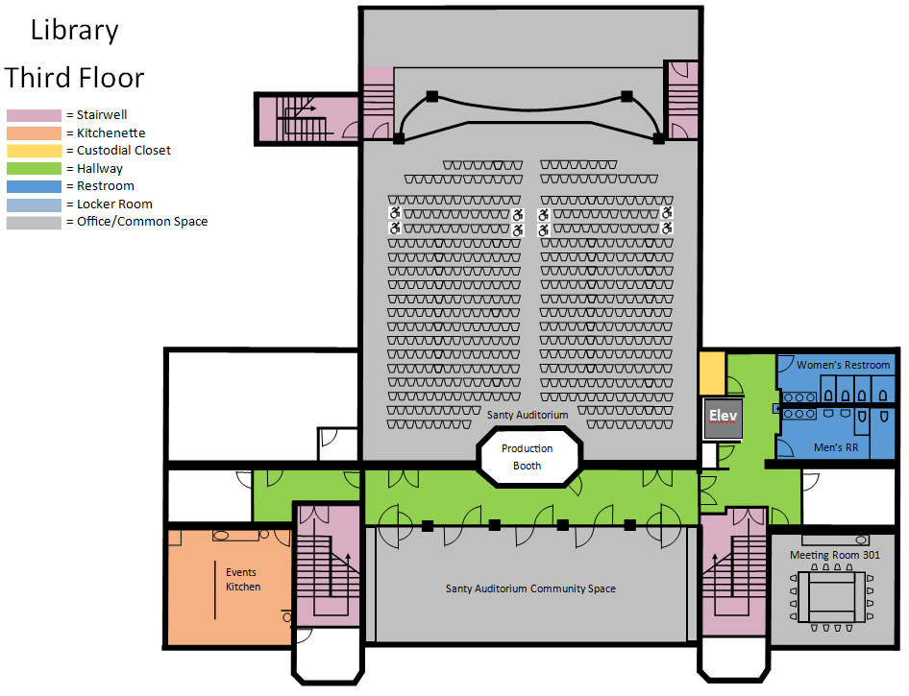
Location 4.
Miners Hospital – 1354 Park Ave.

4a: (October 1 – March 1) All cleaning to be completed three (3) days per week, Monday, Wednesday, Friday from 5:00 AM until 6:00 AM.

4b: (June 1 – Labor Day) All cleaning to be completed five (5) days per week, Monday through Friday from 9:00 AM until 10:00 AM.

Daily Cleaning Projects:

RESTROOMS (3):
- Empty all trash cans and dispose of in dumpster; replace liners and spot clean trash cans
- Restock all paper products and soap
- Clean and disinfect all restroom fixtures, dispensers, faucets, rails, sinks, toilets, and urinals
- Clean and disinfect all flush sensors and underside of all toilets
- Clean and disinfect all countertops
- Clean and disinfect all handrails and doorknobs
- Clean mirrors
- Clean all interior glass doors, windows, and window ledges, as needed
- Wipe down partitions and walls
- Vacuum all carpeting, including mats, if applicable
- Sweep, mop, and disinfect hard surfaced floors, if applicable

INTERIOR COMMON AREAS – CORRIDORS, ENTRANCES AND STAIRS:
- Empty all trash cans and dispose of in dumpster; replace liners and spot clean trash cans
- Clean and disinfect all handrails and doorknobs
- Clean all interior glass doors, windows, and window ledges, as needed
- Vacuum all carpeting, including mats, if applicable
- Sweep, mop, and disinfect hard surfaced floors, if applicable

OFFICES:
- Empty all trash cans and dispose of in dumpster; replace liners and spot clean trash cans
- Clean and disinfect all handrails and doorknobs
- Clean all interior glass doors, windows, and window ledges, as needed
- Vacuum all carpeting, including mats, if applicable
- Sweep, mop, and disinfect hard surfaced floors, if applicable

KITCHEN AREA:
- Empty all trash cans and dispose of in dumpster; replace liners and spot clean trash cans
- Restock all paper products and soap
- Clean and disinfect all handrails and doorknobs
- Clean tables, counter tops. and sink
- Clean all interior glass doors, windows, and window ledges, as needed
- Vacuum all carpeting, including mats, if applicable
- Sweep, mop, and disinfect hard surfaced floors, if applicable

MEETING ROOMS:
- Empty all trash cans and dispose of in dumpster; replace liners and spot clean trash cans
- Clean and disinfect all handrails and doorknobs
- Clean all interior glass doors, windows, and window ledges, as needed
- Vacuum all carpeting, including mats, if applicable
- Sweep, mop, and disinfect hard surfaced floors, if applicable

ADDITIONAL ITEMS:
- Spot cleaning
- Check and report on any maintenance issues (i.e., low on paper products, soap, etc.)
- All janitorial closets are to be kept clean, sanitary, and have a proper MSDS Book
MINER’S HOSPITAL RENDERINGS
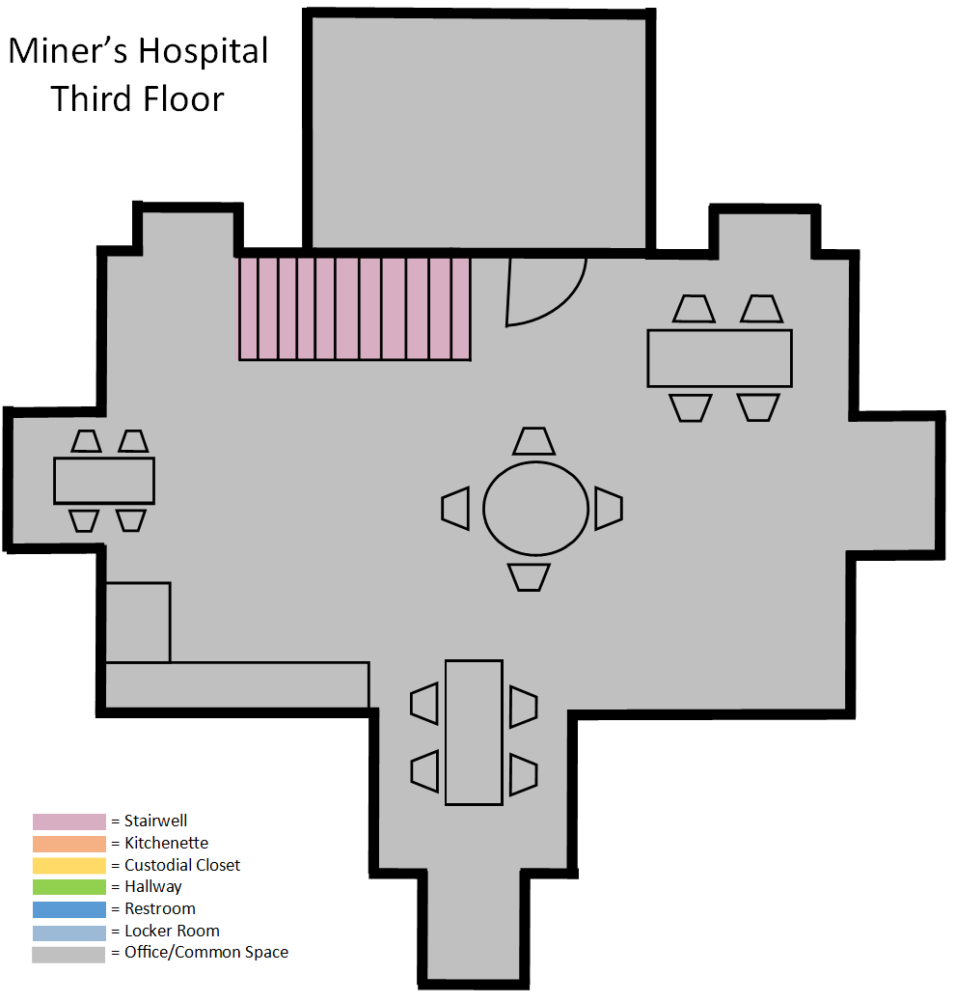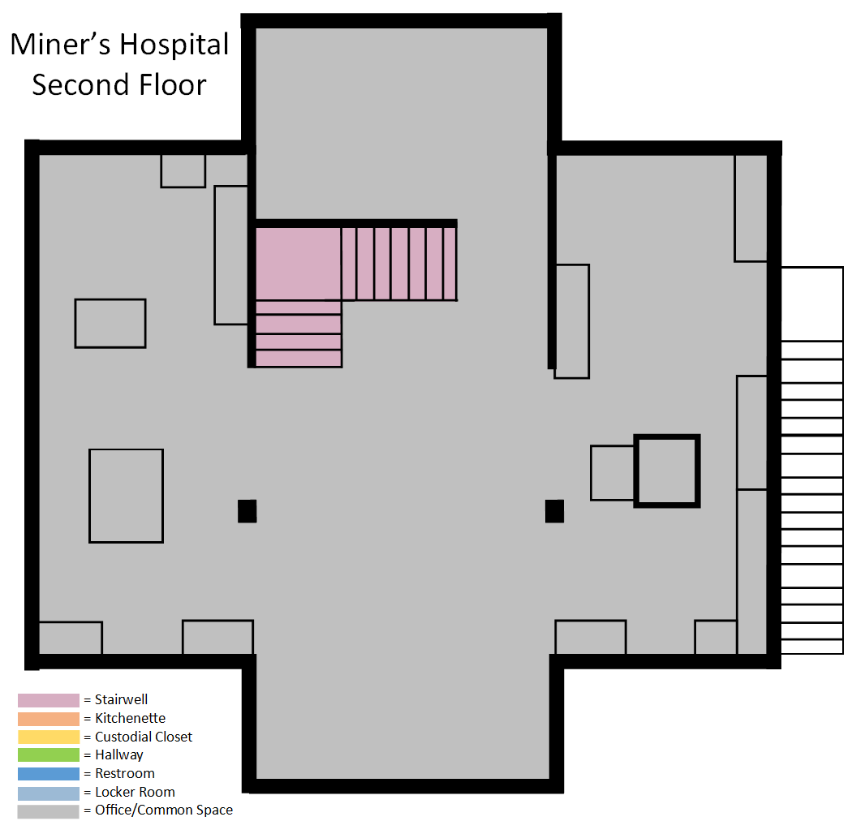

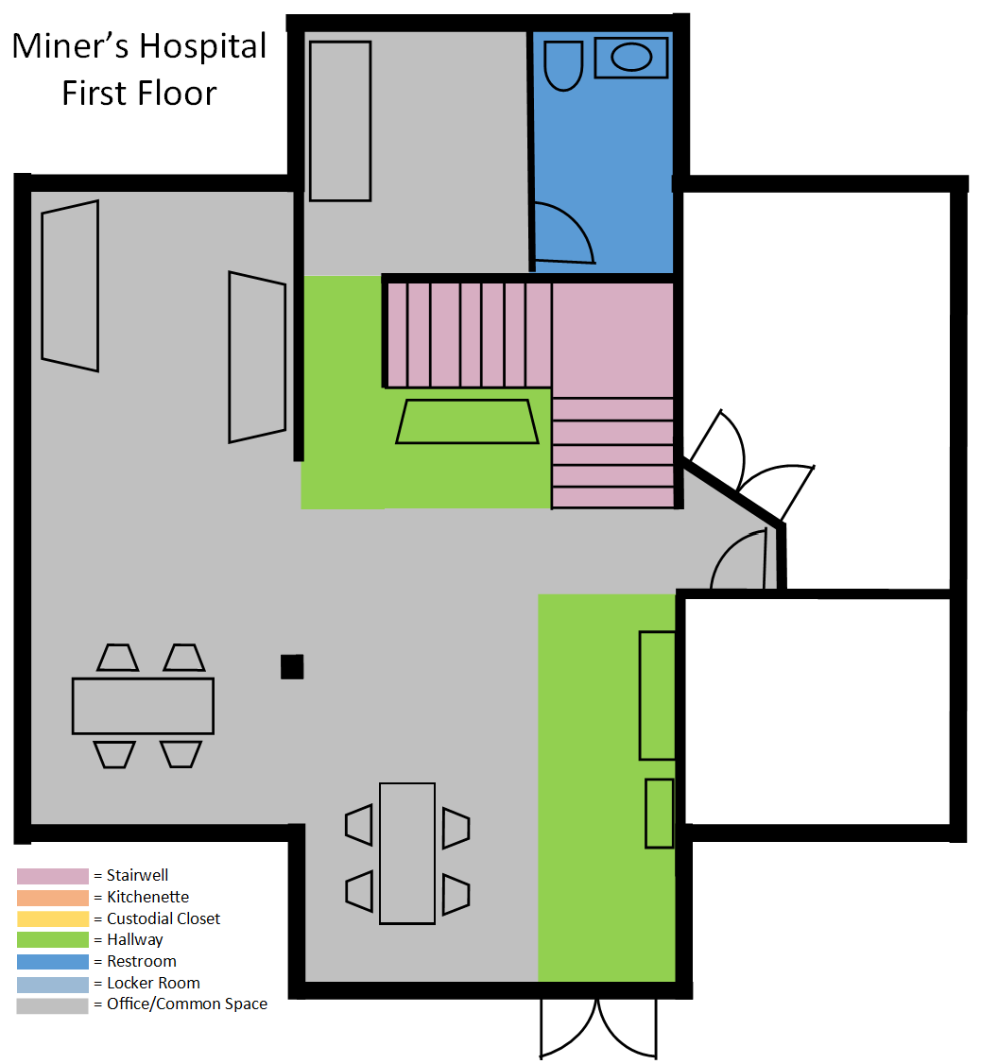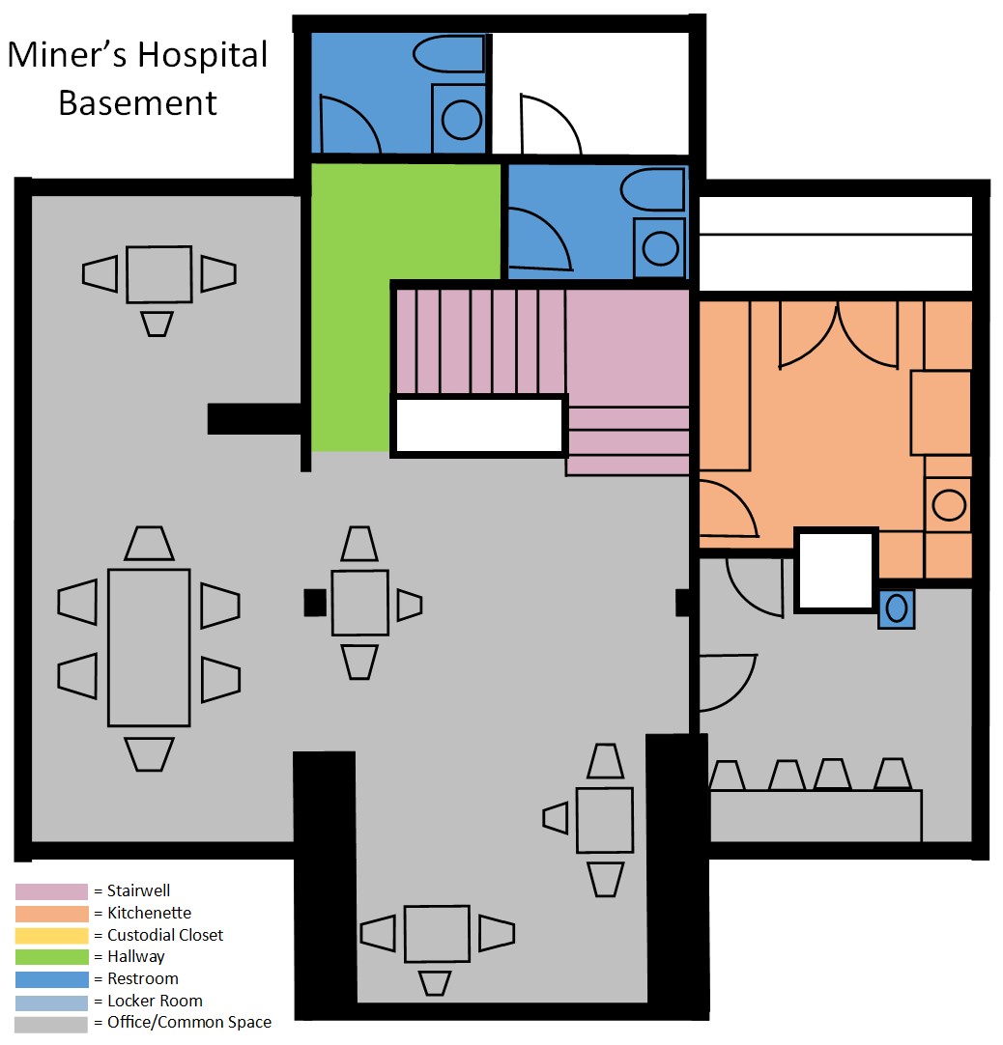

Location 5.
PC MARC – 1200 Little Kate Road
All cleaning to be completed seven (7) nights per week from 9:00 PM until 1:00 AM.

Daily Cleaning Projects:

RESTROOMS (6):
- Empty all trash cans and dispose of in dumpster; replace liners and spot clean trash cans
- Restock all paper products and soap
- Clean and disinfect all handrails and doorknobs
- Clean and disinfect all restroom fixtures, dispensers, faucets, rails, sinks, toilets, and urinals
- Clean and disinfect all flush sensors and underside of all toilets
- Clean and disinfect all countertops
- Clean mirrors
- Clean all interior glass doors, windows, and window ledges, as needed
- Wipe down partitions and walls
- Vacuum all carpeting, including mats, if applicable
- Sweep, mop, and disinfect hard surfaced floors, if applicable

LOCKER ROOMS (2):
- Empty all trash cans and dispose of in dumpster; replace liners and spot clean trash cans
- Restock all paper products and soap
- Clean and disinfect all handrails and doorknobs
- Clean and disinfect all restroom fixtures, dispensers, faucets, rails, sinks, toilets, and urinals
- Clean and disinfect all flush sensors and underside of all toilets
- Clean and disinfect all countertops
- Clean mirrors
- Clean all interior glass doors, windows, and window ledges, as needed
- Clean and disinfect showers
- Check sauna and spot clean
- Wipe down lockers, partitions, and walls
- Vacuum all carpeting, including mats, if applicable
- Sweep, mop, and disinfect hard surfaced floors, if applicable

CHILDREN’S PLAYROOM AND RESTROOM (1):
- Empty all trash cans and dispose of in dumpster; replace liners and spot clean trash cans
- Restock all paper products and soap
- Clean and disinfect all handrails and doorknobs
- Clean and disinfect all restroom fixtures, dispensers, faucets, rails, sinks, and toilet
- Clean all interior glass doors, windows, and window ledges, as needed
- Clean and disinfect tabletops and hard surfaced chairs, if applicable
- Spot clean fabric chairs, mats, or couches as needed
- Clean and disinfect all flush handle and underside of toilet
- Clean mirrors
- Vacuum all carpeting, including mats, if applicable
- Sweep, mop, and disinfect hard surfaced floors, if applicable

INTERIOR COMMON AREAS – CORRIDORS, CENTRAL SITTING AREAS, STAIRS, AND ENTRY DESK:
- Empty all trash cans and dispose of in dumpster; replace liners and spot clean trash cans
- Clean and disinfect all handrails and doorknobs
- Clean and disinfect tabletops and hard surfaced chairs, if applicable
- Clean and disinfect water fountains
- Spot clean fabric chairs, mats, or couches as needed
- Pick up any trash left in common areas that may have been missed by staff
- Clean all interior glass doors, windows, and window ledges, as needed
- Vacuum or sweep, mop and disinfect stairways
- Vacuum all carpeting, including mats, if applicable
- Sweep, mop, and disinfect hard surfaced floors, if applicable
*NOTE: Please do not clean, dust, or wipe down any gym equipment (i.e., treadmills, elliptical, weights, etc.).

KITCHEN AREAS (3) & PARTY ROOM (1):
- Empty all trash cans and dispose of in dumpster; replace liners and spot clean trash cans
- Restock all paper products and soap
- Clean and disinfect all handrails and doorknobs
- Clean tables, counter tops, and sink(s)
- Clean all interior glass doors, windows, and window ledges, as needed
- Vacuum all carpeting, including mats, if applicable
- Sweep, mop, and disinfect hard surfaced floors, if applicable

ELEVATOR:
- Polish stainless steel, wipe down walls and doors, and disinfect buttons
- Clean and disinfect all handrails and doorknobs
- Vacuum all carpeting, including mats, if applicable
- Sweep, mop, and disinfect hard surfaced floors, if applicable

STAFF OFFICES & CLIMBING WALL (cleaning on Fridays and Tuesdays ONLY):
- Empty all trash cans and dispose of in dumpster; replace liners and spot clean trash cans
- Clean and disinfect all handrails and doorknobs
- Clean all interior glass doors, windows, and window ledges, as needed
- Vacuum all carpeting in Climbing Zone*.
- Vacuum all carpeting, including mats, if applicable
- Sweep, mop, and disinfect hard surfaced floors, if applicable
*NOTE: Mats will be stacked in different locations before each night.

ADDITIONAL ITEMS:
- Spot cleaning
- Check and report on any maintenance issues (i.e., low on paper products, soap, etc.)
- All janitorial closets are to be kept clean, sanitary, and have a proper MSDS Book

PC MARC RENDERING

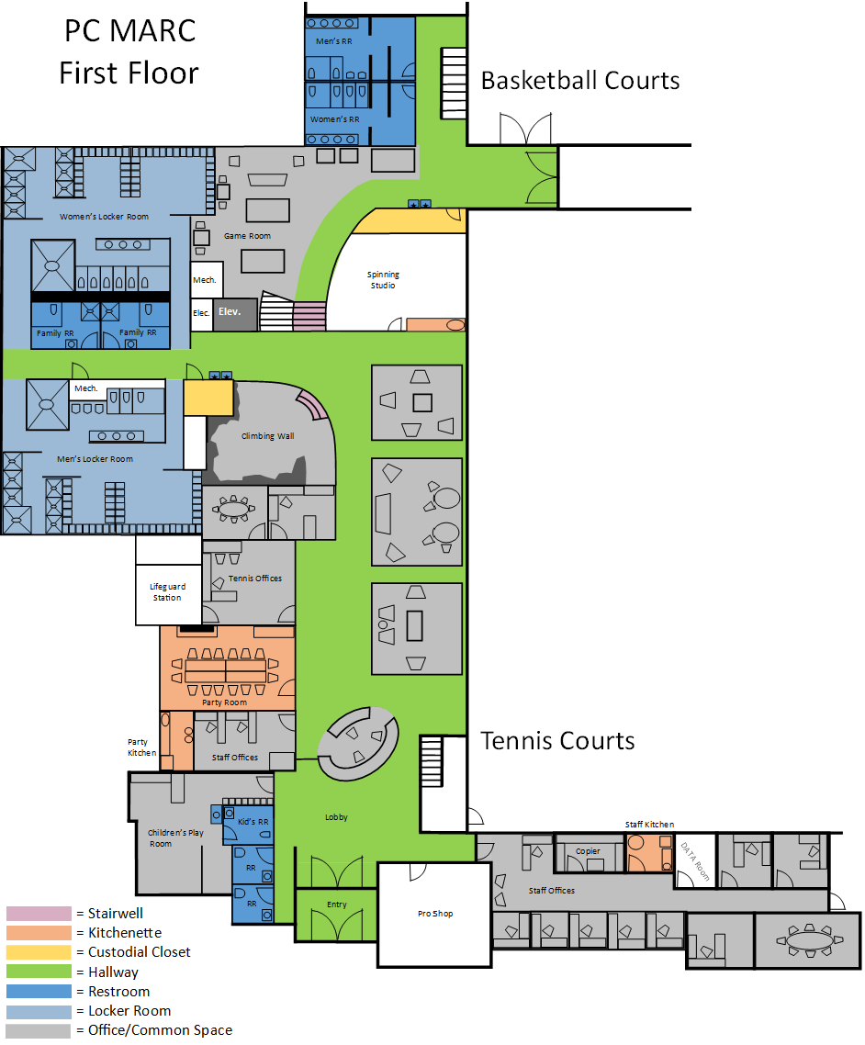

Location 6.
Public Works West Building – 1053 Iron Horse Drive

6a: (November 1 – April 1) All cleaning to be completed seven (7) days per week from 8:00 AM until 12:00 PM.

6b: (April 1 – November 1) All cleaning to be completed five (5) days per week, Monday through Friday from 8:00 AM until 12:00 PM.

Daily Cleaning Projects:

RESTROOMS (6):
- Empty all trash cans and dispose of in dumpster; replace liners and spot clean trash cans
- Restock all paper products and soap
- Clean and disinfect all handrails and doorknobs
- Clean and disinfect all restroom fixtures, dispensers, faucets, rails, sinks, toilets, and urinals
- Clean and disinfect all flush sensors and underside of all toilets
- Clean and disinfect all countertops
- Clean mirrors
- Clean all interior glass doors, windows, and window ledges, as needed
- Wipe down partitions and walls
- Vacuum all carpeting, including mats, if applicable
- Sweep, mop, and disinfect hard surfaced floors, if applicable

LOCKER ROOMS (2):
- Empty all trash cans and dispose of in dumpster; replace liners and spot clean trash cans
- Restock all paper products and soap
- Clean and disinfect all handrails and doorknobs
- Clean and disinfect all restroom fixtures, dispensers, faucets, rails, sinks, toilets, and urinals
- Clean and disinfect all flush sensors and underside of all toilets
- Clean and disinfect all countertops
- Clean mirrors
- Clean and disinfect showers
- Clean all interior glass doors, windows, and window ledges, as needed
- Wipe down lockers, partitions, and walls
- Vacuum all carpeting, including mats, if applicable
- Sweep, mop, and disinfect hard surfaced floors, if applicable

INTERIOR COMMON AREAS – CORRIDORS, ENTRANCE AND STAIRS:
- Empty all trash cans and dispose of in dumpster; replace liners and spot clean trash cans
- Clean and disinfect all handrails and doorknobs
- Clean and disinfect water fountains
- Clean all interior glass doors, windows, and window ledges, as needed
- Vacuum or sweep, mop, and disinfect stairways
- Vacuum all carpeting, including mats, if applicable
- Sweep, mop, and disinfect hard surfaced floors, if applicable

COMMON OFFICE AREAS – ADMIN ENTRY DESK, OFFICES [all three levels] (Cleaning on Tuesday and Thursday ONLY):
- Empty all trash cans and dispose of in dumpster; replace liners and spot clean trash cans
- Clean and disinfect all handrails and doorknobs
- Wipe down tables and counters
- Clean all interior glass doors, windows, and window ledges, as needed
- Clean and disinfect tabletops and hard surfaced chairs, if applicable
- Spot clean fabric chairs or couches as needed
- Vacuum all carpeting, including mats, if applicable
- Sweep, mop, and disinfect hard surfaced floors, if applicable

BREAK ROOM/KITCHEN (3):
- Empty all trash cans and dispose of in dumpster; replace liners and spot clean trash cans
- Restock all paper products and soap
- Clean and disinfect all handrails and doorknobs
- Clean tables, counter tops, and sink(s)
- Clean all interior glass doors, windows, and window ledges, as needed
- Clean and disinfect doorknobs
- Vacuum all carpeting, including mats, if applicable
- Sweep, mop, and disinfect hard surfaced floors, if applicable

TRAINING ROOM in 1616 Shortline Road Housing Building (20 sq. foot area)
- Empty all trash cans and dispose of in dumpster; replace liners and spot clean trash cans
- Clean and disinfect doorknobs
- Clean and disinfect tabletops, countertops, and hard surfaced chairs, if applicable
- Vacuum all carpeting, including mats, if applicable
- Sweep, mop, and disinfect hard surfaced floors, if applicable

ELEVATOR:
- Polish stainless steel, wipe down walls and doors, and disinfect buttons
- Clean and disinfect all handrails and doorknobs
- Vacuum all carpeting, including mats, if applicable
- Sweep, mop, and disinfect hard surfaced floors, if applicable

ADDITIONAL ITEMS:
- Spot cleaning
- Check and report on any maintenance issues (i.e., low on paper products, soap, etc.)
- All janitorial closets are to be kept clean, sanitary, and have a proper MSDS Book

PUBLIC WORKS WEST RENDERINGS
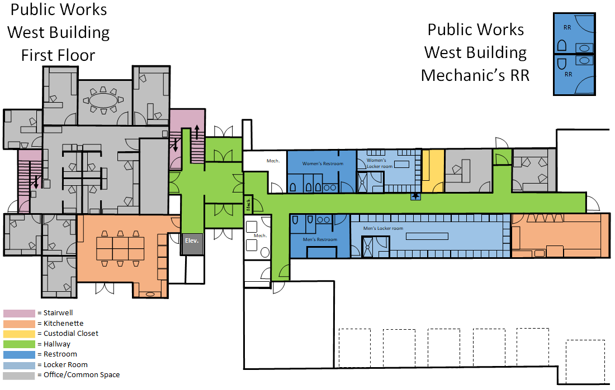

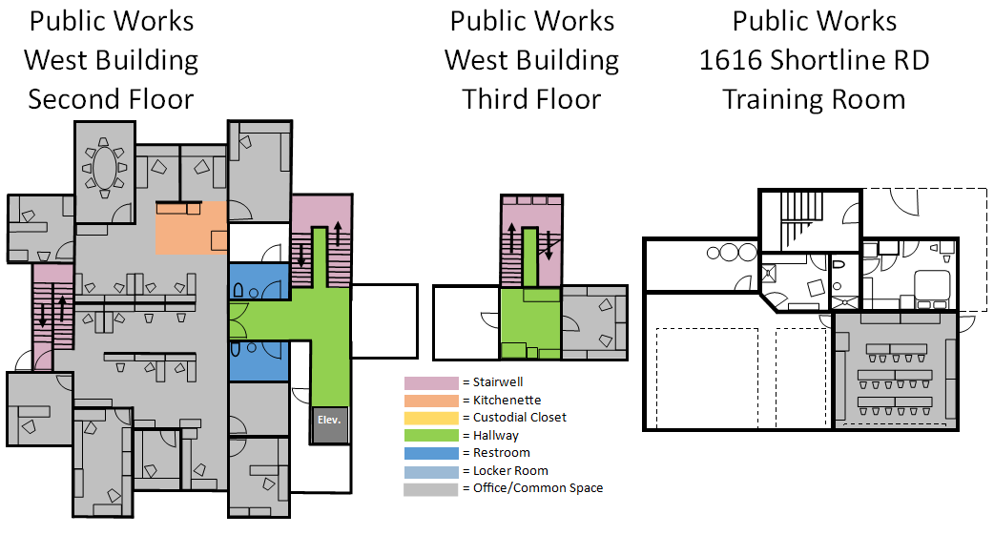
Location 7.
Public Works East Building – 1053 Iron Horse Drive

7a: (November 1 – April 1) All cleaning to be completed seven (7) days per week from 1:00 PM until 4:00 PM.

7b: (April 1 – November 1) All cleaning to be completed five (5) days per week, Monday through Friday from 1:00 PM until 4:00 PM.

Daily Cleaning Projects:

RESTROOMS (2):
- Empty all trash cans and dispose of in dumpster; replace liners and spot clean trash cans
- Restock all paper products and soap
- Clean and disinfect all handrails and doorknobs
- Clean and disinfect all restroom fixtures, dispensers, faucets, rails, sinks, toilets, and urinals
- Clean and disinfect all flush sensors and underside of all toilets
- Clean and disinfect all countertops
- Clean mirrors
- Clean all interior glass doors, windows, and window ledges, as needed
- Wipe down partitions and walls
- Vacuum all carpeting, including mats, if applicable
- Sweep, mop, and disinfect hard surfaced floors, if applicable

INTERIOR COMMON AREAS – CORRIDORS, ENTRANCE AND STAIRS:
- Empty all trash cans and dispose of in dumpster; replace liners and spot clean trash cans
- Clean and disinfect water fountains
- Clean and disinfect all handrails and doorknobs
- Clean all interior glass doors, windows, and window ledges, as needed
- Vacuum or sweep, mop and disinfect stairways
- Vacuum all carpeting, including mats, if applicable
- Sweep, mop, and disinfect hard surfaced floors, if applicable

COMMON OFFICE AREAS (Cleaning on Tuesday and Thursday ONLY):
- Empty all trash cans and dispose of in dumpster; replace liners and spot clean trash cans
- Clean and disinfect all handrails and doorknobs
- Wipe down tables and counters
- Clean all interior glass doors, windows, and window ledges, as needed
- Clean and disinfect tabletops and hard surfaced chairs, if applicable
- Spot clean fabric chairs or couches as needed
- Vacuum all carpeting, including mats, if applicable
- Sweep, mop, and disinfect hard surfaced floors, if applicable

BREAKROOM/KITCHEN:
- Empty all trash cans and dispose of in dumpster; replace liners and spot clean trash cans
- Restock all paper products and soap
- Clean and disinfect all handrails and doorknobs
- Clean and disinfect all tabletops, counter tops, and sinks
- Clean all interior glass doors, windows and window ledges, as needed.
- Vacuum all carpeting, including mats, if applicable
- Sweep, mop, and disinfect hard surfaced floors, if applicable

GARAGE BREAK ROOM (60 sq. foot area, Monday thru Friday ONLY):
- Empty all trash cans and dispose of in dumpster; replace liners and spot clean trash cans
- Clean and disinfect all tabletops
- Clean and disinfect all handrails and doorknobs
- Wipe down lockers, partitions, and walls
- Vacuum all carpeting, including mats, if applicable
- Sweep, mop, and disinfect hard surfaced floors, if applicable

ADDITIONAL ITEMS:
- Spot cleaning
- Check and report on any maintenance issues (i.e., low on paper products, soap, etc.)
- All janitorial closets are to be kept clean, sanitary, and have a proper MSDS Book

PUBLIC WORKS EAST RENDERING
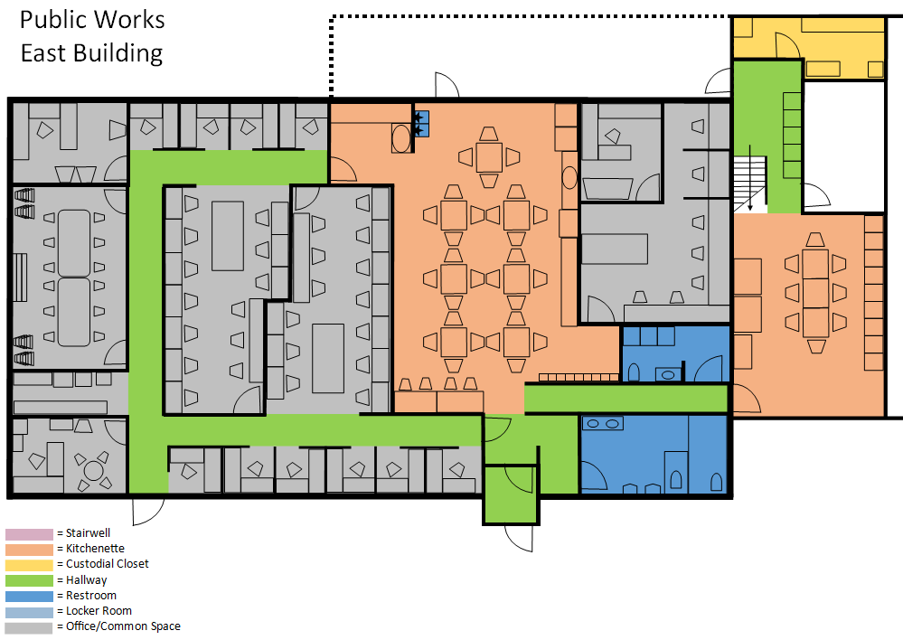

Location 8.
Quinn’s Water Treatment Plant – 2800 Richardson Flat Road

All cleaning to be completed two (2) days per week, Monday and Thursday from 7:00 AM until 9:00 AM.

Daily Cleaning Projects:

BATHROOMS (4):
- Empty all trash cans and dispose of in dumpster; replace liners and spot clean trash cans
- Restock all paper products and soap
- Clean and disinfect all handrails and doorknobs
- Clean and disinfect all restroom fixtures, dispensers, faucets, rails, sinks, toilets and urinals
- Clean and disinfect all flush sensors and underside of all toilets
- Clean and disinfect all countertops
- Clean and disinfect showers
- Clean mirrors
- Clean and disinfect water fountains
- Wipe down partitions and walls
- Vacuum all carpeting, including mats, if applicable
- Sweep, mop, and disinfect hard surfaced floors, if applicable

LOCKER ROOM
- Empty all trash cans and dispose of in dumpster; replace liners and spot clean trash cans
- Clean and disinfect all benches and doorknobs
- Wipe down lockers, partitions, and walls
- Vacuum all carpeting, including mats, if applicable
- Sweep, mop, and disinfect hard surfaced floors, if applicable

LAB
  - Restock all paper products and soap
  - Clean and disinfect all handrails and doorknobs
  - Vacuum all carpeting, including mats, if applicable
  - Sweep, mop, and disinfect hard surfaced floors, if applicable

OFFICES
  - Empty all trash cans and dispose of in dumpster; replace liners and spot clean trash cans
  - Vacuum all carpeting, including mats, if applicable
  - Sweep, mop, and disinfect hard surfaced floors, if applicable

KITCHEN
  - Empty all trash cans and dispose of in dumpster; replace liners and spot clean trash cans
  - Restock all paper products and soap
  - Vacuum all carpeting, including mats, if applicable
  - Sweep, mop, and disinfect hard surfaced floors, if applicable

ADDITIONAL ITEMS:
  - Spot cleaning
  - Check and report on any maintenance issues (i.e., low on paper products, soap, etc.)
  - All janitorial closets are to be kept clean, sanitary, and have a proper MSDS Book

QUINN’S WATER TREATMENT PLANT RENDERINGS
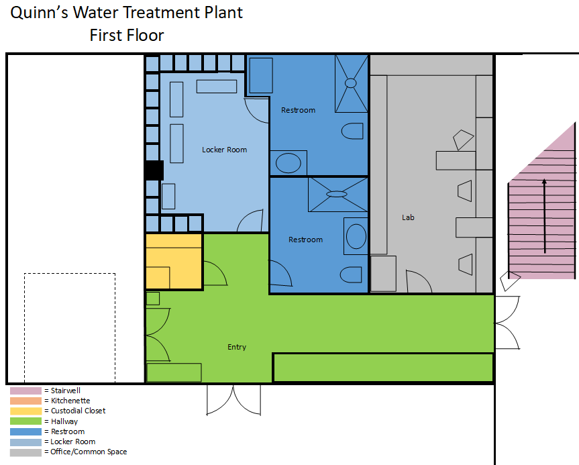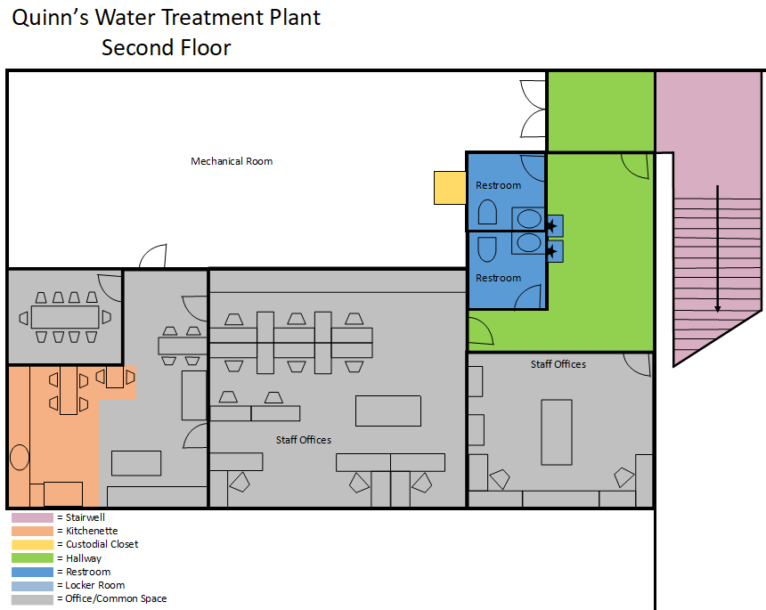
Location 9.
Quinn’s Maintenance Building – 425 FJ Gilmore Way

All cleaning to be completed two (2) days per week, Monday and Thursday from 6:00 AM until 7:00 AM.

Daily Cleaning Projects:

RESTROOMS (1):
- Empty all trash cans and dispose of in dumpster; replace liners and spot clean trash cans
- Restock all paper products and soap
- Clean and disinfect all handrails and doorknobs
- Clean and disinfect all restroom fixtures, dispensers, faucets, rails, sinks, toilets, and urinals
- Clean and disinfect all flush sensors and underside of all toilets
- Clean and disinfect all countertops
- Clean mirrors
- Wipe down partitions and walls
- Vacuum all carpeting, including mats, if applicable
- Sweep, mop, and disinfect hard surfaced floors, if applicable

INTERIOR COMMON AREAS –AND OFFICE:
- Empty all trash cans and dispose of in dumpster; replace liners and spot clean trash cans
- Clean and disinfect all handrails and doorknobs
- Clean all interior glass doors, windows, and window ledges, as needed
- Vacuum all carpeting, including mats, if applicable
- Sweep, mop, and disinfect hard surfaced floors, if applicable

KITCHEN/BREAKROOM
  - Empty all trash cans and dispose of in dumpster; replace liners and spot clean trash cans
  - Clean tables, counter tops, and sink(s)
  - Restock all paper products and soap
  - Vacuum all carpeting, including mats, if applicable
  - Sweep, mop, and disinfect hard surfaced floors, if applicable

ADDITIONAL ITEMS:
- Spot cleaning
- Check and report on any maintenance issues (i.e., low on paper products, soap, etc.)
- All janitorial closets are to be kept clean, sanitary, and have proper MSDS Book

QUINN’S MAINTENANCE BUILDING RENDERING

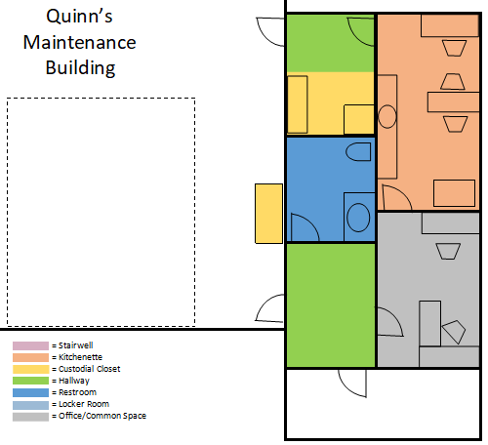
Location 10.
Quinn’s Restrooms – 300 FJ Gillmor Way

All cleaning to be completed seven (7) days per week from 5:00 AM until 6:00 AM.

Daily Cleaning Projects:

RESTROOMS (2):
- Empty all trash cans and dispose of in dumpster; replace liners and spot clean trash cans
- Restock all paper products and soap
- Clean and disinfect all handrails and doorknobs
- Clean and disinfect all restroom fixtures, dispensers, faucets, rails, sinks, toilets and urinals
- Clean and disinfect all flush sensors and underside of all toilets
- Clean and disinfect all countertops
- Clean mirrors
- Wipe down partitions and walls
- Vacuum all carpeting, including mats, if applicable
- Sweep, mop, and disinfect hard surfaced floors, if applicable

ADDITIONAL ITEMS:
- Clean and disinfect water fountains as needed
- Spot cleaning
- Check and report on any maintenance issues (i.e., low on paper products, soap, etc.
- All janitorial closets are to be kept clean, sanitary, and have proper MSDS Book

QUINN’S RESTROOM RENDERING
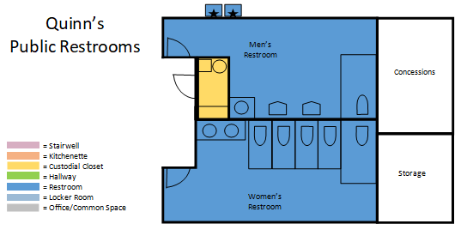
Location 11.
Farm Shed on HWY 224 – 3000 Park Avenue

All cleaning to be completed two (2) days per week, Monday and Thursday from 9:00 AM until 10:00 AM.

Daily Cleaning Projects:

RESTROOMS:
- Empty all trash cans and dispose of in dumpster; replace liners and spot clean trash cans
- Restock all paper products and soap
- Clean and disinfect all handrails and doorknobs
- Clean and disinfect all restroom fixtures, dispensers, faucets, rails, sinks, toilets, and urinals
- Clean and disinfect all flush sensors and underside of all toilets
- Clean and disinfect all countertops
- Clean mirrors
- Clean and disinfect water fountains
- Wipe down partitions and walls
- Vacuum all carpeting, including mats, if applicable
- Sweep, mop, and disinfect hard surfaced floors, if applicable

LOCKER ROOM
- Empty all trash cans and dispose of in dumpster; replace liners and spot clean trash cans
- Clean and disinfect all benches
- Clean and disinfect all handrails and doorknobs
- Wipe down lockers and walls
- Vacuum all carpeting, including mats, if applicable
- Sweep, mop, and disinfect hard surfaced floors, if applicable

KITCHEN
  - Empty all trash cans and dispose of in dumpster; replace liners and spot clean trash cans
  - Restock all paper products and soap
  - Clean and disinfect all handrails and doorknobs
  - Vacuum all carpeting, including mats, if applicable
  - Sweep, mop, and disinfect hard surfaced floors, if applicable

ADDITIONAL ITEMS:
- Spot cleaning
- Check and report on any maintenance issues (i.e., low on paper products, soap, etc.)
- All janitorial closets are to be kept clean, sanitary, and have a proper MSDS Book
FARM SHED AT MCPOLIN BARN RENDERING
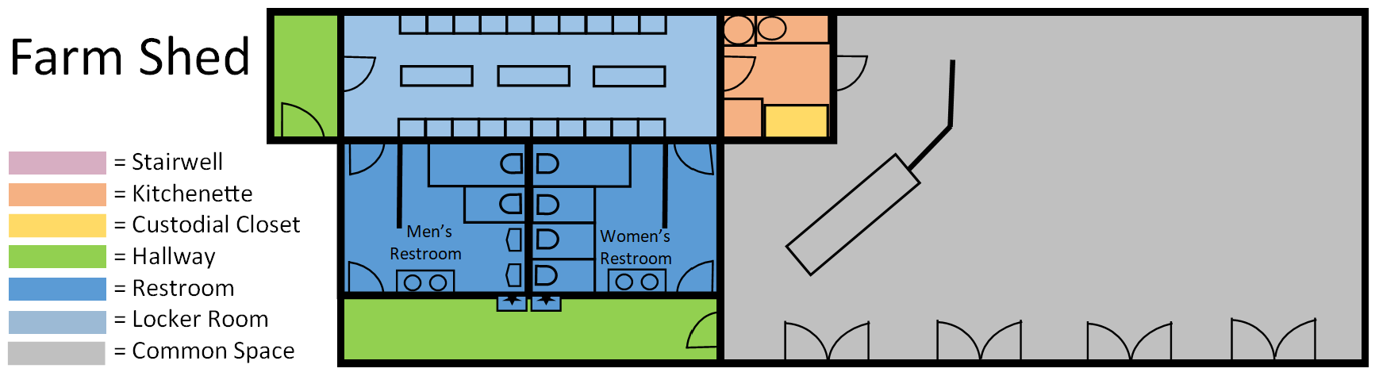
Location 12.
Transit Center – 558 Swede Alley

12a: (April 1 – June 1 & Labor Day – December 1) All cleaning to be completed seven (7) days per week from 5:00 AM until 7:00 AM.

12b: (December 1 – April 1 & June 1 – Labor Day) All cleaning to be completed seven (7) days per week, twice per day. First cleaning to be completed from 5:00 AM until 7:00 AM. Second cleaning to be completed from 2:00 PM and 4:00 PM daily.

Daily Cleaning Projects:

RESTROOMS (4):
- Empty all trash cans and dispose of in dumpster; replace liners and spot clean trash cans
- Restock all paper products and soap
- Clean and disinfect all handrails and doorknobs
- Clean and disinfect all restroom fixtures, dispensers, faucets, rails, sinks, toilets, and urinals
- Clean and disinfect all flush sensors and underside of all toilets
- Clean and disinfect all countertops
- Clean mirrors
- Clean all interior glass doors, windows, and window ledges, as needed
- Wipe down partitions and walls
- Vacuum all carpeting, including mats, if applicable
- Sweep, mop, and disinfect hard surfaced floors, if applicable

SHOWER ROOMS (2):
- Empty all trash cans and dispose of in dumpster; replace liners and spot clean trash cans
- Restock all paper products and soap
- Clean and disinfect all handrails and doorknobs
- Clean and disinfect all restroom fixtures, dispensers, faucets, rails, sinks, toilets, and urinals
- Clean and disinfect all flush sensors and underside of all toilets
- Clean and disinfect all countertops
- Clean mirrors
- Clean all interior glass doors, windows, and window ledges, as needed
- Clean and disinfect showers
- Wipe down walls
- Vacuum all carpeting, including mats, if applicable
- Sweep, mop, and disinfect hard surfaced floors, if applicable

INTERIOR COMMON AREAS – CORRIDORS, WAITING AREAS, STAIRS, AND ENTRY WAYS:
- Empty all trash cans and dispose of in dumpster; replace liners and spot clean trash cans
- Clean and disinfect all handrails and doorknobs
- Clean all interior glass doors, windows, and window ledges, as needed
- Clean and disinfect water fountains
- Clean entry doors interior glass windows and spot clean all interior glass windows
- Vacuum or sweep and mop stairways
- Vacuum all carpeting, including mats, if applicable
- Sweep, mop, and disinfect hard surfaced floors, if applicable

TRANSIT BREAKROOM AREA
- Empty all trash cans and dispose of in dumpster; replace liners and spot clean trash cans
- Clean and disinfect large tables
- Clean and disinfect counter tops
- Clean and disinfect all handrails and doorknobs
- Vacuum all carpeting, including mats, if applicable
- Sweep, mop, and disinfect hard surfaced floors, if applicable

ELEVATOR:
- Polish stainless steel, wipe down walls and doors, and disinfect buttons
- Clean and disinfect all handrails and doorknobs
- Vacuum all carpeting, including mats, if applicable
- Sweep, mop, and disinfect hard surfaced floors, if applicable

ADDITIONAL ITEMS:
- Spot cleaning
- Check and report on any maintenance issues (i.e., low on paper products, soap, etc.)
- All janitorial closets are to be kept clean, sanitary, and have a proper MSDS Book

TRANSIT CENTER RENDERINGS
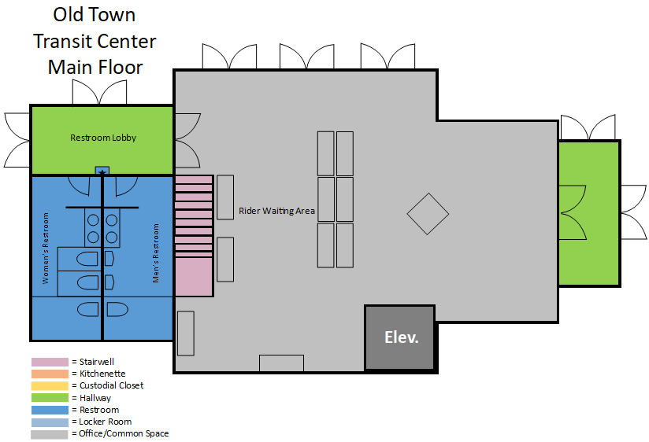
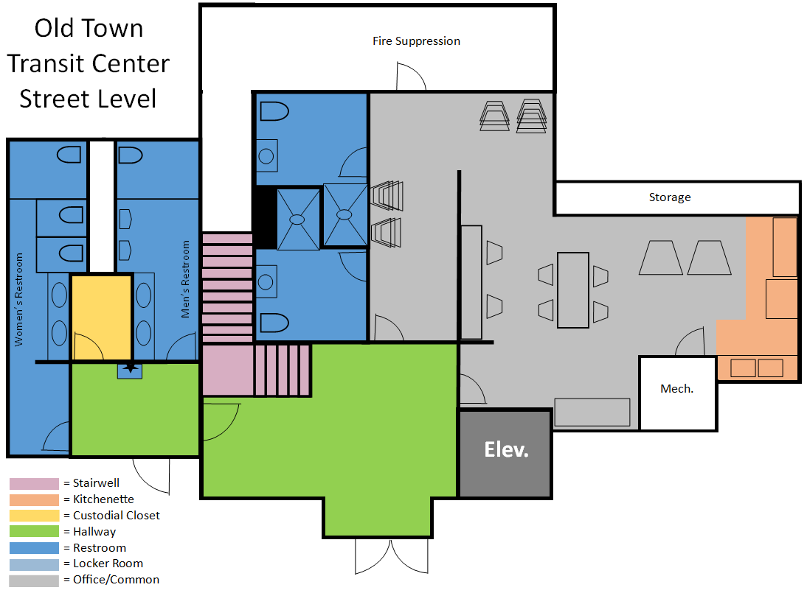
Location 13.
Miner’s Plaza Restrooms – 415 Main Street

13a: (April 1 – June 1 & Labor Day – December 1) All cleaning to be completed seven (7) days per week from 7:00 AM until 8:00 AM.

13b: (December 1 – April 1 & June 1 – Labor Day) All cleaning to be completed seven (7) days per week, twice per day. First cleaning to be completed from 7:00 AM until 8:00 AM. Second cleaning to be completed from 4:00 PM and 5:00 PM daily.

Daily Cleaning Projects:

RESTROOMS (2):
- Empty all trash cans and dispose of in dumpster; replace liners and spot clean trash cans
- Restock all paper products and soap
- Clean and disinfect all restroom fixtures, dispensers, faucets, rails, sinks, toilets, and urinals
- Clean and disinfect all flush sensors and underside of all toilets
- Clean and disinfect all countertops and doorknobs
- Clean mirrors
- Clean all interior glass doors, windows, and window ledges, as needed
- Wipe down partitions and walls
- Vacuum all carpeting, including mats, if applicable
- Sweep, mop, and disinfect hard surfaced floors, if applicable

ADDITIONAL ITEMS:
- Spot cleaning
- Check and report on any maintenance issues
- All janitorial closets are to be kept clean, sanitary, and have a proper MSDS Book

MINER’S PLAZA RESTROOM RENDERING
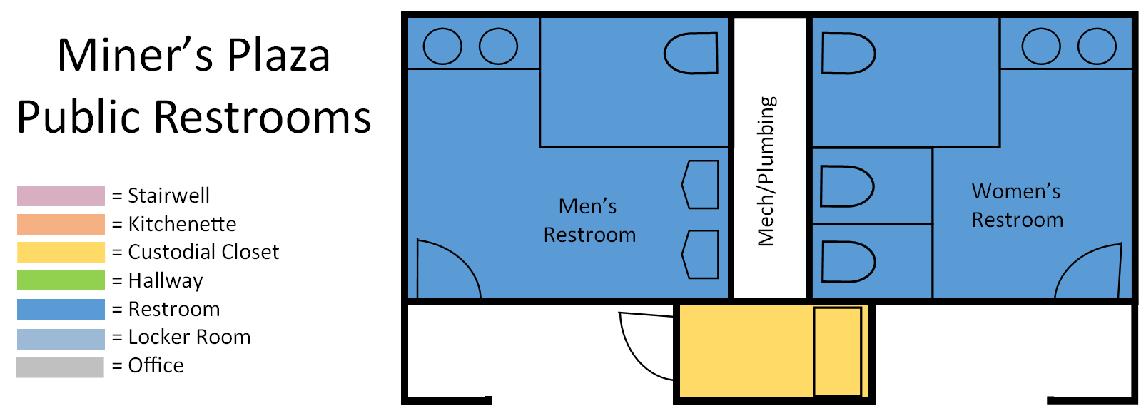
Location 14.
Museum Restrooms – 528 Main Street

14a: (April 1 – June 1 & Labor Day – December 1) All cleaning to be completed seven (7) days per week from 8:00 AM until 9:00 AM.

14b: (December 1 – April 1 & June 1 – Labor Day) All cleaning to be completed seven (7) days per week, twice per day. First cleaning to be completed from 8:00 AM until 9:00 AM. Second cleaning to be completed from 5:00 PM and 6:00 PM daily.

Daily Cleaning Projects:

RESTROOMS (2):
- Empty all trash cans and dispose of in dumpster; replace liners and spot clean trash cans
- Restock all paper products and soap
- Clean and disinfect all handrails and doorknobs
- Clean and disinfect all restroom fixtures, dispensers, faucets, rails, sinks, toilets, and urinals
- Clean and disinfect all flush sensors and underside of all toilets
- Clean and disinfect all countertops
- Clean mirrors
- Clean all interior glass doors, windows, and window ledges, as needed
- Wipe down partitions and walls
- Vacuum all carpeting, including mats, if applicable
- Sweep, mop, and disinfect hard surfaced floors, if applicable

INTERIOR COMMON AREAS – CORRIDORS AND STAIRS:
- Empty all trash cans and dispose of in dumpster; replace liners and spot clean trash cans
- Clean and disinfect all handrails and doorknobs
- Clean and disinfect doorknobs and water fountains
- Clean all interior glass doors, windows, and window ledges, as needed
- Clean and disinfect water fountains
- Vacuum, sweep, mop, and disinfect stairways
- Vacuum all carpeting, including mats, if applicable
- Sweep, mop, and disinfect hard surfaced floors, if applicable

ADDITIONAL ITEMS:
- Spot cleaning
- Check and report on any maintenance issues (i.e., low on paper products, soap, etc.)
- All janitorial closets are to be kept clean, sanitary, and have a proper MSDS Book

MUSEUM RESTROOM RENDERING
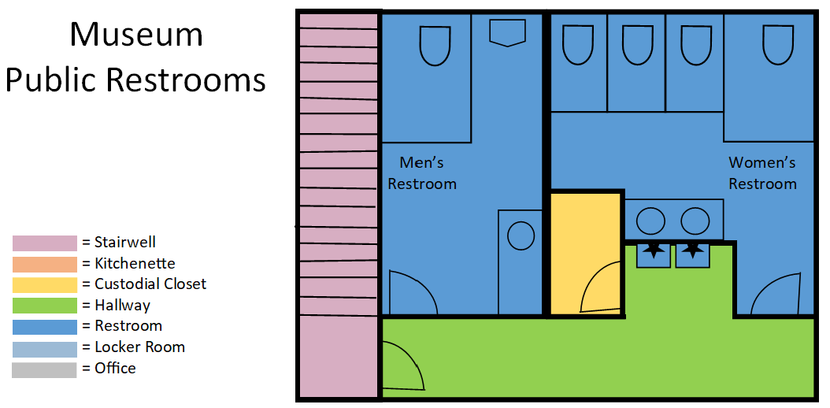
Location 15.
China Bridge Elevator – 350 Swede Alley

All cleaning to be completed seven (7) days per week from 9:00 AM until 10:00 AM.

Daily Cleaning Projects:

ELEVATOR:
- Polish stainless steel, wipe down walls and doors, and disinfect buttons on all levels
- Clean and disinfect all handrails and doorknobs
- Clean out floor track for the doors on each level with blower
- Vacuum all carpeting, including mats, if applicable
- Sweep, mop, and disinfect hard surfaced floors, if applicable

ADDITIONAL ITEMS:
- Spot cleaning
- Check and report on any maintenance issues (i.e., low on paper products, soap, etc.)
- All janitorial closets are to be kept clean, sanitary, and have a proper MSDS Book

CHINA BRIDGE ELEVATOR RENDERING
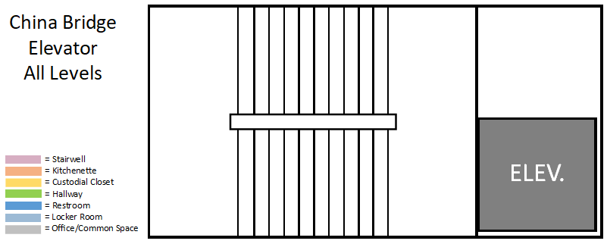

Location 16.
Golf Building – 1800 Three Kings Drive

(April 1 – November 1) All cleaning to be completed one (1) day per week, on Friday, from 10:00 AM until 11:00 AM.

Daily Cleaning Projects:

RESTROOMS (2):
- Empty all trash cans and dispose of in dumpster; replace liners and spot clean trash cans
- Restock all paper products and soap
- Clean and disinfect all handrails and doorknobs
- Clean and disinfect all restroom fixtures, dispensers, faucets, rails, sinks, toilets, and urinals
- Clean and disinfect all flush sensors and underside of all toilets
- Clean and disinfect all countertops
- Clean mirrors
- Clean all interior glass doors, windows, and window ledges, as needed
- Wipe down partitions and walls
- Vacuum all carpeting, including mats, if applicable
- Sweep, mop, and disinfect hard surfaced floors, if applicable

INTERIOR COMMON AREAS – STAFF OFFICES AND HALLWAY:
- Empty all trash cans and dispose of in dumpster; replace liners and spot clean trash cans
- Clean tables and counter tops
- Clean and disinfect all handrails and doorknobs
- Clean all interior glass doors, windows, and window ledges, as needed
- Vacuum all carpeting, including mats, if applicable
- Sweep, mop, and disinfect hard surfaced floors, if applicable

KITCHEN/BREAKROOM
  - Empty all trash cans and dispose of in dumpster; replace liners and spot clean trash cans
  - Clean tables, counter tops, and sink(s)
  - Restock all paper products and soap
  - Vacuum all carpeting, including mats, if applicable
  - Sweep, mop, and disinfect hard surfaced floors, if applicable

ADDITIONAL ITEMS:
- Spot cleaning
- Check and report on any maintenance issues (i.e., low on paper products, soap, etc.)
- All janitorial closets are to be kept clean, sanitary, and have a proper MSDS Book

GOLF BUILDING RENDERING
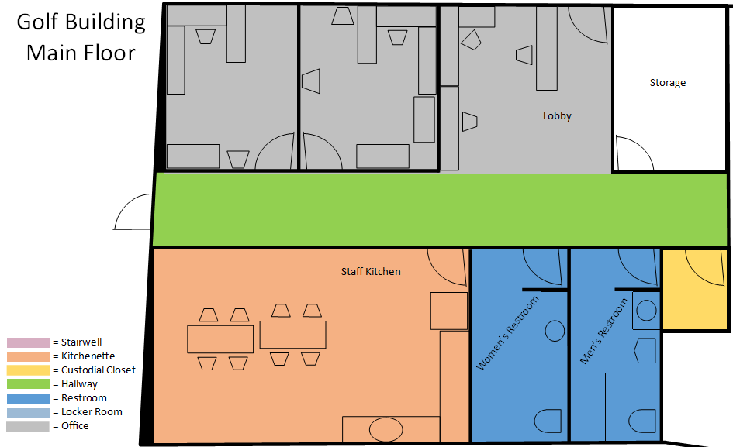
Location 17.
Recreation Center – 1400 Sullivan Road

(April 1 – November 1) All cleaning to be completed five (5) day per week, Monday through Friday, from 7:30 AM until 9:00 AM.

Daily Cleaning Projects:

RESTROOMS (2):
- Empty all trash cans and dispose of in dumpster; replace liners and spot clean trash cans
- Restock all paper products and soap
- Clean and disinfect all handrails and doorknobs
- Clean and disinfect all restroom fixtures, dispensers, faucets, rails, sinks, toilets, and urinals
- Clean and disinfect all flush sensors and underside of all toilets
- Clean and disinfect all countertops
- Clean and disinfect water fountains as needed
- Clean mirrors
- Clean all interior glass doors, windows, and window ledges, as needed
- Wipe down partitions and walls
- Vacuum all carpeting, including mats, if applicable
- Sweep, mop, and disinfect hard surfaced floors, if applicable

INTERIOR COMMON AREAS – CORRIDORS, CONCESSION AREA, ENTRANCE AND MEETING ROOM ON ALL LEVELS:
- Empty all trash cans and dispose of in dumpster; replace liners and spot clean trash cans
- Clean and disinfect all handrails and doorknobs
- Clean tables, counter tops, and sink(s)
- Clean and disinfect all handrails and doorknobs
- Clean all interior glass doors, windows, and window ledges, as needed
- Vacuum all carpeting, including mats, if applicable
- Sweep, mop, and disinfect hard surfaced floors, if applicable

KITCHEN
  - Empty all trash cans and dispose of in dumpster; replace liners and spot clean trash cans
  - Clean and disinfect all handrails and doorknobs
  - Clean tables, counter tops, and sink
  - Restock all paper products and soap
  - Vacuum all carpeting, including mats, if applicable
  - Sweep, mop, and disinfect hard surfaced floors, if applicable

ADDITIONAL ITEMS:
- Spot cleaning
- Check and report on any maintenance issues (i.e., low on paper products, soap, etc.)
- All janitorial closets are to be kept clean, sanitary, and have a proper MSDS Book

RECREATION CENTER RENDERING

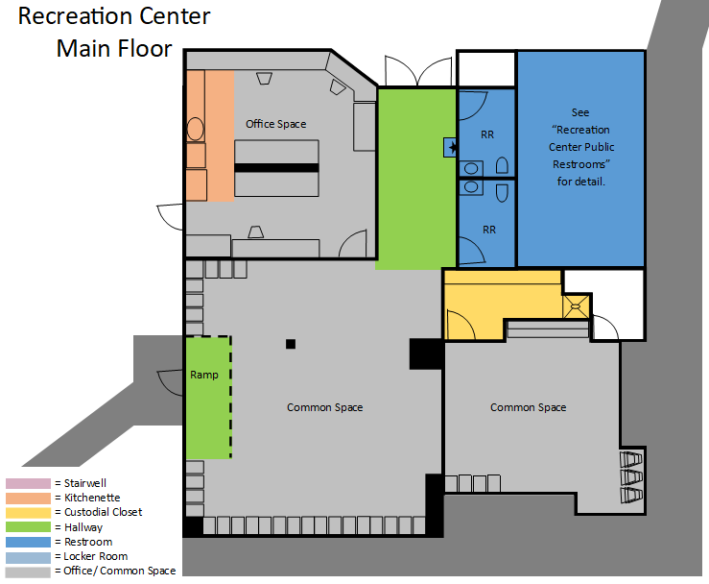
Location 18.
Recreation Center Restrooms – 1400 Sullivan Road

(April 1 – November 1) All cleaning to be completed seven (7) days per week from 7:00 AM until 7:30 AM.

Daily Cleaning Projects:

RESTROOMS (2):
- Empty all trash cans and dispose of in dumpster; replace liners and spot clean trash cans
- Restock all paper products and soap
- Clean and disinfect all handrails and doorknobs
- Clean and disinfect all restroom fixtures, dispensers, faucets, rails, sinks, toilets and urinals
- Clean and disinfect all flush sensors and underside of all toilets
- Clean and disinfect all countertops
- Clean mirrors
- Wipe down partitions and walls
- Vacuum all carpeting, including mats, if applicable
- Sweep, mop, and disinfect hard surfaced floors, if applicable

ADDITIONAL ITEMS:
- Clean and disinfect water fountains as needed
- Spot cleaning
- Check and report on any maintenance issues (i.e., low on paper products, soap, etc.)
- All janitorial closets are to be kept clean, sanitary, and have a proper MSDS Book

RECREATION CENTER RESTROOM RENDERING
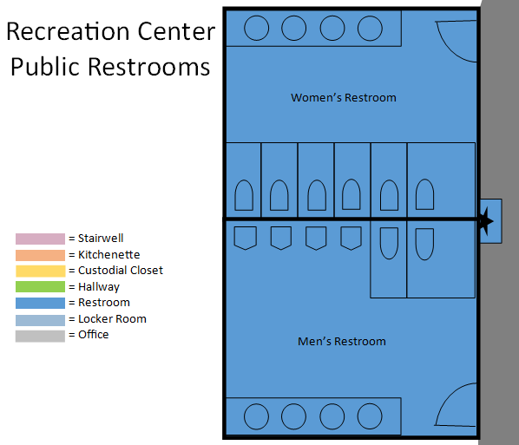
Location 19.
South End Park Restrooms – 1352 Park Avenue

(April 1 – November 1) All cleaning to be completed seven (7) days per week from 6:00 AM until 7:00 AM.

Daily Cleaning Projects:

RESTROOMS (2):
- Empty all trash cans and dispose of in dumpster; replace liners and spot clean trash cans
- Restock all paper products and soap
- Clean and disinfect all handrails and doorknobs
- Clean and disinfect all restroom fixtures, dispensers, faucets, rails, sinks, toilets and urinals
- Clean and disinfect all flush sensors and underside of all toilets
- Clean and disinfect all countertops
- Clean mirrors
- Wipe down partitions and walls
- Vacuum all carpeting, including mats, if applicable
- Sweep, mop, and disinfect hard surfaced floors, if applicable

ADDITIONAL ITEMS:
- Clean and disinfect water fountains as needed
- Spot cleaning
- Check and report on any maintenance issues (i.e., low on paper products, soap, etc.)
- All janitorial closets are to be kept clean, sanitary, and have a proper MSDS Book
SOUTH END PARK RESTROOM RENDERING
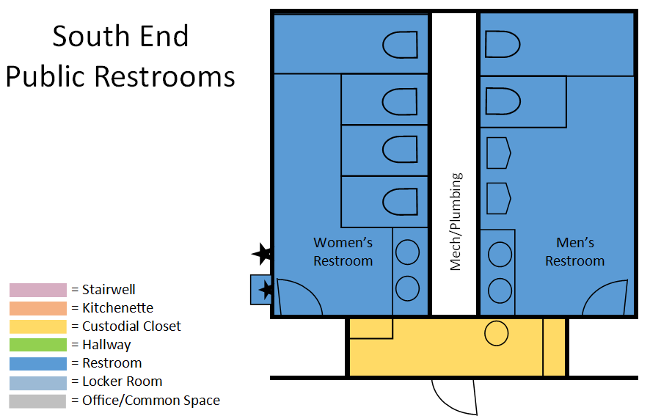
Location 20.
Middle School Restrooms – 2270 Kearns Boulevard

(April 1 – November 1) All cleaning to be completed seven (7) days per week from 8:00 AM until 9:00 AM.

Daily Cleaning Projects:

RESTROOMS (2):
- Empty all trash cans and dispose of in dumpster; replace liners and spot clean trash cans
- Restock all paper products and soap
- Clean and disinfect all handrails and doorknobs
- Clean and disinfect all restroom fixtures, dispensers, faucets, rails, sinks, toilets and urinals
- Clean and disinfect all flush sensors and underside of all toilets
- Clean and disinfect all countertops
- Clean mirrors
- Wipe down partitions and walls
- Vacuum all carpeting, including mats, if applicable
- Sweep, mop, and disinfect hard surfaced floors, if applicable

ADDITIONAL ITEMS:
- Spot cleaning
- Check and report on any maintenance issues (i.e., low on paper products, soap, etc.)
- All janitorial closets are to be kept clean, sanitary, and have a proper MSDS Book
MIDDLE SCHOOL RESTROOM RENDERING
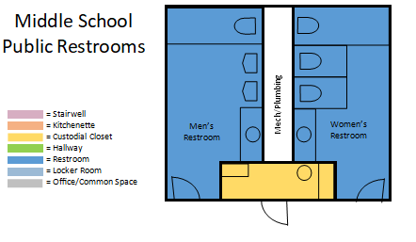
Location 21.
High School Restrooms – 1750 Kearns Boulevard

(April 1 – November 1) All cleaning to be completed seven (7) days per week from 7:00 AM until 8:00 AM.

Daily Cleaning Projects:

RESTROOMS (2):
- Empty all trash cans and dispose of in dumpster; replace liners and spot clean trash cans
- Restock all paper products and soap
- Clean and disinfect all handrails and doorknobs
- Clean and disinfect all restroom fixtures, dispensers, faucets, rails, sinks, toilets and urinals
- Clean and disinfect all flush sensors and underside of all toilets
- Clean and disinfect all countertops
- Clean mirrors
- Wipe down partitions and walls
- Vacuum all carpeting, including mats, if applicable
- Sweep, mop, and disinfect hard surfaced floors, if applicable

ADDITIONAL ITEMS:
- Clean and disinfect water fountains as needed
- Spot cleaning
- Check and report on any maintenance issues (i.e., low on paper products, soap, etc.)
- All janitorial closets are to be kept clean, sanitary and have proper M SDS Book
HIGH SCHOOL RESTROOM RENDERING
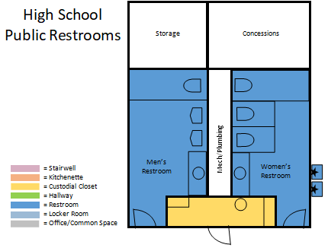
Location 22.
Rotary Park Restrooms – Pay Day Drive

(April 1 – November 1) All cleaning to be completed seven (7) days per week from 5:00 AM until 6:00 AM.

Daily Cleaning Projects:

RESTROOMS (2):
- Empty all trash cans and dispose of in dumpster; replace liners and spot clean trash cans
- Restock all paper products and soap
- Clean and disinfect all handrails and doorknobs
- Clean and disinfect all restroom fixtures, dispensers, faucets, rails, sinks, toilets and urinals
- Clean and disinfect all flush sensors and underside of all toilets
- Clean and disinfect all countertops
- Clean mirrors
- Wipe down partitions and walls
- Vacuum all carpeting, including mats, if applicable
- Sweep, mop, and disinfect hard surfaced floors, if applicable

ADDITIONAL ITEMS:
- Clean and disinfect water fountains as needed
- Spot cleaning
- Check and report on any maintenance issues (i.e., low on paper products, soap, etc.)
- All janitorial closets are to be kept clean, sanitary, and have a proper MSDS Book

ROTARY PARK RESTROOM RENDERING 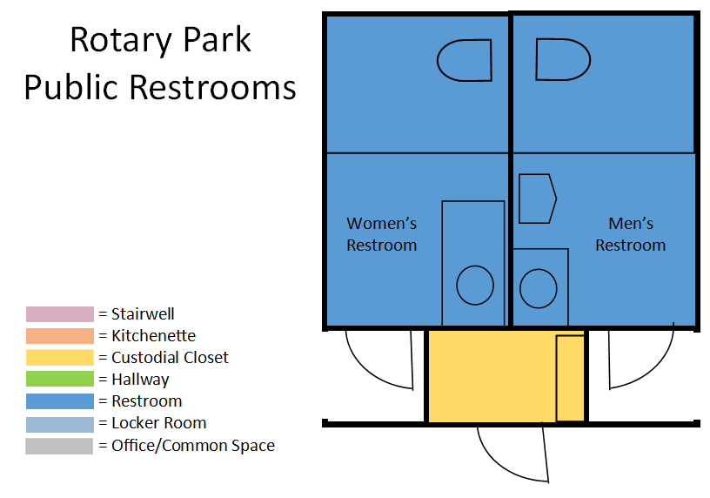

Location 23.
Creekside Park Restrooms – 2392 Holiday Ranch

(April 1 – November 1) All cleaning to be completed seven (7) days per week from 6:00 AM until 7:00 AM.

Daily Cleaning Projects:

RESTROOMS (2):
- Empty all trash cans and dispose of in dumpster; replace liners and spot clean trash cans
- Restock all paper products and soap
- Clean and disinfect all handrails and doorknobs
- Clean and disinfect all restroom fixtures, dispensers, faucets, rails, sinks, toilets and urinals
- Clean and disinfect all flush sensors and underside of all toilets
- Clean and disinfect all countertops
- Clean mirrors
- Wipe down partitions and walls
- Vacuum all carpeting, including mats, if applicable
- Sweep, mop, and disinfect hard surfaced floors, if applicable

ADDITIONAL ITEMS:
- Clean and disinfect water fountains as needed
- Spot cleaning
- Check and report on any maintenance issues (i.e., low on paper products, soap, etc.)
- All janitorial closets are to be kept clean, sanitary, and have a proper MSDS Book

CREEKSIDE RESTROOM RENDERING
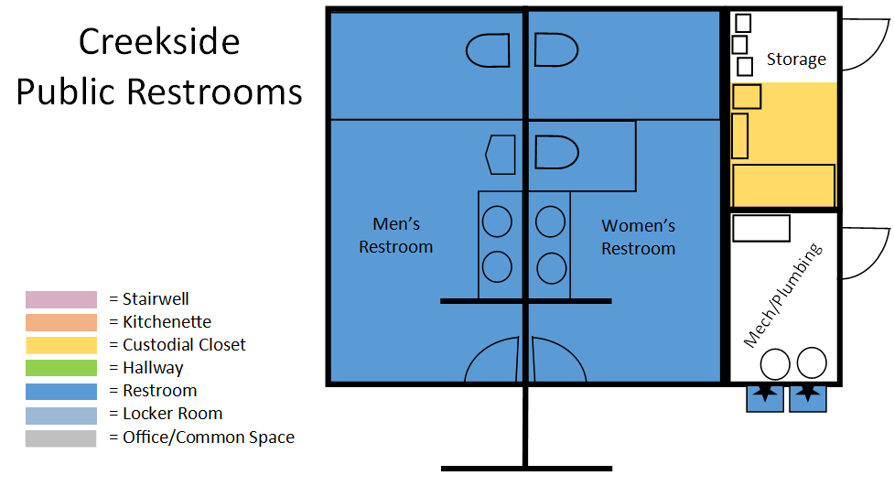
Scope of Services – Exhibit B
Deep Cleaning Standards All City Municipal Buildings
All cleaning to be done on a weekly, monthly, quarterly, and yearly basis as specified below on all buildings.

Weekly Cleaning Projects:

ALL AREAS:
  - Edge vacuum all carpeted areas, including corners and under desks
  - Clean stairway risers, ledges, and dust handrails, if applicable
  - Spot clean stains on all hard surfaced floors and walls
  - Dust all hard surfaces, including bookshelves, cabinets, chairs, file cabinets, tables and walls
  - Clean and disinfect light switches
  - Clean entry doors (interior and exterior sides), including kick plates

RESTROOMS:
  - Dust all partition tops
  - Wipe down and disinfect ceramic tile walls, if applicable

Monthly Cleaning Projects:

ALL AREAS:
  - Restore finish on all non-carpeted hard surfaced floors
  - Shampoo carpets in all carpeted areas
  - Dust tops of all hard surfaces, including frames, mirrors, hanging light fixtures, air vents and walls
  - Low dusting of baseboards and window ledges
  - Fill floor drains with at least one gallon of water and disinfect to prevent sewer smells

KITCHEN:
  - Damp wipe tops of all appliances, including refrigerators, microwaves, and vending machines.
  - Wipe fronts of all cabinetries

Quarterly Cleaning Projects:

ALL AREAS:
  - Buff and high gloss finish all non-carpeted hard surfaced floors, except the Farm Shed
  - Dust and clean all venetian and vertical blinds, if applicable
  - Brush and clean all air vents

Yearly Cleaning Projects:

ALL AREAS:
  - Strip and re-wax all non-carpeted hard surfaced floors
  - Buff and high gloss finish the stained concrete floor in Farm Shed ONLY (to be completed approximately between April and May)

Scope of Services – Exhibit C
Special Events
Park City holds the following annual special events during which City facilities see higher usage and thus need supplementary janitorial services above the usual daily tasks as identified in Scope of Services –
Exhibit A. While Exhibit C lists major special events, the City does host several smaller special events throughout the year which m ay require supplementary janitorial services and/or additional janitorial staff presence. The City will provide advance notification to the contractor when special events are
finalized, as well as the specific supplementary janitorial services required for each event. All events and event dates/times are subject to change and/or cancellation.

Special Event 1.
SUNDANCE FILM FESTIVAL

All cleaning is in addition to services outlined in Scope of Services – Exhibit A for the locations listed below.

DURATION:
  - Ten (10) days – End of January of each year (times subject to change)
  - First Thursday 3:00 PM to 10:00 PM
  - All other days 8:00 AM to 10:00 PM

STAFFING:
  - Contractor to provide one (1) extra dedicated janitorial staff member, equipped with cell phone, rotating between locations.

CLEANING LOCATIONS:
  - Transit Center Restrooms
  - Miner’s Plaza Restrooms
  - Museum Restrooms

CLEANING SERVICES:
- Empty all trash cans and dispose of in dumpster; replace liners and spot clean trash cans
- Restock all paper products and soap
- Clean and disinfect all handrails and doorknobs
- Clean and disinfect all restroom fixtures, dispensers, faucets, rails, sinks, toilets and urinals
- Clean and disinfect all flush sensors and underside of all toilets
- Clean and disinfect all countertops
- Vacuum all carpeting, including mats, if applicable
- Sweep, mop, and disinfect hard surfaced floors, if applicable

Special Event 2.
KIMBALL ARTS FESTIVAL

All cleaning is in addition to services outlined in Scope of Services – Exhibit A for the locations listed below.

DURATION:
  - Three (3) Days – Typically the first weekend in August (times subject to change)
  - Friday 3:00 PM to 9:00 PM
  - Saturday 9:00 AM to 9:00 PM
  - Sunday 9:00 AM to 7:00 PM

STAFFING:
  - Contractor to provide one (1) dedicated janitorial staff member, equipped with cell phone, rotating between locations.

CLEANING LOCATIONS:
  - Transit Center Restrooms
  - Miner’s Plaza Restrooms
  - Museum Restrooms

CLEANING SERVICES:
- Empty all trash cans and dispose of in dumpster; replace liners and spot clean trash cans
- Restock all paper products and soap
- Clean and disinfect all handrails and doorknobs
- Clean and disinfect all restroom fixtures, dispensers, faucets, rails, sinks, toilets and urinals
- Clean and disinfect all flush sensors and underside of all toilets
- Clean and disinfect all countertops
- Vacuum all carpeting, including mats, if applicable
- Sweep, mop, and disinfect hard surfaced floors, if applicable

Special Event 3.
FOURTH OF JULY CELEBRATION

All cleaning is in addition to services outlined in Scope of Services – Exhibit A for the locations listed below.

DURATION:
  - One (1) day: July 4th

STAFFING:
  - Contractor to provide two (2) dedicated janitorial staff member, equipped with cell phone, rotating between locations.

CLEANING LOCATIONS:
  - Transit Center Restrooms (10:00 AM and 1:00 PM ONLY)
  - Miner’s Plaza Restrooms (10:00 AM and 1:00 PM ONLY)
  - Museum Restrooms (10:00 AM and 1:00 PM ONLY)
  - South End Park Restrooms (7:00 AM to 9:00 PM)
  - Recreation Center Restrooms (7:00 AM to 9:00 PM)

CLEANING SERVICES:
- Empty all trash cans and dispose of in dumpster; replace liners and spot clean trash cans
- Restock all paper products and soap
- Clean and disinfect all handrails and doorknobs
- Clean and disinfect all restroom fixtures, dispensers, faucets, rails, sinks, toilets and urinals
- Clean and disinfect all flush sensors and underside of all toilets
- Clean and disinfect all countertops
- Vacuum all carpeting, including mats, if applicable
- Sweep, mop, and disinfect hard surfaced floors, if applicable

Special Event 4.
AUTUMN ALOFT FESTIVAL

All cleaning is in addition to services outlined in Scope of Services – Exhibit A for the locations listed below.

DURATION:
  - One Day – Mid-September (times subject to change)
  - Typically, Saturday
  - 7:00 AM to 10:00 AM

STAFFING:
  - Contractor to provide one (1) dedicated janitorial staff member, equipped with cell phone, rotating between locations.

CLEANING LOCATIONS:
  - Middle School Restrooms
  - High School Restrooms

CLEANING SERVICES:
- Empty all trash cans and dispose of in dumpster; replace liners and spot clean trash cans
- Restock all paper products and soap
- Clean and disinfect all handrails and doorknobs
- Clean and disinfect all restroom fixtures, dispensers, faucets, rails, sinks, toilets and urinals
- Clean and disinfect all flush sensors and underside of all toilets
- Clean and disinfect all countertops
- Vacuum all carpeting, including mats, if applicable
- Sweep, mop, and disinfect hard surfaced floors, if applicable

Special Event 5.
PARK SILLY SUNDAY MARKET

All cleaning is in addition to services outlined in Scope of Services – Exhibit A for the locations listed below.

DURATION:
  - Sundays, Mid-June through Mid-September (times subject to change)
  - 11:00 AM

STAFFING:
  - Contractor to provide one (1) dedicated janitorial staff member, equipped with cell phone, rotating between locations.

CLEANING LOCATIONS:
  - Transit Center Restrooms (10:00 AM and 1:00 PM ONLY)
  - Miner’s Plaza Restrooms (10:00 AM and 1:00 PM ONLY)
  - Museum Restrooms (10:00 AM and 1:00 PM ONLY)

CLEANING SERVICES:
- Empty all trash cans and dispose of in dumpster; replace liners and spot clean trash cans
- Restock all paper products and soap
- Clean and disinfect all handrails and doorknobs
- Clean and disinfect all restroom fixtures, dispensers, faucets, rails, sinks, toilets and urinals
- Clean and disinfect all flush sensors and underside of all toilets
- Clean and disinfect all countertops
- Vacuum all carpeting, including mats, if applicable
- Sweep, mop, and disinfect hard surfaced floors, if applicable

Scope of Services – Exhibit D
Equipment Supply
Park City would like contractors to submit a payment schedule for equipment they would supply for the services listed at each of the locations in Exhibits A, B and C. Contractors will be responsible for storing and maintaining this equipment. If submittal is chosen, Park City will fund the initial supply of new equipment and replacement only when the useful life of the equipment has been reached. Park City will not be responsible to replace equipment in the event of operator error.

All cleaning equipment must be approved by the building maintenance supervisor prior to purchase.

CLEANING RAGS:
  - Freshly laundered rags are to be used in each location for each cleaning

MOPS/BUCKETS:
  - Freshly laundered mop heads are to be used in each location for each cleaning

GLOVES, MASKS, AND SAFETY GLASSES:
  - As needed for employees

VACUUMS:
  - One floor or backpack vacuum per each employee on staff that day.
    - Must have a HEPA filter

Payment Schedule – Exhibit E
Hourly Rates
Park City would like contractors to submit a payment Schedule for the hourly rates they would charge during the instances listed below. Contractors will be responsible for upholding

INSTANCES:

  - Non-Holiday, Normal Business Hours
  - Emergency Calls
  - After-Hours
  - Holidays

ADDITIONAL SERVICES
  - Quick Clean of a Facility, replacement of supplies/paper products
  - Replacement of supplies/paper products ONLY

Emergency Response Time:
Please specify your guaranteed response time to emergency cleaning requests. Locations of all twenty-three (23) City facilities should be considered. If your guaranteed response time is different for various locations, please list the individual response times on a separate sheet.

Payment Schedule – Exhibit A
Locations

Payment schedule must be completed in entirety.

 | Year Round | Daily $ | Monthly $ | Yearly $
1 | Police Facility | _______ | _______ | _______
2 | Marsac Building | _______ | _______ | _______
3 | Library Center | _______ | _______ | _______
4a | Miners Hospital | _______ | _______ | _______
5 | PC MARC | _______ | _______ | _______
6a | Public Works West Building | _______ | _______ | _______
6b | Public Works West Building | _______ | _______ | _______
7a | Public Works East Building | _______ | _______ | _______
7b | Public Works East Building | _______ | _______ | _______
8 | Quinn’s Water Treatment | _______ | _______ | _______
9 | Quinn’s Maintenance Building | _______ | _______ | _______
10 | Quinn’s Restrooms | _______ | _______ | _______
11 | Farm Shed | _______ | _______ | _______
12a | Transit Center | _______ | _______ | _______
12b | Transit Center | _______ | _______ | _______
13a | Miners Plaza Restrooms | _______ | _______ | _______
13b | Miners Plaza Restrooms | _______ | _______ | _______
14a | Museum Restrooms | _______ | _______ | _______
14b | Museum Restrooms | _______ | _______ | _______
15 | China Bridge Elevators | _______ | _______ | _______
 | Summer Only (APR 1 – NOV 1) | Daily $ | Monthly $ | Yearly $
4b | Miners Hospital | _______ | _______ | _______
16 | Golf Building | _______ | _______ | _______
17 | Recreation Center | _______ | _______ | _______
18 | Recreation Center Restrooms | _______ | _______ | _______
19 | South End Park Restrooms | _______ | _______ | _______
20 | Middle School Restrooms | _______ | _______ | _______
21 | High School Restrooms | _______ | _______ | _______
22 | Rotary Park Restrooms | _______ | _______ | _______
23 | Creekside Park Restrooms | _______ | _______ | _______
 | Total | _______ | _______ | _______

Payment Schedule – Exhibit B
Deep Cleaning Standards All City Municipal Buildings

Payment schedule must be completed in entirety.

Please list total cost for each event.

1. Weekly Deep Cleaning Projects | $______________
2. Monthly Deep Cleaning Projects | $______________
3. Quarterly Deep Cleaning Projects | $______________
4. Annual Deep Cleaning Projects | $______________

Total $_______

Payment Schedule – Exhibit C
Special Events

Payment schedule must be completed in entirety.

Please list total cost for staffing each event.

1. Sundance Film Festival | $______________
2. Kimball Arts Festival | $______________
3. Fourth of July Celebration | $______________
4. Autumn Aloft Festival | $______________
5. Park Silly Sunday Market | $______________

Total $_______

Please specify hourly rate for:

  - Additional Special Events with advance notice $ hour

Payment Schedule – Exhibit D
Equipment Supply

Payment schedule must be completed in entirety.

Please list total cost for each piece of equipment to perform all jobs listed in Exhibit A.

1. Clean Rags | $______________
2. Clean Mop Heads | $______________
3. Gloves, Masks, and Safety Glasses | $______________
4. Vacuums | $______________
Total $_______

Please list total cost for each piece of equipment to perform all jobs listed in Exhibit B.

1. Clean Rags | $______________
2. Clean Mop Heads | $______________
3. Gloves, Masks, and Safety Glasses | $______________
4. Vacuums | $______________
Total $_______ _

Please list total cost for each piece of equipment to perform all jobs listed in Exhibit C.

1. Clean Rags | $______________
2. Clean Mop Heads | $______________
3. Gloves, Masks, and Safety Glasses | $______________
4. Vacuums | $______________
Total $_______ _

Total of all equipment $_____________
Payment Schedule – Exhibit E
Hourly Rates

Payment schedule must be completed in entirety.

Please specify hourly rate for:

  - Non-Holiday, Normal Business Hours $______________
  - Emergency Calls $______________
  - After-Hours $______________
  - Holidays $______________

Please specify cost for:
  - Quick Clean of a Facility, replacement of supplies/paper products $______________
  - Replacement of supplies/paper products ONLY $______________

Emergency Response Time:
Please specify your guaranteed response time to emergency cleaning requests. Locations of all twenty-three (23) City facilities should be considered. If your guaranteed response time is different for various locations, please list the individual response times on a separate sheet:

  - Guaranteed Emergency Response Time _______________________
  - Comments ______________________________________________________________
___________________________________________________________________________
___________________________________________________________________________
___________________________________________________________________________

________________________________________________ _______________
Contractor Authorized Signature Date

________________________________________________
Print Name

________________________________________________
Title

________________________________________________ Company

Exhibit F

Template Updated 08-21

PARK CITY MUNICIPAL CORPORATION
SERVICE PROVIDER/PROFESSIONAL SERVICES AGREEMENT

This Service Provider/Professional Services Agreement (the “Agreement”) is made and entered into as of this ____ day of _____________, 20__, by and between PARK CITY MUNICIPAL CORPORATION, a Utah municipal corporation, (“City”), and ____________________________________, a _______________________________ (Insert state of incorporation) ___________________________________ (insert either “corporation” or “limited liability company”), (“Service Provider”), collectively, the City and the Service Provider are referred to as (the “Parties).”

WITNESSETH:

WHEREAS, the City desires to have certain services and tasks performed as set forth below requiring specialized skills and other supportive capabilities;

WHEREAS, sufficient City resources are not available to provide such services; and

WHEREAS, the Service Provider represents that the Service Provider is qualified and possesses sufficient skills and the necessary capabilities, including technical and professional expertise, where required, to perform the services and/or tasks set forth in this Agreement.

NOW, THEREFORE, in consideration of the terms, conditions, covenants, and performance contained herein, the Parties hereto agree as follows:

1. SCOPE OF SERVICES.

The Service Provider shall perform such services and accomplish such tasks, including the furnishing of all materials and equipment necessary for full performance thereof, as are identified and designated as Service Provider responsibilities throughout this Agreement and as set forth in the “Scope of Services” attached hereto as “Exhibit A” and incorporated herein (the “Project”). The total fee for the Project shall not exceed __________________ Dollars ($_____________).

The City has designated __________, or his/her designee as City’s Representative, who shall have authority to act on the City’s behalf with respect to this Agreement consistent with the budget contract policy.

2. TERM.

No work shall occur prior to the issuance of a Notice to Proceed which cannot occur until execution of this Agreement, which execution date shall be commencement of the term and the term shall terminate on ________________________ or earlier, unless extended by mutual written agreement of the Parties.

3. COMPENSATION AND METHOD OF PAYMENT.

A. Payments for services provided hereunder shall be made monthly following the performance of such services.

B. No payment shall be made for any service rendered by the Service Provider except for services identified and set forth in this Agreement.

C. For all “extra” work the City requires, the City shall pay the Service Provider for work performed under this Agreement according to the schedule attached hereto as “Exhibit B,” or if none is attached, as subsequently agreed to by both Parties in writing.

D. The Service Provider shall submit to the City Manager or her designee on forms approved by the City Manager, an invoice for services rendered during the pay period. The City shall make payment to the Service Provider within thirty (30) days thereafter. Requests for more rapid payment will be considered if a discount is offered for early payment. Interest shall accrue at a rate of six percent (6%) per annum for services remaining unpaid for sixty (60) days or more.

E. The Service Provider reserves the right to suspend or terminate work and this Agreement if any unpaid account exceeds sixty (60) days.

F. Service Provider acknowledges that the continuation of this Agreement after the end of the City’s fiscal year is specifically subject to the City Council’s approval of the annual budget.

4. RECORDS AND INSPECTIONS.

A. The Service Provider shall maintain books, records, documents, statements, reports, data, information, and other material with respect to matters covered, directly or indirectly, by this Agreement, including (but not limited
to) that which is necessary to sufficiently and properly reflect all direct and indirect costs related to the performance of this Agreement, and shall maintain such accounting procedures and practices as may be necessary to assure proper accounting of all funds paid pursuant to this Agreement.

B. The Service Provider shall retain all such books, records, documents, statements, reports, data, information, and other material with respect to matters covered, directly or indirectly, by this Agreement for six (6) years after expiration of the Agreement.

C. The Service Provider shall, at such times and in such form as the City may require, make available for examination by the City, its authorized representatives, the State Auditor, or other governmental officials authorized by law to monitor this Agreement, all such books, records, documents, statements, reports, data, information, and other material with respect to matters covered, directly or indirectly, by this Agreement. The Service Provider shall permit the City or its designated authorized representative to audit and inspect other data relating to all matters covered by this Agreement. The City may, at its discretion, conduct an audit at its expense, using its own or outside auditors, of the Service Provider’s activities, which relate directly or indirectly to this Agreement.

D. The City is subject to the requirements of the Government Records Access and Management Act, Chapter 2, Title 63G, Utah Code,1953, as amended and Park City Municipal Code Title 5 (“GRAMA”). All materials submitted by Service Provider pursuant to this Agreement are subject to disclosure unless such materials are exempt from disclosure pursuant to GRAMA. The burden of claiming an exemption from disclosure rests solely with Service Provider. Any materials for which Service Provider claims a privilege from disclosure based on business confidentiality shall be submitted marked as “confidential - business confidentiality” and accompanied by a concise statement from Service Provider of reasons supporting its claim of business confidentiality. Generally, GRAMA only protects against the disclosure of trade secrets or commercial information that could reasonably be expected to result in unfair competitive injury. The City will make reasonable efforts to notify Service Provider of any requests made for disclosure of documents submitted under a claim of confidentiality. Service Provider specifically waives any claims against the City related to any disclosure of materials pursuant to GRAMA.

5. INDEPENDENT CONTRACTOR RELATIONSHIP.

A. The Parties intend that an independent Service Provider/City relationship will be created by this Agreement. No agent, employee, or representative of the Service Provider shall be deemed to be an employee, agent, or representative of the City for any purpose, and the employees of the Service Provider are not entitled to any of the benefits the City provides for its employees. The Service Provider will be solely and entirely responsible for its acts and for the acts of its agents, employees, subcontractors or representatives during the performance of this Agreement.

B. In the performance of the services herein contemplated, the Service Provider is an independent contractor with the authority to control and direct the performance of the details of the work, however, the results of the work contemplated herein must meet the approval of the City and shall be subject to the City’s general rights of inspection and review to secure the satisfactory completion thereof.

6. SERVICE PROVIDER EMPLOYEE/AGENTS.

The City may at its sole discretion require the Service Provider to remove an employee(s), agent(s), or representative(s) from employment on this Project. The Service Provider may, however, employ that (those) individuals(s) on other non-City related projects.

7. HOLD HARMLESS INDEMNIFICATION.

A. The Service Provider shall indemnify and hold the City and its agents, employees, and officers, harmless from and shall process and defend at its own expense any and all claims, demands, suits, at law or equity, actions, penalties, losses, damages, or costs, of whatsoever kind or nature, brought against the City arising out of, in connection with, or incident to the execution of this Agreement and/or the Service Provider’s negligent performance or failure to perform any aspect of this Agreement; provided, however, that if such claims are caused by or result from the concurrent negligence of the City, its agents, employees, and officers, this indemnity provision shall be valid and enforceable only to the extent of the negligence of the Service Provider; and provided further, that nothing herein shall require the Service Provider to hold harmless or defend the City, its agents, employees and/or officers from any claims arising from the sole negligence of the City, its agents, employees, and/or officers. The Service Provider expressly agrees that the indemnification provided herein constitutes the Service Provider’s limited waiver of immunity as an employer under Utah Code Section 34A-2-105; provided, however, this waiver shall apply only to the extent an employee of Service Provider claims or recovers compensation from the City for a loss or injury that Service Provider would be obligated to indemnify the City for under this Agreement. This limited waiver has been mutually negotiated by the Parties, and is expressly made effective only for the purposes of this Agreement. The provisions of this section shall survive the expiration or termination of this Agreement.

B. No liability shall attach to the City by reason of entering into this Agreement except as expressly provided herein.

8. INSURANCE.

The Service Provider shall procure and maintain for the duration of the Agreement, insurance against claims for injuries to persons or damage to property which may arise from or in connection with the performance of the work hereunder by the Service Provider, their agents, representatives, employees, or subcontractors. The Service Provider shall provide a Certificate of Insurance evidencing:

A. General Liability insurance written on an occurrence basis with limits no less than One Million Dollars ($1,000,000) per occurrence and Three Million Dollars ($3,000,000) aggregate for personal injury, bodily injury and property damage.

The Service Provider shall increase the limits of such insurance to at least the amount of the Limitation of Judgments described in Section 63G-7-604 of the Governmental Immunity Act of Utah, as calculated by the state risk manager every two years and stated in Utah Admin. Code R37-4-3.

B. Automobile Liability insurance with a combined single limit of not less than Two Million Dollars ($2,000,000) each accident for bodily injury, death of any person, and property damage arising out of the ownership, maintenance, and use of owned, hired, and non-owned motor vehicles. This policy must not contain any exclusion or limitation with respect to loading or unloading of a covered vehicle.

C. Professional Liability (Errors and Omissions) insurance (if applicable) with annual limits no less than One Million Dollars ($1,000,000) per occurrence. Service Provider agrees to continue to procure and maintain professional liability insurance coverage meeting these requirements for the applicable period of statutory limitation of claims (or statute of repose, if applicable) after the project completion or termination of this Agreement.

If written on a claims-made basis, the Service Provider warrants that the retroactive date applicable to coverage precedes the effective date of this agreement; and that continuous coverage will be maintained for an extended reporting period endorsement (tail coverage) will be purchased for a period of at least three (3) years beginning from the time that work under this agreement is complete.

D. Workers Compensation insurance and Employers Liability coverage with Workers Compensation limits complying with statutory requirements, and Employer’s Liability Insurance limits of at least One Million Dollars ($1,000,000) each accident, One Million Dollars ($1,000,000) for bodily injury by accident, and One Million Dollars ($1,000,000) each employee for injury by disease.
.
The Workers’ Compensation policy shall be endorsed with a waiver of subrogation in favor of Park City Municipal Corporation for all work performed by the Service Provider, its employees, agents and subcontractors.

E. Park City Municipal Corporation, its officers, officials, employees, and volunteers are to be covered as additional insureds on general liability and auto liability insurance policies, with respect to work performed by or on behalf of the Service Provider including materials, parts, or equipment furnished in connection with such work or operations and automobiles owned, leased, hired, or borrowed by or on behalf of the Service Provider and a copy of the endorsement naming the City as an additional insured shall be attached to the Certificate of Insurance.

F. Should any of the above described policies be cancelled before the expiration date thereof, Service Provider shall deliver notice to the City within thirty (30) days of cancellation. The City reserves the right to request certified copies of any required policies.

G. The Service Provider’s insurance shall contain a clause stating that coverage shall apply separately to each insured against whom claim is made or suit is brought, except with respect to the limits of the insurer’s liability.

H. For any claims related to this Agreement, the Service Provider’s insurance coverage shall be primary insurance coverage with respect to Park City Municipal Corporation, its officers, officials, employees, and
volunteers. Any insurance or self-insurance maintained by Park City Municipal Corporation, its officers, officials, employees, or volunteers shall be excess of the Service Provider’s insurance and shall not contribute with it.

9. TREATMENT OF ASSETS.

Title to all property furnished by the City shall remain in the name of the City and the City shall become the owner of the work product and other documents, if any, prepared by the Service Provider pursuant to this Agreement (contingent on City’s performance hereunder).

10. COMPLIANCE WITH LAWS AND WARRANTIES.

A. The Service Provider, in the performance of this Agreement, shall comply with all applicable federal, state, and local laws and ordinances, including regulations for licensing, certification and operation of facilities, programs and accreditation, and licensing of individuals, and any other standards or criteria as described in this Agreement to assure quality of services.

B. Unless otherwise exempt, the Service Provider is required to have a valid Park City business license.

C. The Service Provider specifically agrees to pay any applicable fees or charges which may be due on account of this Agreement.

D. If this Agreement is entered into for the physical performance of services within Utah, the Service Provider shall register and participate in E-Verify or an equivalent program. The Service Provider agrees to verify employment eligibility through E-Verify, or an equivalent program, for each new employee that is employed within Utah, unless exempted by Utah Code § 63G-12-302.
E. Service Provider shall be solely responsible to the City for the quality of all services performed by its employees or sub-contractors under this Agreement. Service Provider hereby warrants that the services performed by its employees or sub-contractors will be performed substantially in conformance with the standard of care observed by similarly situated companies providing services under similar conditions.

11. NONDISCRIMINATION.

Any Service Provider that enters into an agreement for goods or services with Park City Municipal Corporation or any of its boards, agencies, or departments shall:

- Implement an employment nondiscrimination policy prohibiting discrimination in hiring, discharging, promoting or demoting, matters of compensation, or any other employment­ related decision or benefit against a person otherwise qualified, because of actual or perceived race; color; sex; pregnancy, childbirth, or pregnancy- related conditions; age, if the individual is 40 years of age or older; religion; national origin; disability; sexual orientation; gender identity; genetic information; or military status.

- In the performance of this Agreement, Service Provider shall not discriminate on account of actual or perceived race; color; sex; pregnancy, childbirth, or pregnancy-related conditions; age, if the individual is 40 years of age or older; religion; national origin; disability; sexual orientation; gender identity; genetic information; or military status.

- Incorporate the foregoing provisions in all subcontracts or assignments hereunder and take such actions as may be required to ensure full compliance with the provisions of this policy.

12. ASSIGNMENTS/SUBCONTRACTING.

A. The Service Provider shall not assign its performance under this Agreement or any portion of this Agreement without the written consent of the City, and it is further agreed that said consent must be sought in writing by the Service Provider not less than thirty (30) days prior to the date of any proposed assignment. The City reserves the right to reject without cause any such assignment. Any assignment made without the prior express written consent of the City, as required by this paragraph, shall be deemed null and void.

B. Any work or services assigned hereunder shall be subject to each provision of this Agreement and proper bidding procedures where applicable as set forth in local, state or federal statutes, ordinance and guidelines.

C. Any technical/professional service subcontract not listed in this Agreement, must have express advance approval by the City.

D. Each subcontractor that physically performs services within Utah shall submit an affidavit to the Service Provider stating that the subcontractor has used E-Verify, or an equivalent program, to verify the employment status of each new employee, unless exempted by Utah Code § 63G-12-302.

13. CHANGES.

Either party may request changes to the scope of services and performance to be provided hereunder, however, no change or addition to this Agreement shall be valid or binding upon either party unless such change or addition be in writing and signed by both Parties. Such amendments shall be attached to and made part of this Agreement.

14. PROHIBITED INTEREST, NO THIRD PARTY RIGHTS AND NO GRATUITY TO CITY EMPLOYEES.

- No member, officer, or employee of the City shall have any interest, direct or indirect, in this Agreement or the proceeds thereof.

- Nothing herein is intended to confer rights of any kind in any third party.

C. No City employee who has procurement decision making authority and is engaged in the procurement process, or the process of administering a contract, may knowingly receive anything of value including but not limited to gifts, meals, lodging or travel from anyone that is seeking or has a contract with the City.

15. MODIFICATIONS TO TASKS AND MISCELLANEOUS PROVISIONS.

A. All work proposed by the Service Provider is based on current government ordinances and fees in effect as of the date of this Agreement.

B. Any changes to current government ordinances and fees which affect the scope or cost of the services proposed may be billed as an “extra” pursuant to Paragraph 3(C), or deleted from the scope, at the option of the City.

C. The City shall make provision for access to the property and/or project and adjacent properties, if necessary, for performing the services herein.

16. TERMINATION.

A. Either party may terminate this Agreement, in whole or in part, at any time, by at least thirty (30) days' written notice to the other party. The Service Provider shall be paid its costs, including contract close-out costs, and profit on work performed up to the time of termination. The Service Provider shall promptly submit a termination claim to the City. If the Service Provider has any property in its possession belonging to the City, the Service Provider will account for the same, and dispose of it in a manner directed by the City.

B. If the Service Provider fails to perform in the manner called for in this Agreement, or if the Service Provider fails to comply with any other provisions of the Agreement and fails to correct such noncompliance within three (3) days’ written notice thereof, the City may immediately terminate this Agreement for cause. Termination shall be effected by serving a notice of termination on the Service Provider setting forth the manner in which the Service Provider is in default. The Service Provider will only be paid for services performed in accordance with the manner of performance set forth in this Agreement.

17. NOTICE.

Notice provided for in this Agreement shall be sent by certified mail to the addresses designated for the Parties below. Notice is effective upon the date it was sent, except that a notice of termination pursuant to Paragraph 16 is effective upon receipt. All reference to “days” in this Agreement shall mean calendar days.

18. ATTORNEYS FEES AND COSTS.

If any legal proceeding is brought for the enforcement of this Agreement, or because of a dispute, breach, default, or misrepresentation in connection with any of the provisions of this Agreement, the prevailing party shall be entitled to recover from the other party, in addition to any other relief to which such party may be entitled, reasonable attorney’s fees and other costs incurred in connection with that action or proceeding.

19. JURISDICTION AND VENUE.

A. This Agreement has been and shall be construed as having been made and delivered within the State of Utah and it is agreed by each party hereto that this Agreement shall be governed by the laws of the State of Utah, both as to interpretation and performance.

B. Any action of law, suit in equity, or judicial proceeding for the enforcement of this Agreement, or any provisions thereof, shall be instituted and maintained only in any of the courts of competent jurisdiction in Summit County, Utah.

20. SEVERABILITY AND NON-WAIVER.

A. If, for any reason, any part, term, or provision of this Agreement is held by a court of the United States to be illegal, void or unenforceable, the validity of the remaining provisions shall not be affected, and the rights and obligations of the Parties shall be construed and enforced as if the Agreement did not contain the particular provision held to be invalid.

B. If it should appear that any provision hereof is in conflict with any statutory provision of the State of Utah, said provision which may conflict therewith shall be deemed inoperative and null and void insofar as it may be in conflict therewith, and shall be deemed modified to conform in such statutory provisions.

C. It is agreed by the Parties that the forgiveness of the non-performance of any provision of this Agreement does not constitute a subsequent waiver of the provisions of this Agreement. No waiver shall be effective unless it is in writing and signed by an authorized representative of the waiving party.

21. ENTIRE AGREEMENT.

The Parties agree that this Agreement is the complete expression of the terms hereto and any oral representations or understandings not incorporated herein are excluded. Further, any modification of this Agreement shall be in writing and signed by both Parties. Failure to comply with any of the provisions stated herein shall constitute material breach of contract and cause for termination. Both Parties recognize time is of the essence in the performance of the provisions of this Agreement.

22. COUNTERPARTS.

This Agreement may be executed in counterparts, each of which will be deemed an original and all of which together will constitute one and the same instrument.

23. ELECTRONIC SIGNATURES.

Each party agrees that the signatures of the parties included in this Agreement, whether affixed on an original document manually and later electronically transmitted or whether affixed by an electronic signature through an electronic signature system such as DocuSign, are intended to authenticate this writing and to create a legal and enforceable agreement between the parties hereto.

IN WITNESS WHEREOF the Parties hereto have caused this Agreement to be executed the day and year first hereinabove written.

PARK CITY MUNICIPAL CORPORATION, a Utah municipal corporation
445 Marsac Avenue

Post Office Box 1480
Park City, UT 84060-1480

________________________________
Matt Dias, City Manager
Attest:

___________________________
City Recorder’s Office

Approved as to form:

___________________________
City Attorney’s Office
SERVICE PROVIDER NAME
Address:
Address:
City, State, Zip:

Tax ID#: _________________________
PC Business License# BL_____________

__________________________________
Signature

__________________________________
Printed name

__________________________________

Title

THE CITY REQUIRES THE SERVICE PROVIDER TO COMPLETE EITHER THE NOTARY BLOCK OR THE UNSWORN DECLARATION, WHICH ARE BELOW.
STATE OF UTAH )
) ss.
COUNTY OF SUMMIT )

STATE OF ____________
COUNTY OF __________

On this ____ day of ________________, 20__, personally appeared before me _____________________________, whose identity is personally known to me/or proved to me on the basis of satisfactory evidence and who by me duly sworn/affirmed, did say that he/she is the _________________________ (title or office) of __________________________________, a ___________________________ corporation (or limited liability company), by authority of its Bylaws/Resolution of the Board of Directors (if as to a corporation) or Operating Agreement/Member Resolution (if as to a limited liability company), and acknowledged that he/she signed it voluntarily for its stated purpose as _______________________ (title) for _______________________________, a _______________ corporation (or limited liability company).

__________________________________
Notary Public
I declare under criminal penalty under the law of Utah that the foregoing is true and correct. Signed on the ___ day of ______, 20___at _____________________________________ (insert State and County here).

Printed name _________________________________________

Signature: ____________________________________________

EXHIBIT “A”

SCOPE OF SERVICES

EXHIBIT “B”

PAYM ENT SCHEDU LE FOR “EXTRA” WORK

