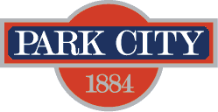

PUBLIC NOTICE- Pursuant to the Municipal Code of Park City, Section 2-3-11, and consistent with Utah Code Annotated 10-8-2(4), Park City Municipal Corporation will hold a public hearing on February 15, 2018, at 6:00PM, in Council Chambers, 445 Marsac Avenue, Park City, UT, 84060, for the purpose of receiving public comment and reviewing the proposals on the disposition of certain real property owned by Park City Municipal Corporation valued in excess of $250,000.00. Park City Municipal Corporation intends to dispose of the following parcels of property:

Parcel RP1 located within Summit County, and specifically at 1450 Park Avenue, Units A, B, C, D, E, F, G, and H, Park City, UT, 84060 (Condominium as approved/recordation pending).

